**DAILY ONLINE ACTIVITIES SUMMARY**

|  |  |  |  |  |  |  |  |  |
| --- | --- | --- | --- | --- | --- | --- | --- | --- |
| **Date:** | **14-06-2020** | | | | | **Name:** | **P Vighnesh Pejathaya** | |
| **Sem & Sec** | **8 sem , A sec** | | | | | **USN:** | **4al16cs060** | |
| **Online Test Summary** | | | | | | | | |
| **Subject** | | **NA** | | | | | | |
| **Max. Marks** | |  | | **Score** | | |  | |
| **Certification Course Summary** | | | | | | | | |
| **Course** | **Cloud Computing** | | | | | | | |
| **Certificate Provider** | | | **IBM** | | **Duration** | | | **120 min** |
| **Coding Challenges** | | | | | | | | |
| **Problem Statement: Program to multiply two Matrix.** | | | | | | | | |
| **Status: Completed** | | | | | | | | |
| **Uploaded the report in Github** | | | | | **yes** | | | |
| **If yes Repository name** | | | | | **Alvas-education-foundation/p_vighnesh** | | | |
| **Uploaded the report in slack** | | | | | **yes** | | | |

Online Test Details: (Attach the snapshot and briefly write the report for the same)

Not Conducted.

Certification Course Details: (Attach the snapshot and briefly write the report for the same)

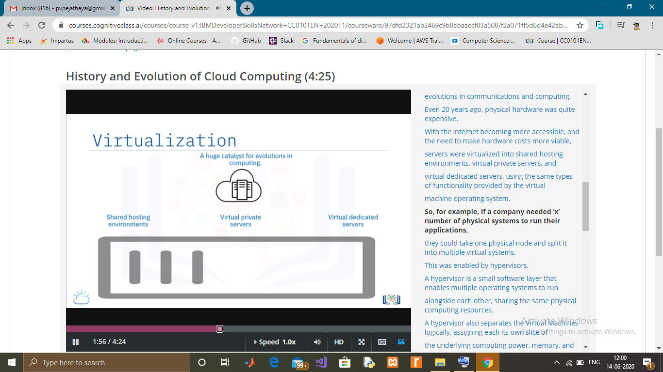

Coding Challenges Details: (Attach the snapshot and briefly write the report for the same)

In Python, we can implement a matrix as nested list (list inside a list).

We can treat each element as a row of the matrix.

For example X = [[1, 2], [4, 5], [3, 6]] would represent a 3x2 matrix.

The first row can be selected as X[0]. And, the element in first row, first column can be selected as X[0][0].

Multiplication of two matrices X and Y is defined only if the number of columns in X is equal to the number of rows Y.

If X is a n x m matrix and Y is a m x l matrix then, XY is defined and has the dimension n x l (but YX is not defined). Here are a couple of ways to implement matrix multiplication in Python.