**DAILY ONLINE ACTIVITIES SUMMARY**

|  |  |  |  |  |  |  |  |  |
| --- | --- | --- | --- | --- | --- | --- | --- | --- |
| **Date:** | **14-07-2020** | | | | | **Name:** | **P Vighnesh Pejathaya** | |
| **Sem & Sec** | **8 sem , A sec** | | | | | **USN:** | **4al16cs060** | |
| **Online Test Summary** | | | | | | | | |
| **Subject** | | **--** | | | | | | |
| **Max. Marks** | |  | | **Score** | | |  | |
| **Certification Course Summary** | | | | | | | | |
| **Course** | **RPA ,AI and Cognitive Learning** | | | | | | | |
| **Certificate Provider** | | | **Linkedin** | | **Duration** | | | **120 min** |
| **Coding Challenges** | | | | | | | | |
| **Problem Statement: Java program to print pattern.** | | | | | | | | |
| **Status: Completed** | | | | | | | | |
| **Uploaded the report in Github** | | | | | **yes** | | | |
| **If yes Repository name** | | | | | **Alvas-education-foundation/p_vighnesh** | | | |
| **Uploaded the report in slack** | | | | | **yes** | | | |

Online Test Details: (Attach the snapshot and briefly write the report for the same)

Not conducted

Certification Course Details: (Attach the snapshot and briefly write the report for the same)

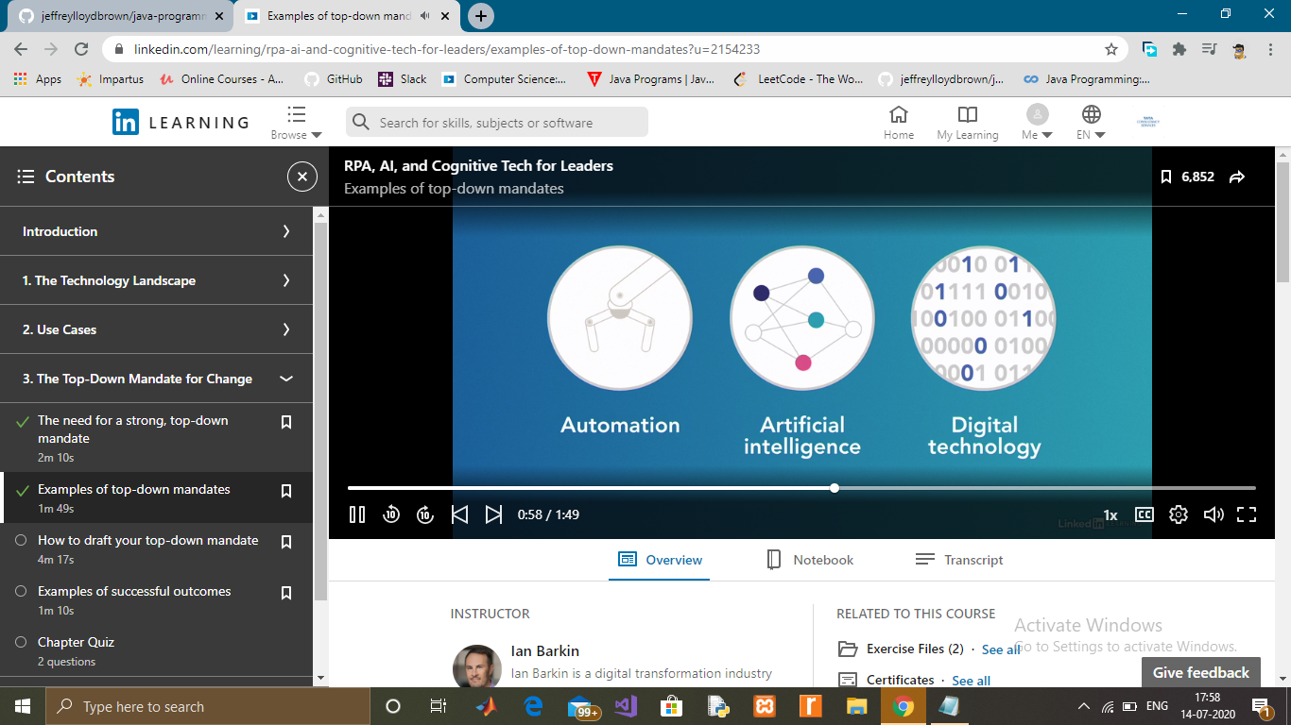

Coding Challenges Details: (Attach the snapshot and briefly write the report for the same)

Java program to print the following pattern on the console

1 2 3 4 5

1 2 3 4

1 2 3

1 2

1