**DAILY ONLINE ACTIVITIES SUMMARY**

|  |  |  |  |  |  |  |  |  |
| --- | --- | --- | --- | --- | --- | --- | --- | --- |
| **Date:** | **15-06-2020** | | | | | **Name:** | **P Vighnesh Pejathaya** | |
| **Sem & Sec** | **8 sem , A sec** | | | | | **USN:** | **4al16cs060** | |
| **Online Test Summary** | | | | | | | | |
| **Subject** | | **SMS** | | | | | | |
| **Max. Marks** | | **60** | | **Score** | | | **Not Available** | |
| **Certification Course Summary** | | | | | | | | |
| **Course** | **Cloud Computing** | | | | | | | |
| **Certificate Provider** | | | **Cognitive classes** | | **Duration** | | | **100 min** |
| **Coding Challenges** | | | | | | | | |
| **Problem Statement: Program to reverse the bits of number.** | | | | | | | | |
| **Status: Completed** | | | | | | | | |
| **Uploaded the report in Github** | | | | | **yes** | | | |
| **If yes Repository name** | | | | | **Alvas-education-foundation/p_vighnesh** | | | |
| **Uploaded the report in slack** | | | | | **yes** | | | |

Online Test Details: (Attach the snapshot and briefly write the report for the same)

No Resulst Announced.

Certification Course Details: (Attach the snapshot and briefly write the report for the same)

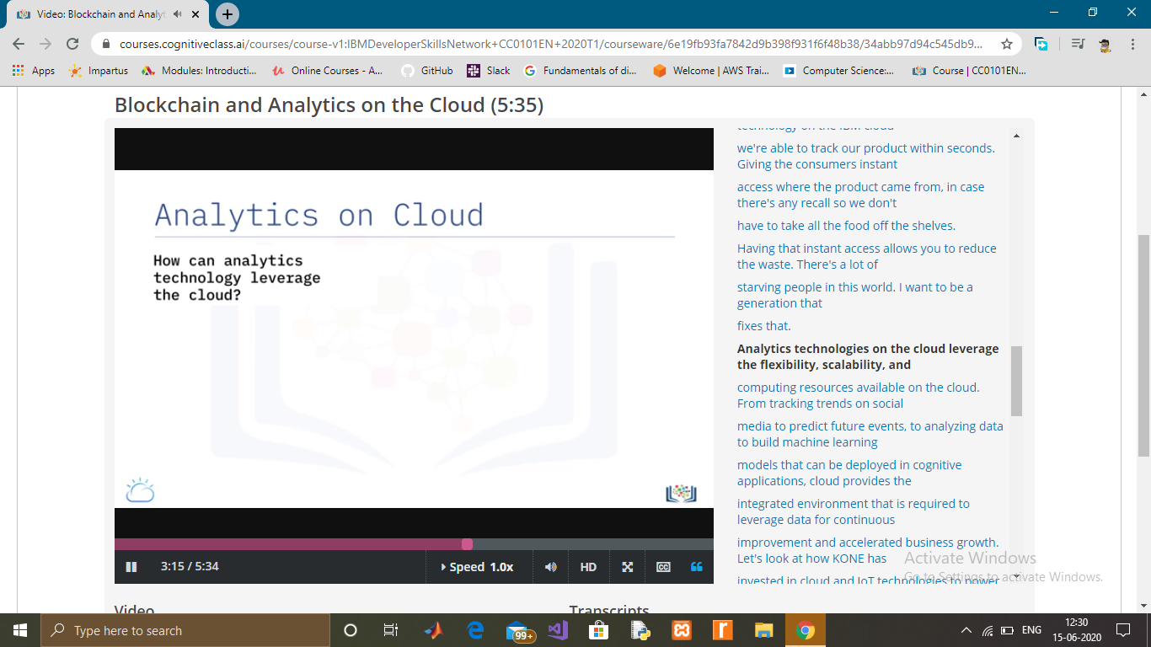

Coding Challenges Details: (Attach the snapshot and briefly write the report for the same)

Given an unsigned integer, reverse all bits of it and return the number with reversed bits.The idea is to keep putting set bits of the num in reverse_num until num becomes zero. After num becomes zero, shift the remaining bits of reverse_num.

Let num is stored using 8 bits and num be 00000110. After the loop you will get reverse_num as 00000011. Now you need to left shift reverse_num 5 more times and you get the exact reverse 01100000.

Input : n = 1

Output : 2147483648

On a machine with size of unsigned

bit as 32. Reverse of 0....001 is

100....0.

Input : n = 2147483648

Output : 1

Time Complexity: O(log n)

Space Complexity: O(1).