**DAILY ONLINE ACTIVITIES SUMMARY**

|  |  |  |  |  |  |  |  |  |
| --- | --- | --- | --- | --- | --- | --- | --- | --- |
| **Date:** | **17-06-2020** | | | | | **Name:** | **P Vighnesh Pejathaya** | |
| **Sem & Sec** | **8 sem , A sec** | | | | | **USN:** | **4al16cs060** | |
| **Online Test Summary** | | | | | | | | |
| **Subject** | | **NA** | | | | | | |
| **Max. Marks** | |  | | **Score** | | |  | |
| **Certification Course Summary** | | | | | | | | |
| **Course** | **Cloud Computing** | | | | | | | |
| **Certificate Provider** | | | **Cognitive classes(IBM)** | | **Duration** | | | **120 min** |
| **Coding Challenges** | | | | | | | | |
| **Problem Statement: Java program to concatenate two arrays.** | | | | | | | | |
| **Status: Completed** | | | | | | | | |
| **Uploaded the report in Github** | | | | | **yes** | | | |
| **If yes Repository name** | | | | | **Alvas-education-foundation/p_vighnesh** | | | |
| **Uploaded the report in slack** | | | | | **yes** | | | |

Online Test Details: (Attach the snapshot and briefly write the report for the same)

Not Conducted.

Certification Course Details: (Attach the snapshot and briefly write the report for the same)

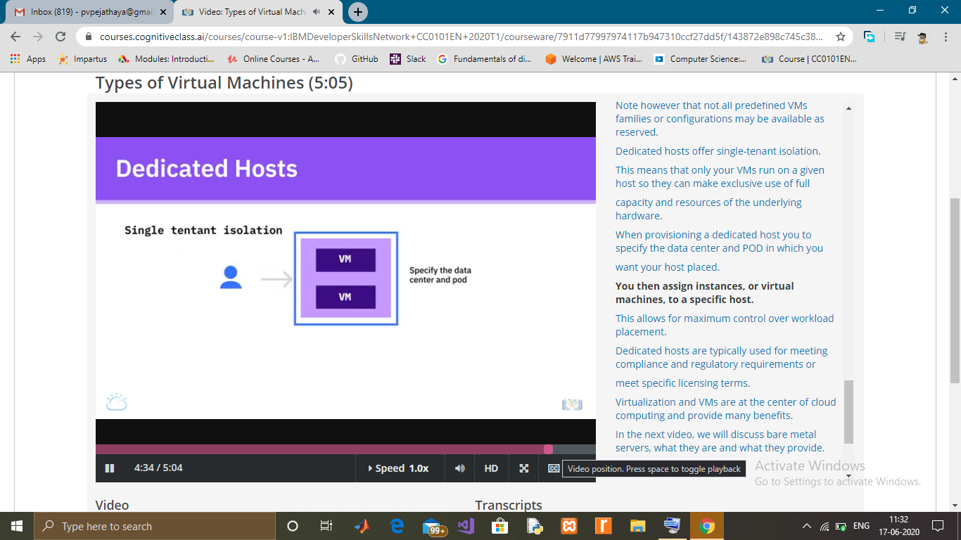

Coding Challenges Details: (Attach the snapshot and briefly write the report for the same)

In order to combine (concatenate) two arrays, we find its length stored in aLen and bLen respectively. Then, we create a new integer array result with length aLen + bLen.

Now, in order to combine to both, we copy each elements in both arrays to result by using arraycopy() function.

The arraycopy(array1, 0, result, 0, aLen) function, in simple terms, tells the program to copy array1 starting from index 0 to result from index 0 to aLen.

Likewise, for arraycopy(array2, 0, result, aLen, bLen) tells the program to copy array2 starting from index 0 to result from index aLen to bLen.