**DAILY ONLINE ACTIVITIES SUMMARY**

|  |  |  |  |  |  |  |  |  |
| --- | --- | --- | --- | --- | --- | --- | --- | --- |
| **Date:** | **18-06-2020** | | | | | **Name:** | **P Vighnesh Pejathaya** | |
| **Sem & Sec** | **8 sem , A sec** | | | | | **USN:** | **4al16cs060** | |
| **Online Test Summary** | | | | | | | | |
| **Subject** | | **SMS** | | | | | | |
| **Max. Marks** | | **60** | | **Score** | | | **Not announced.** | |
| **Certification Course Summary** | | | | | | | | |
| **Course** | **Cloud Computing** | | | | | | | |
| **Certificate Provider** | | | **Cognitive classes(IBM)** | | **Duration** | | | **120 min** |
| **Coding Challenges** | | | | | | | | |
| **Problem Statement: program to find n’th magic Number.** | | | | | | | | |
| **Status: Completed** | | | | | | | | |
| **Uploaded the report in Github** | | | | | **yes** | | | |
| **If yes Repository name** | | | | | **Alvas-education-foundation/p_vighnesh** | | | |
| **Uploaded the report in slack** | | | | | **yes** | | | |

Online Test Details: (Attach the snapshot and briefly write the report for the same)

Conducted but result not announced.

Certification Course Details: (Attach the snapshot and briefly write the report for the same)

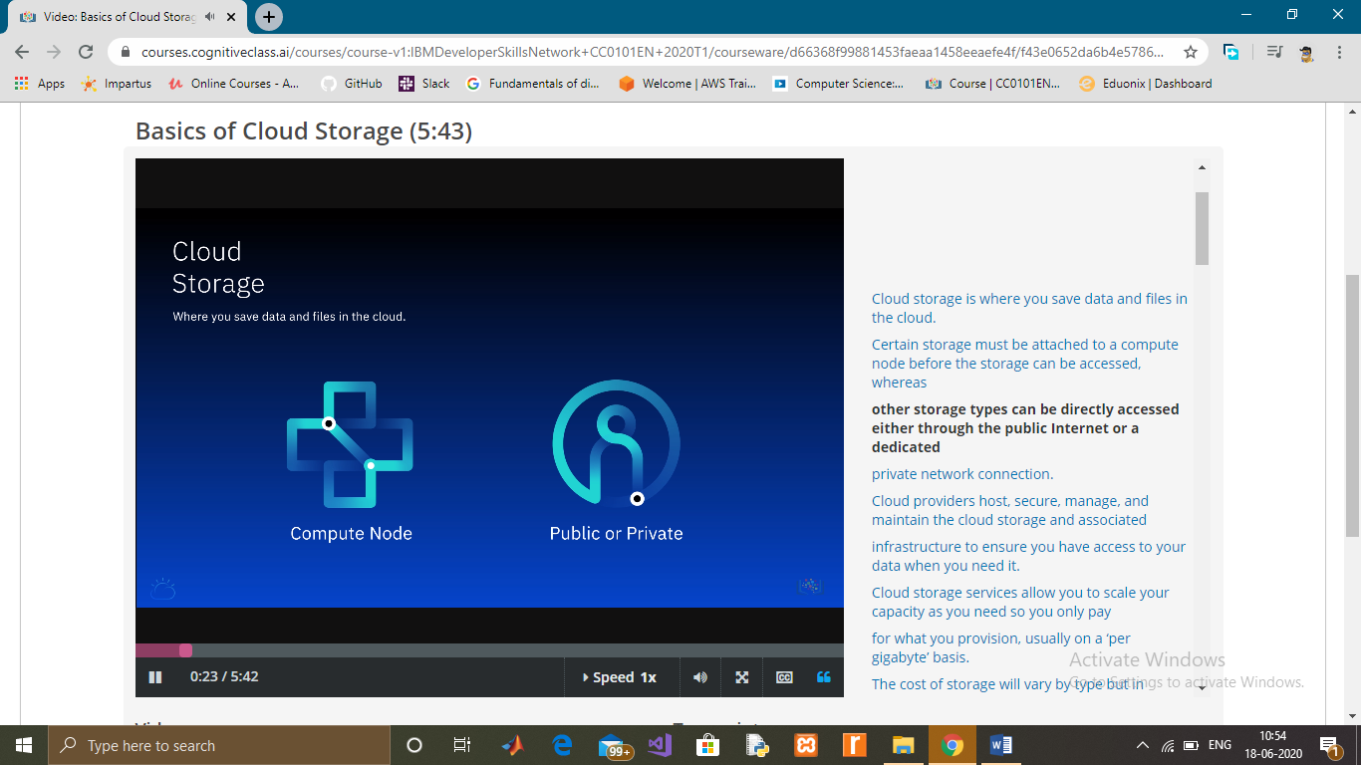

Coding Challenges Details: (Attach the snapshot and briefly write the report for the same)

A magic number is defined as a number which can be expressed as a power of 5 or sum of unique powers of 5. First few magic numbers are 5, 25, 30(5 + 25), 125, 130(125 + 5), ….

Write a function to find the nth Magic number.

Example:

Input: n = 2

Output: 25

Input: n = 5

Output: 130

If we notice carefully the magic numbers can be represented as 001, 010, 011, 100, 101, 110 etc, where 001 is 0*pow(5,3) + 0*pow(5,2) + 1*pow(5,1). So basically we need to add powers of 5 for each bit set in given integer n.