**DAILY ONLINE ACTIVITIES SUMMARY**

|  |  |  |  |  |  |  |  |  |
| --- | --- | --- | --- | --- | --- | --- | --- | --- |
| **Date:** | **18-07-2020** | | | | | **Name:** | **P Vighnesh Pejathaya** | |
| **Sem & Sec** | **8 sem , A sec** | | | | | **USN:** | **4al16cs060** | |
| **Online Test Summary** | | | | | | | | |
| **Subject** | | **--** | | | | | | |
| **Max. Marks** | |  | | **Score** | | |  | |
| **Certification Course Summary** | | | | | | | | |
| **Course** | **IOT introduction.** | | | | | | | |
| **Certificate Provider** | | | **AWS.** | | **Duration** | | | **120 min** |
| **Coding Challenges** | | | | | | | | |
| **Problem Statement: Java program to find number of words in text file.** | | | | | | | | |
| **Status: Completed** | | | | | | | | |
| **Uploaded the report in Github** | | | | | **yes** | | | |
| **If yes Repository name** | | | | | **Alvas-education-foundation/p_vighnesh** | | | |
| **Uploaded the report in slack** | | | | | **yes** | | | |

Online Test Details: (Attach the snapshot and briefly write the report for the same)

Not conducted

Certification Course Details: (Attach the snapshot and briefly write the report for the same)

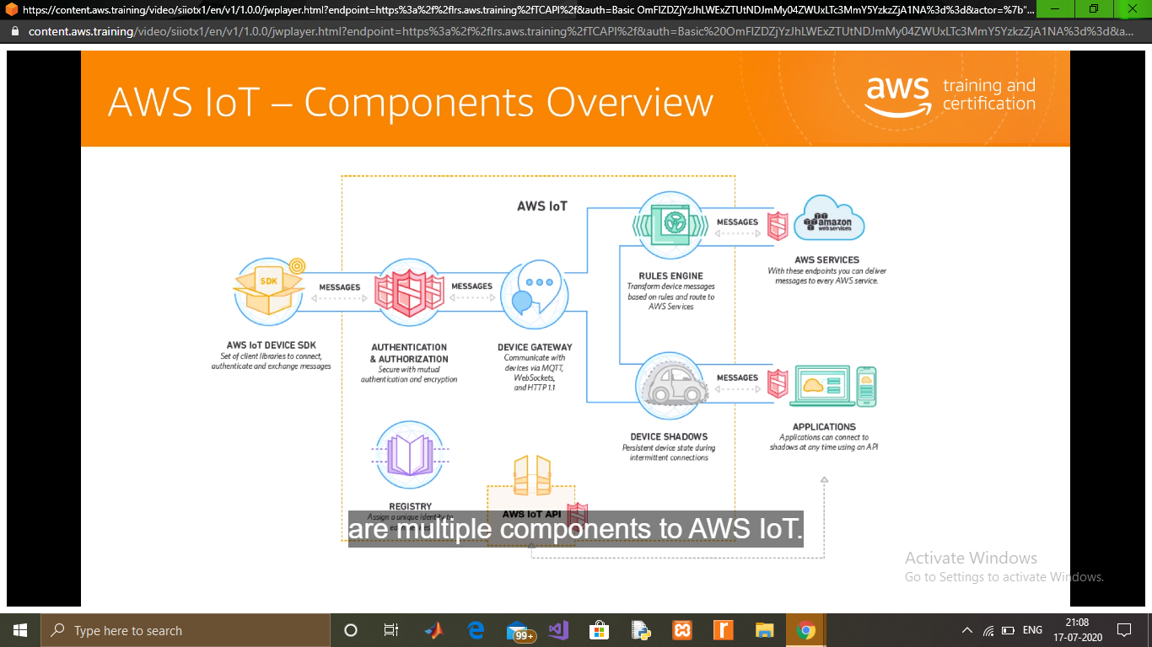

Coding Challenges Details: (Attach the snapshot and briefly write the report for the same)

## **Java Program to find the number of the words in the given text file**

In this program, we need to find the most repeated word present in given text file. This can be done by opening a file in read mode using file pointer. Read the file line by line. Split a line at a time and store in an array. Iterate through the array and count the word. The content of data.txt file used in the program is shown below.

[A computer program is a collection of instructions that performs specific task when executed by a computerComputer requires programs to function.Computer program is usually written by a computer programmer in programming language.A collection of computer programs, libraries, and related data are referred to as software.Computer programs may be categorized along functional lines, such as application software and system software.]--data.txt