**DAILY ONLINE ACTIVITIES SUMMARY**

|  |  |  |  |  |  |  |  |  |
| --- | --- | --- | --- | --- | --- | --- | --- | --- |
| **Date:** | **19-06-2020** | | | | | **Name:** | **P Vighnesh Pejathaya** | |
| **Sem & Sec** | **8 sem , A sec** | | | | | **USN:** | **4al16cs060** | |
| **Online Test Summary** | | | | | | | | |
| **Subject** | | **BDA** | | | | | | |
| **Max. Marks** | | **30** | | **Score** | | | **14** | |
| **Certification Course Summary** | | | | | | | | |
| **Course** | **Cloud Computing** | | | | | | | |
| **Certificate Provider** | | | **Cognitive classes(IBM)** | | **Duration** | | | **120 min** |
| **Coding Challenges** | | | | | | | | |
| **Problem Statement: R program to find factorial of a number.** | | | | | | | | |
| **Status: Completed** | | | | | | | | |
| **Uploaded the report in Github** | | | | | **yes** | | | |
| **If yes Repository name** | | | | | **Alvas-education-foundation/p_vighnesh** | | | |
| **Uploaded the report in slack** | | | | | **yes** | | | |

Online Test Details: (Attach the snapshot and briefly write the report for the same)

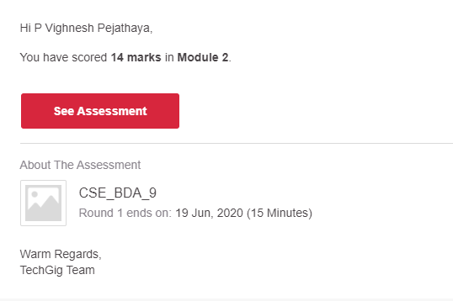

Certification Course Details: (Attach the snapshot and briefly write the report for the same)

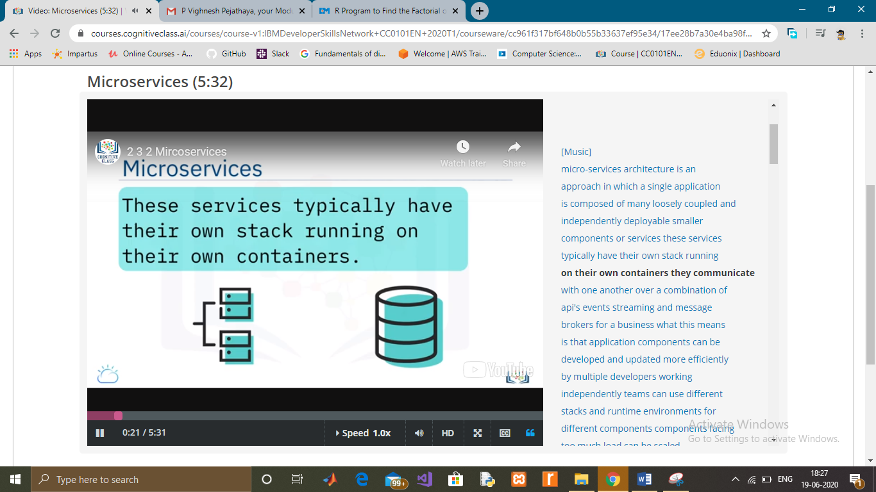

Coding Challenges Details: (Attach the snapshot and briefly write the report for the same)

The factorial of a number is the product of all the integers from 1 to that number. For example, the factorial of 6 (denoted as 6!) is 1*2*3*4*5*6 = 720.

Factorial is not defined for negative numbers and the factorial of zero is one, 0! = 1.

Here, we take input from the user and check if the number is negative, zero or positive using if...else statement.

If the number is positive, we use for loop to calculate the factorial.

We can also use the built-in function factorial() for this.