**DAILY ONLINE ACTIVITIES SUMMARY**

|  |  |  |  |  |  |  |  |  |
| --- | --- | --- | --- | --- | --- | --- | --- | --- |
| **Date:** | **20-06-2020** | | | | | **Name:** | **P Vighnesh Pejathaya** | |
| **Sem & Sec** | **8 sem , A sec** | | | | | **USN:** | **4al16cs060** | |
| **Online Test Summary** | | | | | | | | |
| **Subject** | | **NA** | | | | | | |
| **Max. Marks** | | **--** | | **Score** | | | **--** | |
| **Certification Course Summary** | | | | | | | | |
| **Course** | **Cloud Computing** | | | | | | | |
| **Certificate Provider** | | | **Cognitive classes(IBM)** | | **Duration** | | | **120 min** |
| **Coding Challenges** | | | | | | | | |
| **Problem Statement: C# program to illustrate File.Move().** | | | | | | | | |
| **Status: Completed** | | | | | | | | |
| **Uploaded the report in Github** | | | | | **yes** | | | |
| **If yes Repository name** | | | | | **Alvas-education-foundation/p_vighnesh** | | | |
| **Uploaded the report in slack** | | | | | **yes** | | | |

Online Test Details: (Attach the snapshot and briefly write the report for the same)

Not Conducted.

Certification Course Details: (Attach the snapshot and briefly write the report for the same)

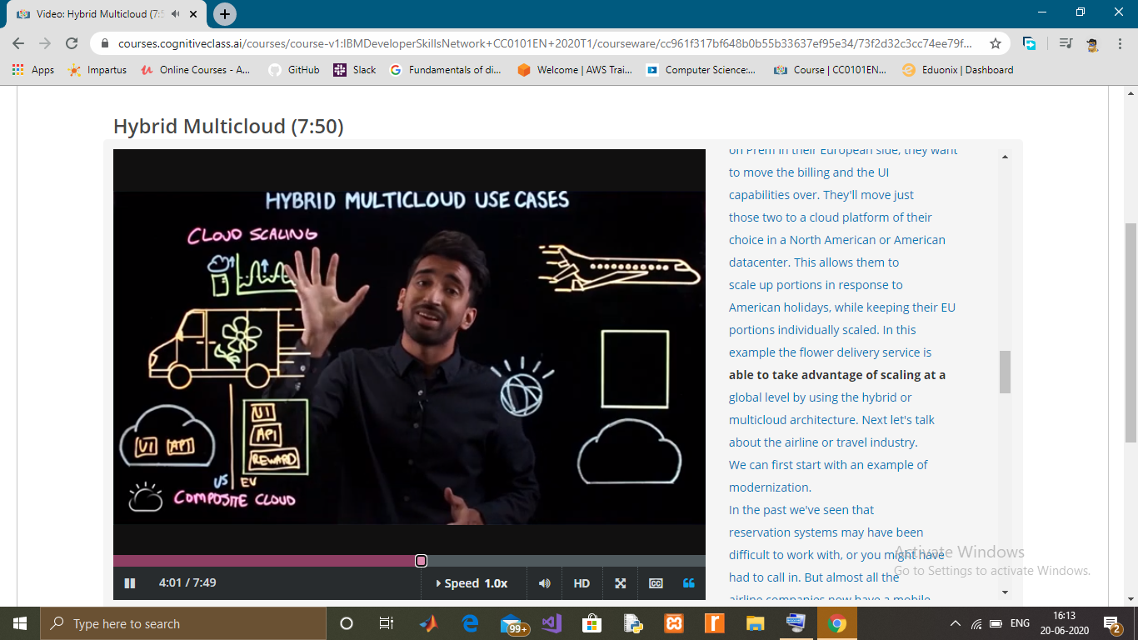

Coding Challenges Details: (Attach the snapshot and briefly write the report for the same)

File.Move() is an inbuilt File class method that is used to move a specified file to a new location. This method also provides the option to specify a new file name.

Syntax:

public static void Move (string sourceFileName, string destFileName);

Parameter: This function accepts two parameters which are illustrated below:

sourceFileName: This is the specified source file which are going to be moved. It can be absolute or relative path.

destFileName: This is the specified destination file where source file is going to be moved.