**DAILY ONLINE ACTIVITIES SUMMARY**

|  |  |  |  |  |  |  |  |  |
| --- | --- | --- | --- | --- | --- | --- | --- | --- |
| **Date:** | **22-06-2020** | | | | | **Name:** | **P Vighnesh Pejathaya** | |
| **Sem & Sec** | **8 sem , A sec** | | | | | **USN:** | **4al16cs060** | |
| **Online Test Summary** | | | | | | | | |
| **Subject** | | **SMS** | | | | | | |
| **Max. Marks** | | **60** | | **Score** | | | **Not Declared.** | |
| **Certification Course Summary** | | | | | | | | |
| **Course** | **Computer Networks.** | | | | | | | |
| **Certificate Provider** | | | **Study Section** | | **Duration** | | | **120 min** |
| **Coding Challenges** | | | | | | | | |
| **Problem Statement: R program to find given number is prime or not.** | | | | | | | | |
| **Status: Completed** | | | | | | | | |
| **Uploaded the report in Github** | | | | | **yes** | | | |
| **If yes Repository name** | | | | | **Alvas-education-foundation/p_vighnesh** | | | |
| **Uploaded the report in slack** | | | | | **yes** | | | |

Online Test Details: (Attach the snapshot and briefly write the report for the same)

Result not Announced.

Certification Course Details: (Attach the snapshot and briefly write the report for the same)

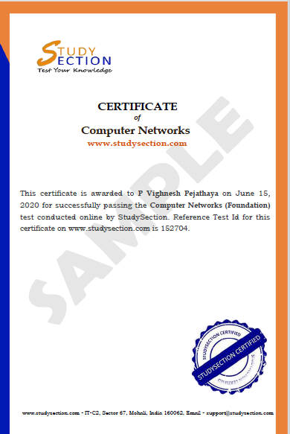

Coding Challenges Details: (Attach the snapshot and briefly write the report for the same)

In the above program, we created a class Complex with two member variables: real and imag. As name suggests, real stores real part of a complex number and imag stores the imaginary part.

The Complex class has a constructor with initializes the value of real and imag.We also created a new static function add() that takes two complex numbers as parameters and returns the result as a complex number.

Inside the add() method, we just add the real and imaginary parts of complex numbers n1 and n2, store it in a new variable temp and return temp.

Then, in the calling function main(), we print it using printf() function.