**DAILY ONLINE ACTIVITIES SUMMARY**

|  |  |  |  |  |  |  |  |  |
| --- | --- | --- | --- | --- | --- | --- | --- | --- |
| **Date:** | **24-06-2020** | | | | | **Name:** | **P Vighnesh Pejathaya** | |
| **Sem & Sec** | **8 sem , A sec** | | | | | **USN:** | **4al16cs060** | |
| **Online Test Summary** | | | | | | | | |
| **Subject** | | **NA** | | | | | | |
| **Max. Marks** | | **--** | | **Score** | | | **--** | |
| **Certification Course Summary** | | | | | | | | |
| **Course** | **Angular and NodeJS (Part-7)** | | | | | | | |
| **Certificate Provider** | | | **Udemy** | | **Duration** | | | **120 min** |
| **Coding Challenges** | | | | | | | | |
| **Problem Statement: Java program to convert string to int.** | | | | | | | | |
| **Status: Completed** | | | | | | | | |
| **Uploaded the report in Github** | | | | | **yes** | | | |
| **If yes Repository name** | | | | | **Alvas-education-foundation/p_vighnesh** | | | |
| **Uploaded the report in slack** | | | | | **yes** | | | |

Online Test Details: (Attach the snapshot and briefly write the report for the same)

Not Conducted.

Certification Course Details: (Attach the snapshot and briefly write the report for the same)

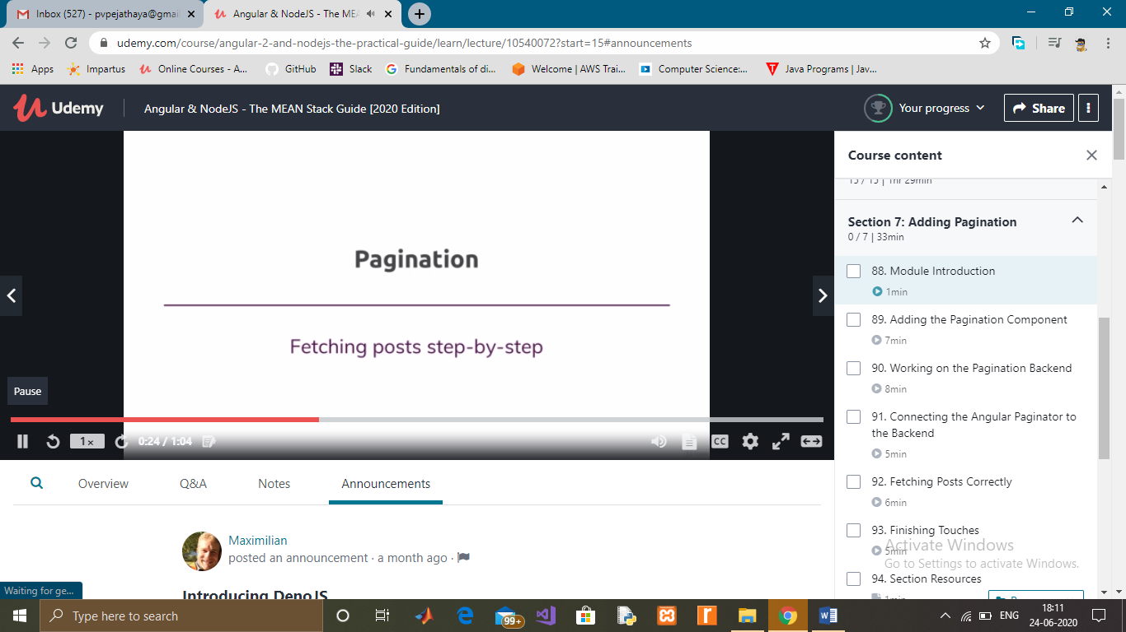

Coding Challenges Details: (Attach the snapshot and briefly write the report for the same)

We can convert String to an int in java using Integer.parseInt() method. To convert String into Integer, we can use Integer.valueOf() method which returns instance of Integer class.

It is generally used if we have to perform mathematical operations on the string which contains a number. Whenever we receive data from TextField or TextArea, entered data is received as a string. If entered data is in number format, we need to convert the string to an int. To do so, we use Integer.parseInt() method.Signature

The parseInt() is the static method of Integer class. The signature of parseInt() method is given below:

public static int parseInt(String s)

Java String to int Example: Integer.parseInt()