**DAILY ONLINE ACTIVITIES SUMMARY**

|  |  |  |  |  |  |  |  |  |
| --- | --- | --- | --- | --- | --- | --- | --- | --- |
| **Date:** | **25-06-2020** | | | | | **Name:** | **P Vighnesh Pejathaya** | |
| **Sem & Sec** | **8 sem , A sec** | | | | | **USN:** | **4al16cs060** | |
| **Online Test Summary** | | | | | | | | |
| **Subject** | | **SMS** | | | | | | |
| **Max. Marks** | | **30** | | **Score** | | | **Not Declared.** | |
| **Certification Course Summary** | | | | | | | | |
| **Course** | **Machine Learning** | | | | | | | |
| **Certificate Provider** | | | **LinkedIn** | | **Duration** | | | **120 min** |
| **Coding Challenges** | | | | | | | | |
| **Problem Statement: Java linear search program.** | | | | | | | | |
| **Status: Completed** | | | | | | | | |
| **Uploaded the report in Github** | | | | | **yes** | | | |
| **If yes Repository name** | | | | | **Alvas-education-foundation/p_vighnesh** | | | |
| **Uploaded the report in slack** | | | | | **yes** | | | |

Online Test Details: (Attach the snapshot and briefly write the report for the same)

Result not Announced.

Certification Course Details: (Attach the snapshot and briefly write the report for the same)

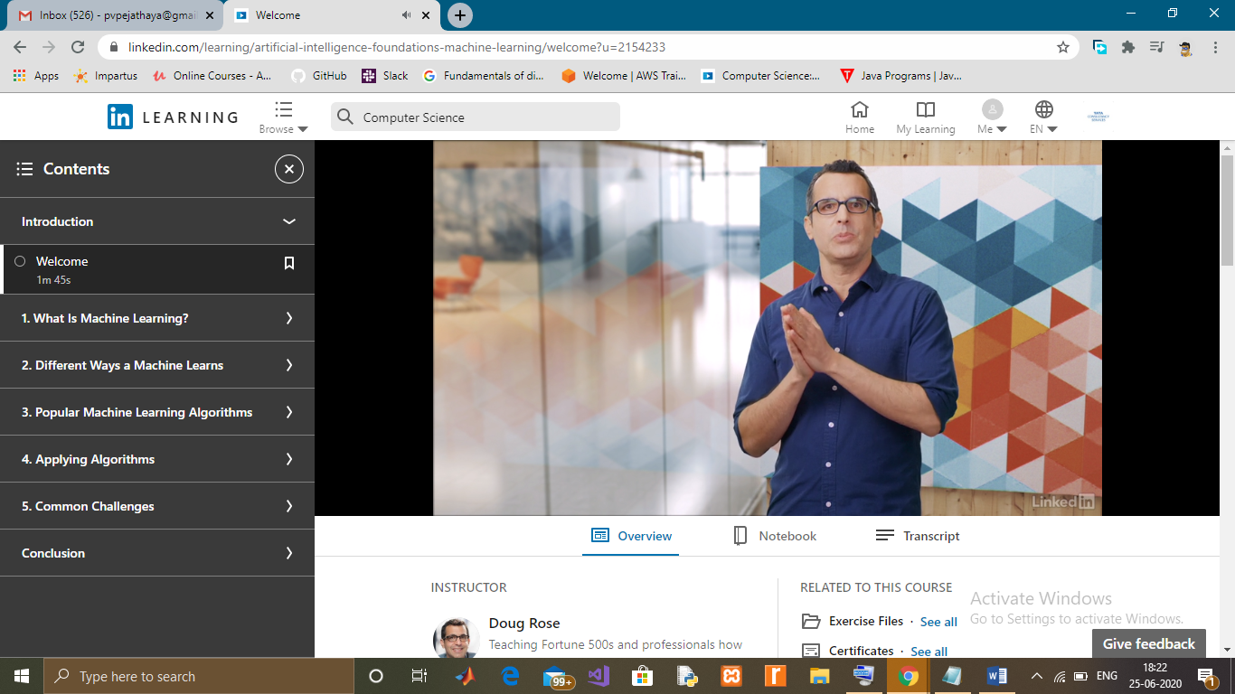

Coding Challenges Details: (Attach the snapshot and briefly write the report for the same)

Linear search is used to search a key element from multiple elements. Linear search is less used today because it is slower than binary search and hashing.

Algorithm:

Step 1: Traverse the array

Step 2: Match the key element with array element

Step 3: If key element is found, return the index position of the array element

Step 4: If key element is not found, return -1