**DAILY ONLINE ACTIVITIES SUMMARY**

|  |  |  |  |  |  |  |  |  |
| --- | --- | --- | --- | --- | --- | --- | --- | --- |
| **Date:** | **26-06-2020** | | | | | **Name:** | **P Vighnesh Pejathaya** | |
| **Sem & Sec** | **8 sem , A sec** | | | | | **USN:** | **4al16cs060** | |
| **Online Test Summary** | | | | | | | | |
| **Subject** | | **NA** | | | | | | |
| **Max. Marks** | | **--** | | **Score** | | | **--** | |
| **Certification Course Summary** | | | | | | | | |
| **Course** | **Machine Learning** | | | | | | | |
| **Certificate Provider** | | | **LinkedIn** | | **Duration** | | | **120 min** |
| **Coding Challenges** | | | | | | | | |
| **Problem Statement: Java binary search program.** | | | | | | | | |
| **Status: Completed** | | | | | | | | |
| **Uploaded the report in Github** | | | | | **yes** | | | |
| **If yes Repository name** | | | | | **Alvas-education-foundation/p_vighnesh** | | | |
| **Uploaded the report in slack** | | | | | **yes** | | | |

Online Test Details: (Attach the snapshot and briefly write the report for the same)

Not conducted

Certification Course Details: (Attach the snapshot and briefly write the report for the same)

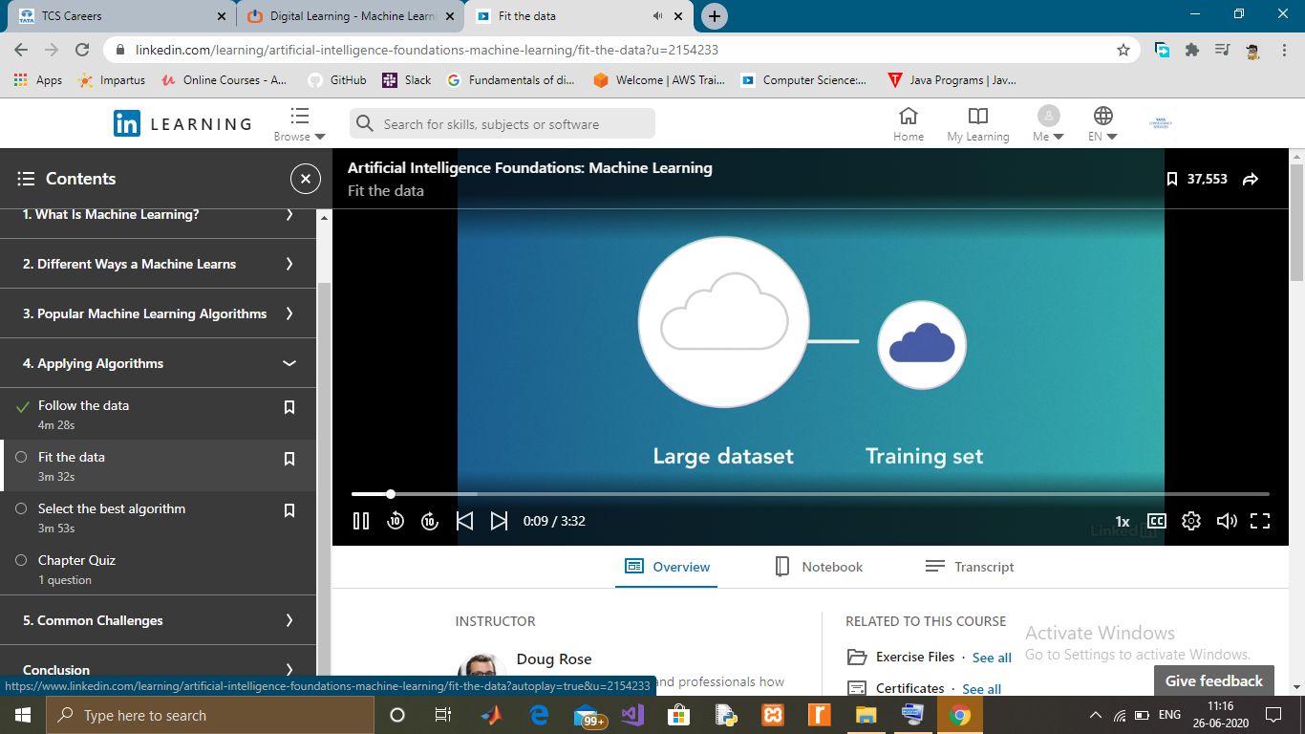

Coding Challenges Details: (Attach the snapshot and briefly write the report for the same)

Binary search is used to search a key element from multiple elements. Binary search is faster than linear search.

In case of binary search, array elements must be in ascending order. If you have unsorted array, you can sort the array using Arrays.sort(arr) method.