**DAILY ONLINE ACTIVITIES SUMMARY**

|  |  |  |  |  |  |  |  |  |
| --- | --- | --- | --- | --- | --- | --- | --- | --- |
| **Date:** | **27-06-2020** | | | | | **Name:** | **P Vighnesh Pejathaya** | |
| **Sem & Sec** | **8 sem , A sec** | | | | | **USN:** | **4al16cs060** | |
| **Online Test Summary** | | | | | | | | |
| **Subject** | | **NA** | | | | | | |
| **Max. Marks** | | **--** | | **Score** | | | **--** | |
| **Certification Course Summary** | | | | | | | | |
| **Course** | **Cloud Concepts** | | | | | | | |
| **Certificate Provider** | | | **Microsoft** | | **Duration** | | | **120 min** |
| **Coding Challenges** | | | | | | | | |
| **Problem Statement: Java Bubble Sort program.** | | | | | | | | |
| **Status: Completed** | | | | | | | | |
| **Uploaded the report in Github** | | | | | **yes** | | | |
| **If yes Repository name** | | | | | **Alvas-education-foundation/p_vighnesh** | | | |
| **Uploaded the report in slack** | | | | | **yes** | | | |

Online Test Details: (Attach the snapshot and briefly write the report for the same)

Not conducted

Certification Course Details: (Attach the snapshot and briefly write the report for the same)

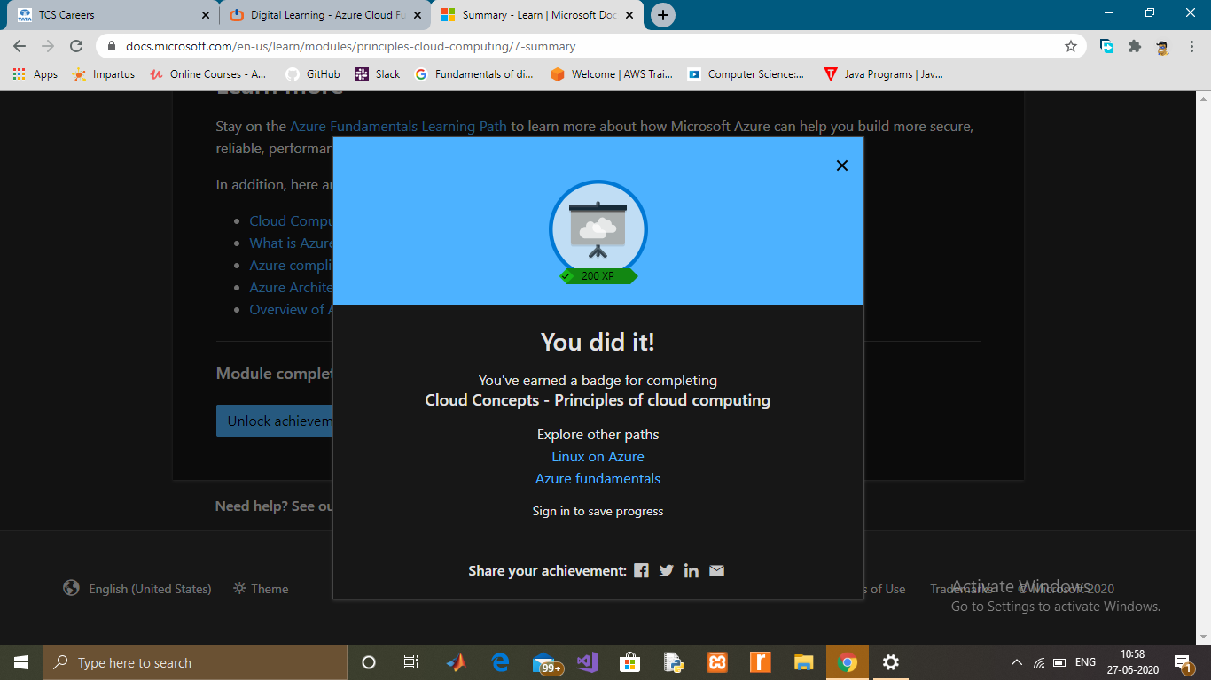

Coding Challenges Details: (Attach the snapshot and briefly write the report for the same)

Bubble Sort in Java

We can create a java program to sort array elements using bubble sort. Bubble sort algorithm is known as the simplest sorting algorithm.

In bubble sort algorithm, array is traversed from first element to last element. Here, current element is compared with the next element. If current element is greater than the next element, it is swapped.