**DAILY ONLINE ACTIVITIES SUMMARY**

|  |  |  |  |  |  |  |  |  |
| --- | --- | --- | --- | --- | --- | --- | --- | --- |
| **Date:** | **28-06-2020** | | | | | **Name:** | **P Vighnesh Pejathaya** | |
| **Sem & Sec** | **8 sem , A sec** | | | | | **USN:** | **4al16cs060** | |
| **Online Test Summary** | | | | | | | | |
| **Subject** | | **NA** | | | | | | |
| **Max. Marks** | | **--** | | **Score** | | | **--** | |
| **Certification Course Summary** | | | | | | | | |
| **Course** | **Applied ML** | | | | | | | |
| **Certificate Provider** | | | **Linkedin** | | **Duration** | | | **120 min** |
| **Coding Challenges** | | | | | | | | |
| **Problem Statement: Java Selection Sort program.** | | | | | | | | |
| **Status: Completed** | | | | | | | | |
| **Uploaded the report in Github** | | | | | **yes** | | | |
| **If yes Repository name** | | | | | **Alvas-education-foundation/p_vighnesh** | | | |
| **Uploaded the report in slack** | | | | | **yes** | | | |

Online Test Details: (Attach the snapshot and briefly write the report for the same)

Not conducted

Certification Course Details: (Attach the snapshot and briefly write the report for the same)

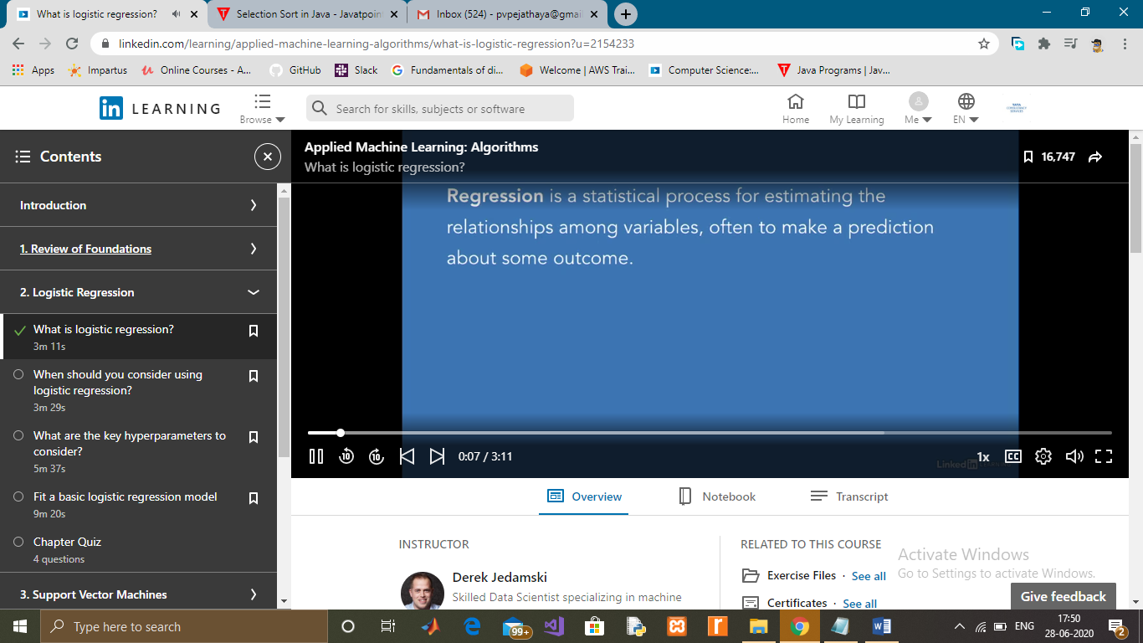

Coding Challenges Details: (Attach the snapshot and briefly write the report for the same)

The selection sort algorithm works in a very simple way. It maintains two subarray for the given array.

The subarray is already sorted.And the second subarray is unsorted.

With every iteration of selection sort, an element is picked from the unsorted subarray and moved to the sorted subarray.

arr[] = 25 35 45 12 65 10

// Find the minimum element in arr[0...5] and place it at beginning.

10 25 35 45 12 65

// Find the minimum element in arr[1...5] and place it at beginning of arr[1...5]

10 12 25 35 45 65

// Find the minimum element in arr[2...5] and place it at beginning of arr[2...5]

No, you can see that the array is already sorted.

10 12 25 35 45 65

Time Complexity

Best: ?(n^2) ,Average: ?(n^2),Worst: O(n^2)

Space Complexity

O(1)