**DAILY ONLINE ACTIVITIES SUMMARY**

|  |  |  |  |  |  |  |  |  |
| --- | --- | --- | --- | --- | --- | --- | --- | --- |
| **Date:** | **29-06-2020** | | | | | **Name:** | **P Vighnesh Pejathaya** | |
| **Sem & Sec** | **8 sem , A sec** | | | | | **USN:** | **4al16cs060** | |
| **Online Test Summary** | | | | | | | | |
| **Subject** | | **SMS** | | | | | | |
| **Max. Marks** | | **30** | | **Score** | | | **Not announced** | |
| **Certification Course Summary** | | | | | | | | |
| **Course** | **Cloud Computing** | | | | | | | |
| **Certificate Provider** | | | **Microsoft** | | **Duration** | | | **120 min** |
| **Coding Challenges** | | | | | | | | |
| **Problem Statement: Java insertion Sort program.** | | | | | | | | |
| **Status: Completed** | | | | | | | | |
| **Uploaded the report in Github** | | | | | **yes** | | | |
| **If yes Repository name** | | | | | **Alvas-education-foundation/p_vighnesh** | | | |
| **Uploaded the report in slack** | | | | | **yes** | | | |

Online Test Details: (Attach the snapshot and briefly write the report for the same)

Results not declared.

Certification Course Details: (Attach the snapshot and briefly write the report for the same)

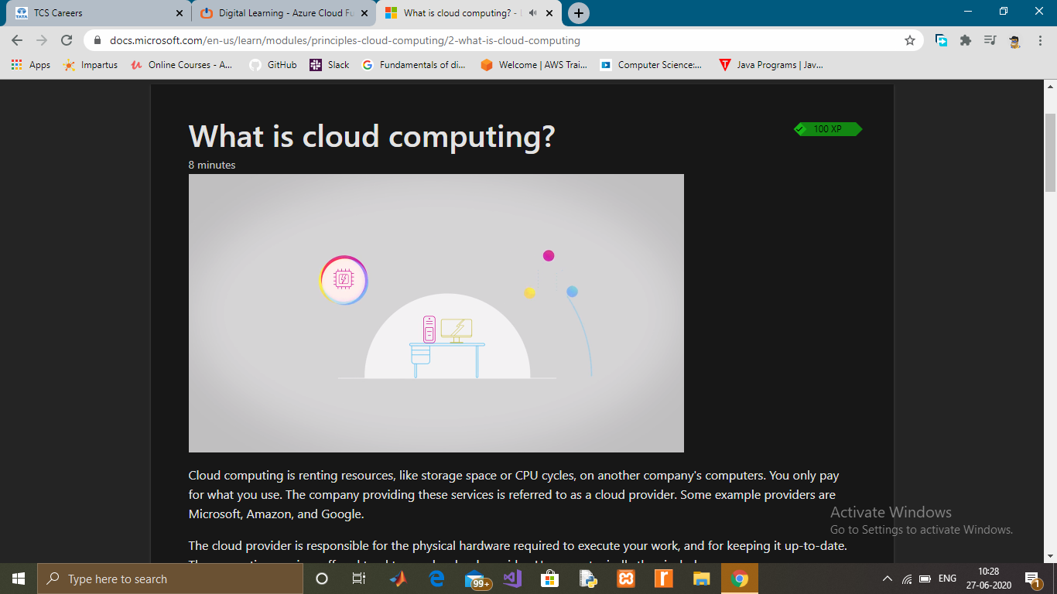

Coding Challenges Details: (Attach the snapshot and briefly write the report for the same)

# Insertion Sort in Java

We can create a java program to sort array elements using insertion sort. Insertion is good for small elements only because it requires more time for sorting large number of elements.

