DAILY ONLINE ACTIVITIES SUMMARY

|  |  |  |  |  |  |  |  |
| --- | --- | --- | --- | --- | --- | --- | --- |
| **Date:** | **18-5-2020** | | | | **Name:** | **Prajna** | |
| **Sem & Sec** | **8th sem ‘B’** | | | | **USN:** | **4AL16CS067** | |
| Online Test Summary | | | | | | | |
| **Subject** | | **SMS** | | | | | |
| **Max. Marks** | | **60** | | **Score** | | **44** | |
| Certification Course Summary | | | | | | | |
| **Course** | **Getting started: Hadoop** | | | | | | |
| **Certificate Provider** | | | **Great Learning** | **Duration** | | | **23min** |
| Coding Challenges | | | | | | | |
| **Problem Statement:1.**Write a program to print frequency of each character in string “Hello friend” using charAt( ) and length  2.Write a java program to print even and odd numbers series using threads**.** | | | | | | | |
| **Status: Completed** | | | | | | | |
| **Uploaded the report in GitHub GitHub link:** | | | | **Yes https://github.com/4al16cs067/onlineactivitesreport** | | | |
| **If yes Repository name** | | | | **onlineactivitiesreport** | | | |
| **Uploaded the report in slack** | | | | **yes** | | | |

Online Test Details: (Attach the snapshot and briefly write the report for the same)

Certification Course Details: (Attach the snapshot and briefly write the report for the same)

Coding Challenges Details: (Attach the snapshot and briefly write the report for the same)

1. 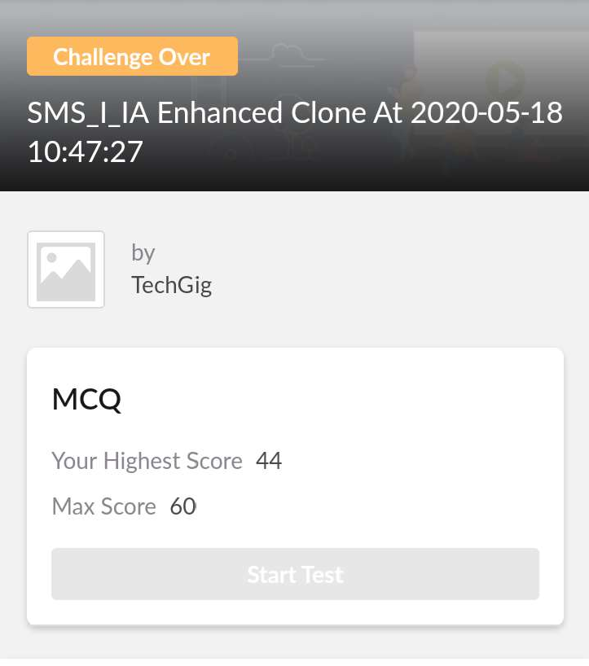online test
2. certification course



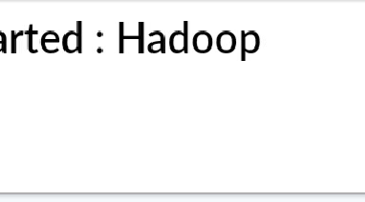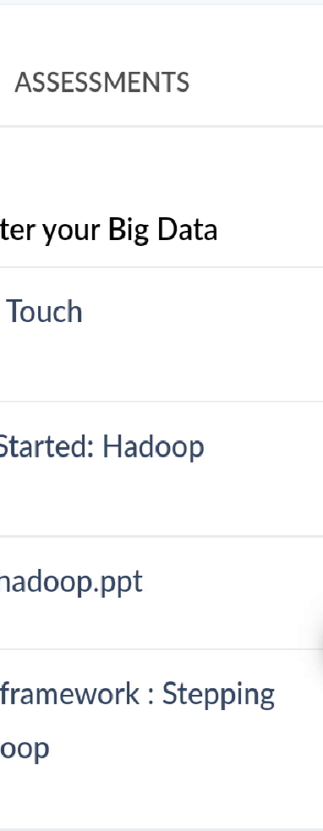

1. coding challenges

# Program1

import java.util.Scanner; public class Main

{

public static void main(String[] args) { int i;

String str;

int count[] = new int[256];

Scanner s = new Scanner(System.in); System.out.print("Enter a String : "); str=s.nextLine();

for (i = 0; i < str.length(); i++) {

count[(int) str.charAt(i)]++;

}

for (i = 0; i < 256; i++) { if (count[i] != 0) {

System.out.println( (char) i + " : " + count[i]);

}

}

}

}

# Program 2

public class PingPong extends Thread {

static StringBuilder object = new StringBuilder("");

public static void main(String[] args) throws InterruptedException {

Thread t1 = new PingPong(); Thread t2 = new PingPong();

t1.setName("ping"); t2.setName(“pong");

t1.start();

t2.start(); }

public void run() {  
working();  
}

void working() {  
while (true) {  
synchronized (object) {  
try {  
System.out.print(Thread.currentThread().getName());  
object.notify();  
object.wait();  
} catch (InterruptedException e) {  
e.printStackTrace();  
}  
}  
}  
}  
}