**DAILY ONLINE ACTIVITIES SUMMARY**

|  |  |  |  |  |  |  |  |  |
| --- | --- | --- | --- | --- | --- | --- | --- | --- |
| **Date:** | **01-06-2020** | | | | | **Name:** | **Prashanth S** | |
| **Sem & Sec** | **8th sem B sec** | | | | | **USN:** | **4AL16CS069** | |
| **Online Test Summary** | | | | | | | | |
| **Subject** | | **SMS** | | | | | | |
| **Max. Marks** | | **60** | | **Score** | | | **60** | |
| **Certification Course Summary** | | | | | | | | |
| **Course** | **Introduction to Ethical hacking** | | | | | | | |
| **Certificate Provider** | | | **Great learning website** | | **Duration** | | | **6hr** |
| **Coding Challenges** | | | | | | | | |
| **Problem Statement:** **Strong number in python** | | | | | | | | |
| **Status: completed** | | | | | | | | |
| **Uploaded the report in Github** | | | | | **yes** | | | |
| **If yes Repository name** | | | | | **prashanth** | | | |
| **Uploaded the report in slack** | | | | | **yes** | | | |

Online Test Details: (Attach the snapshot and briefly write the report for the same)

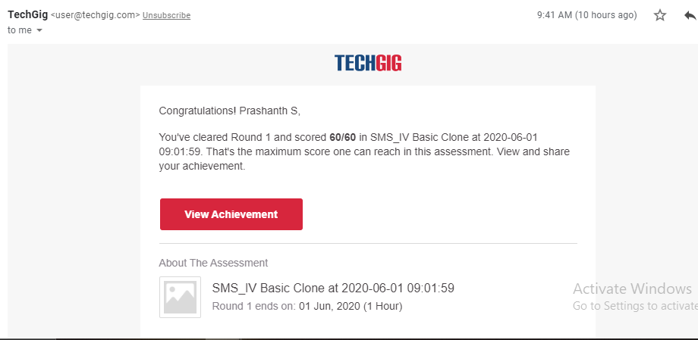

Certification Course Details: (Attach the snapshot and briefly write the report for the same)

Completed

Coding Challenges Details: (Attach the snapshot and briefly write the report for the same)

Coding was given n it was uploaded for github and slack

PROGRAM1

Number = int(input(" Please Enter any Number: "))

Sum = 0

Temp = Number

while(Temp > 0):

Factorial = 1

i = 1

Reminder = Temp % 10

while(i <= Reminder):

Factorial = Factorial * i

i = i + 1

print("\n Factorial of %d = %d" %(Reminder, Factorial))

Sum = Sum + Factorial

Temp = Temp // 10

print("\n Sum of Factorials of a Given Number %d = %d" %(Number, Sum))

if (Sum == Number):

print(" %d is a Strong Number" %Number)

else:

print(" %d is not a Strong Number" %Number)