**DAILY ONLINE ACTIVITIES SUMMARY**

|  |  |  |  |  |  |  |  |  |
| --- | --- | --- | --- | --- | --- | --- | --- | --- |
| **Date:** | **02-06-2020** | | | | | **Name:** | **Prashanth S** | |
| **Sem & Sec** | **8th sem B sec** | | | | | **USN:** | **4AL16CS069** | |
| **Online Test Summary** | | | | | | | | |
| **Subject** | |  | | | | | | |
| **Max. Marks** | |  | | **Score** | | |  | |
| **Certification Course Summary** | | | | | | | | |
| **Course** | **Robotic process automation** | | | | | | | |
| **Certificate Provider** | | | **GUVI** | | **Duration** | | | **3hr** |
| **Coding Challenges** | | | | | | | | |
| **Problem Statement:** **Reverse a list in python** | | | | | | | | |
| **Status: completed** | | | | | | | | |
| **Uploaded the report in Github** | | | | | **yes** | | | |
| **If yes Repository name** | | | | | **prashanth** | | | |
| **Uploaded the report in slack** | | | | | **yes** | | | |

Online Test Details: (Attach the snapshot and briefly write the report for the same)

Certification Course Details: (Attach the snapshot and briefly write the report for the same)

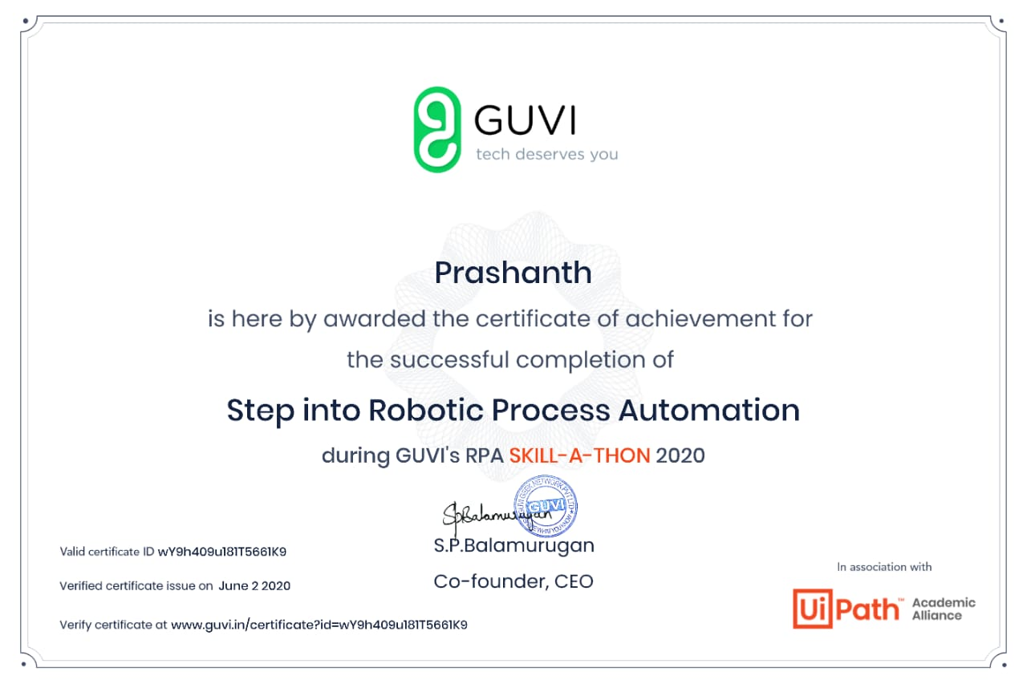

Coding Challenges Details: (Attach the snapshot and briefly write the report for the same)

Coding was given n it was uploaded for github and slack

PROGRAM1

n = int(input("Enter the size of list : "))

numList = list(int(num) for num in input("Enter the list numbers separated by space: ").strip().split())[:n]

numList.reverse();

print "List : ", numList