**DAILY ONLINE ACTIVITIES SUMMARY**

|  |  |  |  |  |  |  |  |  |
| --- | --- | --- | --- | --- | --- | --- | --- | --- |
| **Date:** | **04-06-2020** | | | | | **Name:** | **Prashanth S** | |
| **Sem & Sec** | **8th sem B sec** | | | | | **USN:** | **4AL16CS069** | |
| **Online Test Summary** | | | | | | | | |
| **Subject** | | **SMS** | | | | | | |
| **Max. Marks** | | **60** | | **Score** | | | **60** | |
| **Certification Course Summary** | | | | | | | | |
| **Course** | **Robotic process automation** | | | | | | | |
| **Certificate Provider** | | | **GUVI** | | **Duration** | | | **3hr** |
| **Coding Challenges** | | | | | | | | |
| **Problem Statement:** **lcm in python** | | | | | | | | |
| **Status: completed** | | | | | | | | |
| **Uploaded the report in Github** | | | | | **yes** | | | |
| **If yes Repository name** | | | | | **prashanth** | | | |
| **Uploaded the report in slack** | | | | | **yes** | | | |

Online Test Details: (Attach the snapshot and briefly write the report for the same)

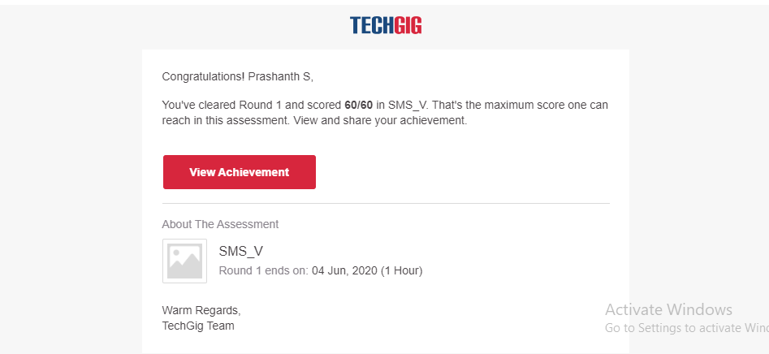

Certification Course Details: (Attach the snapshot and briefly write the report for the same)

COMPLETED

Coding Challenges Details: (Attach the snapshot and briefly write the report for the same)

Coding was given n it was uploaded for github and slack

PROGRAM1

def compute_lcm(x, y):

if x > y:

greater = x

else:

greater = y

while(True):

if((greater % x == 0) and (greater % y == 0)):

lcm = greater

break

greater += 1

return lcm

num1 = int(input("Enter number1"))

num2 = int(input("Enter number2"))

print("The L.C.M. is", compute_lcm(num1, num2))