**DAILY ONLINE ACTIVITIES SUMMARY**

|  |  |  |  |  |  |  |  |  |
| --- | --- | --- | --- | --- | --- | --- | --- | --- |
| **Date:** | **09-06-2020** | | | | | **Name:** | **Prashanth S** | |
| **Sem & Sec** | **8th sem B sec** | | | | | **USN:** | **4AL16CS069** | |
| **Online Test Summary** | | | | | | | | |
| **Subject** | | **BDA** | | | | | | |
| **Max. Marks** | | **30** | | **Score** | | | **23** | |
| **Certification Course Summary** | | | | | | | | |
| **Course** | **Robotic process automation** | | | | | | | |
| **Certificate Provider** | | | **GUVI** | | **Duration** | | | **3hr** |
| **Coding Challenges** | | | | | | | | |
| **Problem Statement:** **bubble sort in python** | | | | | | | | |
| **Status: completed** | | | | | | | | |
| **Uploaded the report in Github** | | | | | **yes** | | | |
| **If yes Repository name** | | | | | **prashanth** | | | |
| **Uploaded the report in slack** | | | | | **yes** | | | |

Online Test Details: (Attach the snapshot and briefly write the report for the same)

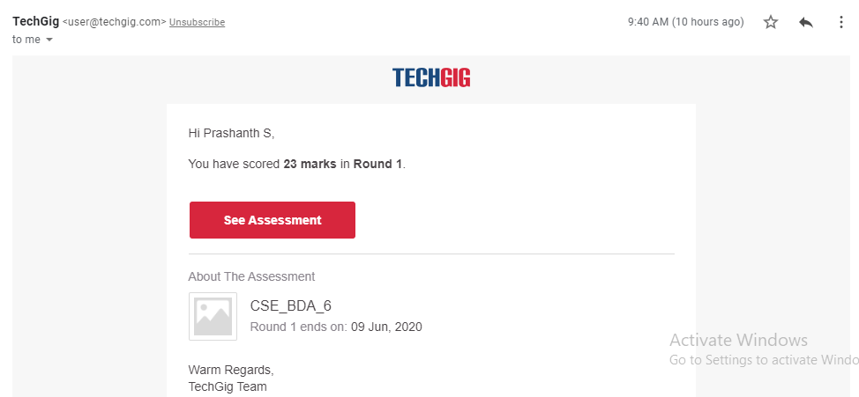

Certification Course Details: (Attach the snapshot and briefly write the report for the same)

COMPLETED

Coding Challenges Details: (Attach the snapshot and briefly write the report for the same)

Coding was given n it was uploaded for github and slack

PROGRAM1

def bubbleSort(arr):

n = len(arr)

for i in range(n-1):

for j in range(0, n-i-1):

if arr[j] > arr[j+1] :

arr[j], arr[j+1] = arr[j+1], arr[j]

arr = [64, 34, 25, 12, 22, 11, 90]

bubbleSort(arr)

print ("Sorted array is:")

for i in range(len(arr)):

print ("%d" %arr[i]),