**DAILY ONLINE ACTIVITIES SUMMARY**

|  |  |  |  |  |  |  |  |  |
| --- | --- | --- | --- | --- | --- | --- | --- | --- |
| **Date:** | **11-06-2020** | | | | | **Name:** | **Prashanth S** | |
| **Sem & Sec** | **8th sem B sec** | | | | | **USN:** | **4AL16CS069** | |
| **Online Test Summary** | | | | | | | | |
| **Subject** | | **SMS** | | | | | | |
| **Max. Marks** | | **60** | | **Score** | | | **60** | |
| **Certification Course Summary** | | | | | | | | |
| **Course** | **Robotic process automation** | | | | | | | |
| **Certificate Provider** | | | **GUVI** | | **Duration** | | | **3hr** |
| **Coding Challenges** | | | | | | | | |
| **Problem Statement:** **Merge sort in python** | | | | | | | | |
| **Status: completed** | | | | | | | | |
| **Uploaded the report in Github** | | | | | **yes** | | | |
| **If yes Repository name** | | | | | **prashanth** | | | |
| **Uploaded the report in slack** | | | | | **yes** | | | |

Online Test Details: (Attach the snapshot and briefly write the report for the same)

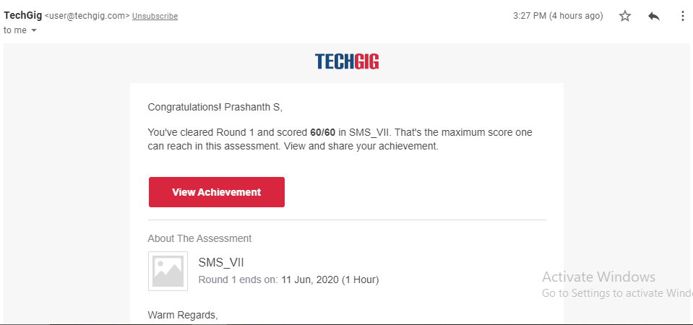

Certification Course Details: (Attach the snapshot and briefly write the report for the same)

COMPLETED

Coding Challenges Details: (Attach the snapshot and briefly write the report for the same)

Coding was given n it was uploaded for github and slack

PROGRAM1

def mergeSort(myList):

if len(myList) > 1:

mid = len(myList)

left = myList[:mid]

right = myList[mid:]

mergeSort(left)

mergeSort(right)

i = 0

j = 0

k = 0

while i < len(left) and j < len(right):

if left[i] < right[j]:

myList[k] = left[i]

i += 1

else:

myList[k] = right[j]

j += 1

k += 1

while i < len(left):

myList[k] = left[i]

i += 1

k += 1

while j < len(right):

myList[k]=right[j]

j += 1

k += 1

myList = [int(item) for item in input("Enter the array of number to sort: ").split()

mergeSort(myList)

print(myList)