**DAILY ONLINE ACTIVITIES SUMMARY**

|  |  |  |  |  |  |  |  |  |
| --- | --- | --- | --- | --- | --- | --- | --- | --- |
| **Date:** | **18-05-2020** | | | | | **Name:** | **Prashanth S** | |
| **Sem & Sec** | **8th sem B sec** | | | | | **USN:** | **4AL16CS069** | |
| **Online Test Summary** | | | | | | | | |
| **Subject** | | **SMS** | | | | | | |
| **Max. Marks** | | **60** | | **Score** | | | **33** | |
| **Certification Course Summary**  Problem statment :1) finding frequency of each character in a string and to print even and odd  for series. 2) java program | | | | | | | | |
| **Course** |  | | | | | | | |
| **Certificate Provider** | | | **Great learning website** | | **Duration** | | | **10-12.30** |
| **Coding Challenges** | | | | | | | | |
| **Problem Statement: Introduction to ethical hacking** | | | | | | | | |
| **Status: completed** | | | | | | | | |
| **Uploaded the report in Github** | | | | | **yes** | | | |
| **If yes Repository name** | | | | | **Cse final year 2019-20** | | | |
| **Uploaded the report in slack** | | | | | **yes** | | | |

Online Test Details: (Attach the snapshot and briefly write the report for the same)

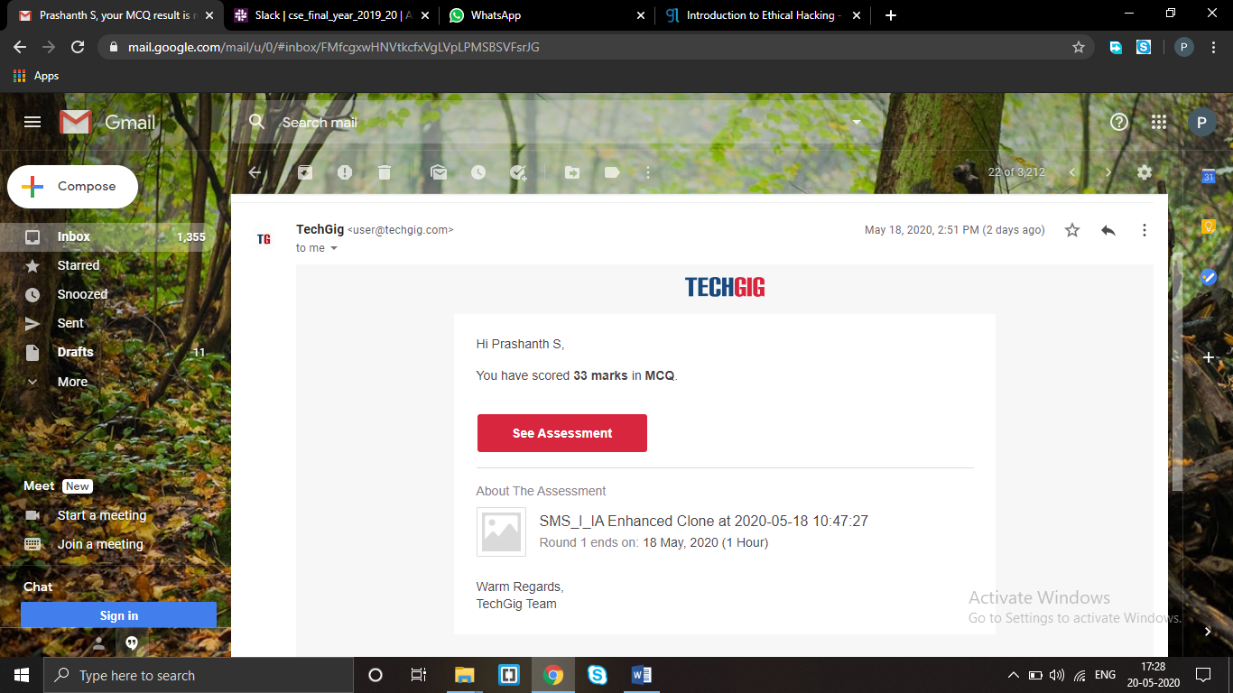

Certification Course Details: (Attach the snapshot and briefly write the report for the same

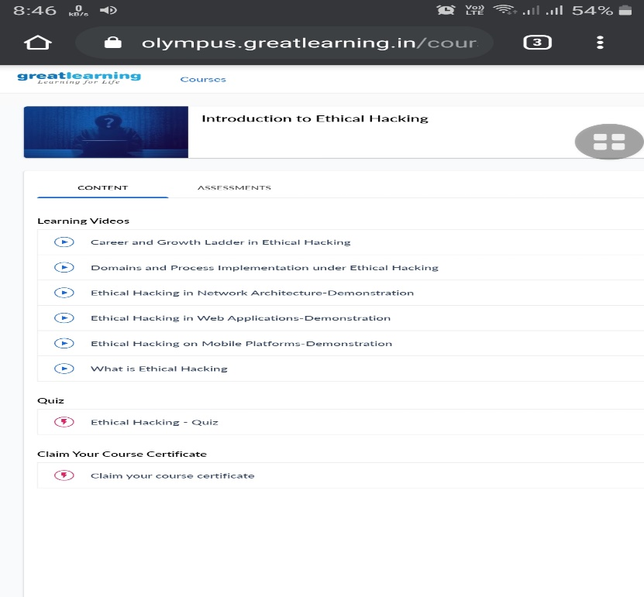

Coding Challenges Details: (Attach the snapshot and briefly write the report for the same)

Coding was given n it was uploaded for github and slack

PROGRAM1

package pk;

import java.util.Scanner;

public c

lass StringOperators {

public static void main(String args[]) {

int i; String str;

int counter[] = new int[256];

Scanner in = new Scanner(System.in);

System.out.print("Enter a String : ");

str=in.nextLine();

for (i = 0; i < str.length(); i++)

{

counter[(int) str.charAt(i)]++;

}

// Print Frequency of characters

for (i = 0; i < 256; i++)

{

if (counter[i] != 0)

{

System.out.println((char) i + ":-

" + counter[i] + " times");

}

}

}

}

**Program no:2**

public class PingPong extends Thread {

static StringBuilder objec

t = new StringBuilder("");

public static void main(String[] args) throws InterruptedException {

Thread t1 = new PingPong();

Thread t2 = new PingPong();

t1.setName("

\nping"); t2.setName(" pong");

t1.start(); t2.start();

}

@override

public void run()

{

worki

ng();

}

void working()

{

while (true)

{

synchronized (object)

{

try {

System.out.print(Thread.currentThread().getName());

object.notify();

object.wait();

}

catch (InterruptedException e) {

e.printStackTrace();

}

}

}

}

}