**DAILY ONLINE ACTIVITIES SUMMARY**

|  |  |  |  |  |  |  |  |  |
| --- | --- | --- | --- | --- | --- | --- | --- | --- |
| **Date:** | **20-05-2020** | | | | | **Name:** | **Prashanth S** | |
| **Sem & Sec** | **8th sem B sec** | | | | | **USN:** | **4AL16CS069** | |
| **Online Test Summary** | | | | | | | | |
| **Subject** | | **IOT** | | | | | | |
| **Max. Marks** | | **30** | | **Score** | | | **26** | |
| **Certification Course Summary**  Generate Armstrong number | | | | | | | | |
| **Course** | **Introduction to Ethical hacking** | | | | | | | |
| **Certificate Provider** | | | **Great learning website** | | **Duration** | | | **6hr** |
| **Coding Challenges** | | | | | | | | |
| **Problem Statement: java coding problem** | | | | | | | | |
| **Status: completed** | | | | | | | | |
| **Uploaded the report in Github** | | | | | **yes** | | | |
| **If yes Repository name** | | | | | **Cse final year 2019-20** | | | |
| **Uploaded the report in slack** | | | | | **yes** | | | |

Online Test Details: (Attach the snapshot and briefly write the report for the same)

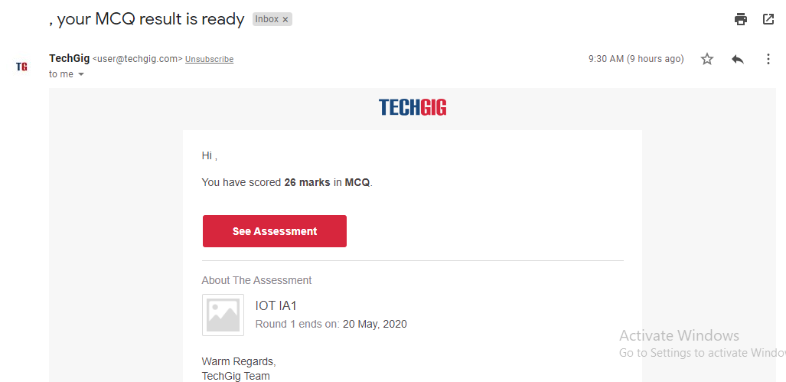

Certification Course Details: (Attach the snapshot and briefly write the report for the same)

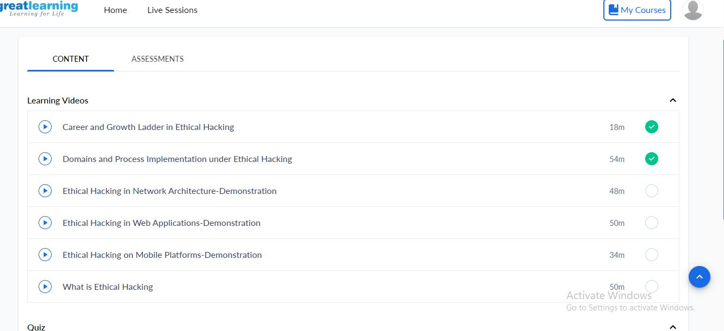

Direct communication cannot be achieved across application domains. However, application domains can still talk to each other by passing objects via marshalling by value (unbound objects), marshalling by reference through a proxy (application-domain-bound objects). There is a third type of object called a context-bound object which can be marshalled by reference across domains and also within the context of its own application domain. Because of the verifiabletype-safetyofmanaged code, a CLI can provide fault isolation between domains at a much lower cost than an operating system process can. The static type verification used for isolation does not require the same process switches or hardware ring transitions that an operating system process requires.

Coding Challenges Details: (Attach the snapshot and briefly write the report for the same)

Coding was given n it was uploaded for github and slack

PROGRAM1

for num in range(100,1000):

temp=num

sum=0

while temp>0:

digit=temp%10

sum=sum+digit**3

temp=temp//10

if sum==num:

print (num)