**DAILY ONLINE ACTIVITIES SUMMARY**

|  |  |  |  |  |  |  |  |  |
| --- | --- | --- | --- | --- | --- | --- | --- | --- |
| **Date:** | **21-05-2020** | | | | | **Name:** | **Prashanth S** | |
| **Sem & Sec** | **8th sem B sec** | | | | | **USN:** | **4AL16CS069** | |
| **Online Test Summary** | | | | | | | | |
| **Subject** | | **SMS** | | | | | | |
| **Max. Marks** | | **60** | | **Score** | | | **45** | |
| **Certification Course Summary** | | | | | | | | |
| **Course** | **Introduction to Ethical hacking** | | | | | | | |
| **Certificate Provider** | | | **Great learning website** | | **Duration** | | | **6hr** |
| **Coding Challenges** | | | | | | | | |
| **Problem Statement: rotate an array to right by given number of times** | | | | | | | | |
| **Status: completed** | | | | | | | | |
| **Uploaded the report in Github** | | | | | **yes** | | | |
| **If yes Repository name** | | | | | **Cse final year 2019-20/prashanth** | | | |
| **Uploaded the report in slack** | | | | | **yes** | | | |

Online Test Details: (Attach the snapshot and briefly write the report for the same)

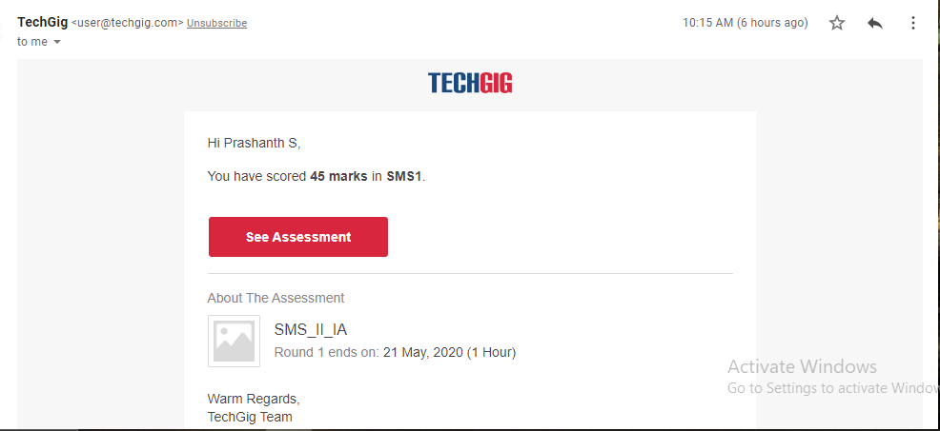

Certification Course Details: (Attach the snapshot and briefly write the report for the same)



The netdiscover is a tool which is used to gather all the important information about the network. It gathers information about the connected clients and the router. As for the connected clients, we'll be able to know their IP, MAC address and the operating system, as well as the ports that they have open in their devices. As for the router, it will help us to know the manufacturer of the router. Then we'll be able to look for vulnerabilities that we can use against the clients or against the router if we are trying to hack them.

In the Network penetration testing, we used airodump-ng to discover all the connected clients to the network. In the second part of the airodump-ng output, we learned how we could see the associated clients and their MAC addresses. All these details we can get before we connect to the target access point. Now, after connecting to the network, we can gather much more detailed information about these devices. To do this task, there are a lot of programs, but we're going to talk about two programs. Now start with the simplest and quickest one, netdiscover.

Coding Challenges Details: (Attach the snapshot and briefly write the report for the same)

Coding was given n it was uploaded for github and slack

PROGRAM1

|  |  |  |
| --- | --- | --- |
| def right_rotate(l,n): | | |
|  | | result=[] | |
|  | for i in range(len(l)-n,len(l)): | | |
|  | result.append(l[i]) | | |
|  | for j in range(0,len(l)-n): | | |
|  | result.append(l[j]) | | |
|  | return result | | |
|  | | |  |
|  | l=[] | | |
|  | l=int(input("Enter the array to rotate")) | | |
|  | k=int(input('enter number of times to right rotate:')) | | |
|  | print(right_rotate(l,k)) | | |