**DAILY ONLINE ACTIVITIES SUMMARY**

|  |  |  |  |  |  |  |  |  |
| --- | --- | --- | --- | --- | --- | --- | --- | --- |
| **Date:** | **23-05-2020** | | | | | **Name:** | **Prashanth S** | |
| **Sem & Sec** | **8th sem B sec** | | | | | **USN:** | **4AL16CS069** | |
| **Online Test Summary** | | | | | | | | |
| **Subject** | |  | | | | | | |
| **Max. Marks** | |  | | **Score** | | |  | |
| **Certification Course Summary** | | | | | | | | |
| **Course** | **Introduction to Ethical hacking** | | | | | | | |
| **Certificate Provider** | | | **Great learning website** | | **Duration** | | | **6hr** |
| **Coding Challenges** | | | | | | | | |
| **Problem Statement: Check whether string is anagram** | | | | | | | | |
| **Status: completed** | | | | | | | | |
| **Uploaded the report in Github** | | | | | **yes** | | | |
| **If yes Repository name** | | | | | **prashanth** | | | |
| **Uploaded the report in slack** | | | | | **yes** | | | |

Online Test Details: (Attach the snapshot and briefly write the report for the same)

Certification Course Details: (Attach the snapshot and briefly write the report for the same)

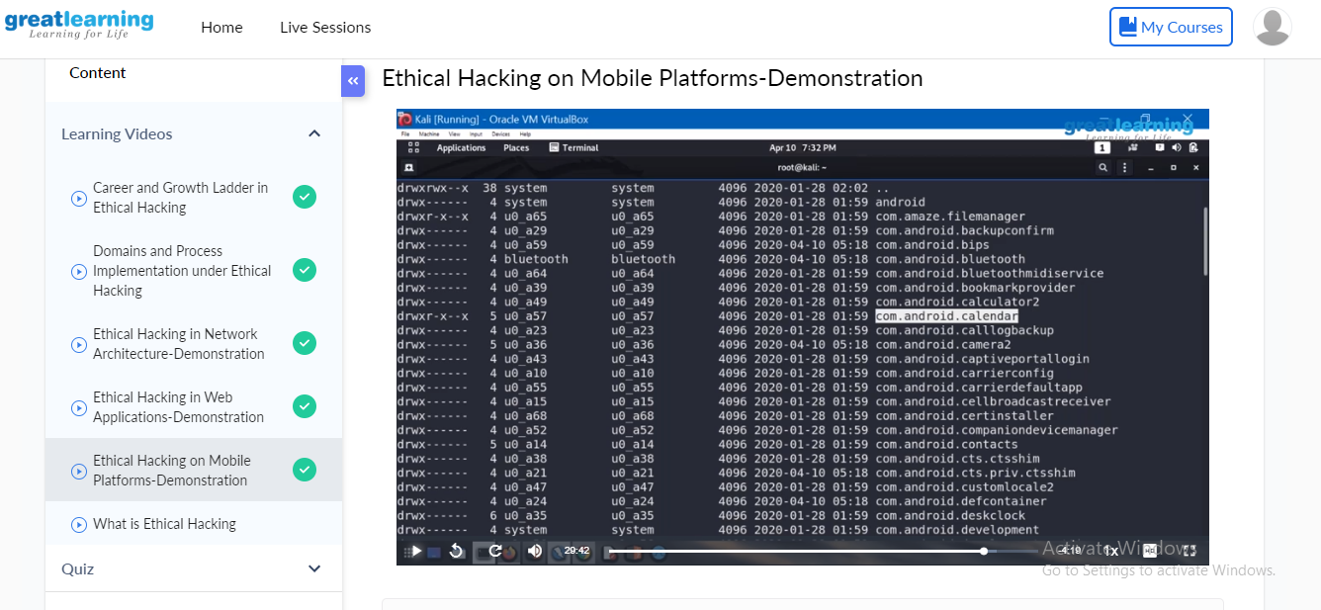

A penetration test, or pen test, is a simulated attack against your web application. Previously, penetration testing was mostly performed on networks, rather than the applications running on those networks.The purpose of a pen test is to identify vulnerabilities in your application exploitable from an outside attacker. Penetration testing can be performed against the various types of code and systems used in your application, such as APIs and servers.Penetration testing at the application level has become more common, thanks to the introduction of the Secure Software Development Lifecycle (SSDL).

SSDL gives security greater importance during all phases of application development and maintenance.Best practices dictate web applications should undergo penetration testing once every quarter. But the reality is quite different. A recent study discovered that most organizations do not follow this advice, with about one-third of those surveyed only pen testing their applications once per year.

Coding Challenges Details: (Attach the snapshot and briefly write the report for the same)

Coding was given n it was uploaded for github and slack

PROGRAM1

|  |  |
| --- | --- |
|  | s1=input("Enter first string:") |
|  | s2=input("Enter second string:") |
|  | if(sorted(s1)==sorted(s2)): |
|  | print("The strings are anagrams.") |
|  | else: |
|  | print("The strings aren't anagrams.") |