**DAILY ONLINE ACTIVITIES SUMMARY**

|  |  |  |  |  |  |  |  |  |
| --- | --- | --- | --- | --- | --- | --- | --- | --- |
| **Date:** | **27-05-2020** | | | | | **Name:** | **Prashanth S** | |
| **Sem & Sec** | **8th sem B sec** | | | | | **USN:** | **4AL16CS069** | |
| **Online Test Summary** | | | | | | | | |
| **Subject** | | **IOT** | | | | | | |
| **Max. Marks** | | **30** | | **Score** | | | **28** | |
| **Certification Course Summary** | | | | | | | | |
| **Course** | **Introduction to Ethical hacking** | | | | | | | |
| **Certificate Provider** | | | **Great learning website** | | **Duration** | | | **6hr** |
| **Coding Challenges** | | | | | | | | |
| **Problem Statement: Palindrome in python** | | | | | | | | |
| **Status: completed** | | | | | | | | |
| **Uploaded the report in Github** | | | | | **yes** | | | |
| **If yes Repository name** | | | | | **prashanth** | | | |
| **Uploaded the report in slack** | | | | | **yes** | | | |

Online Test Details: (Attach the snapshot and briefly write the report for the same)

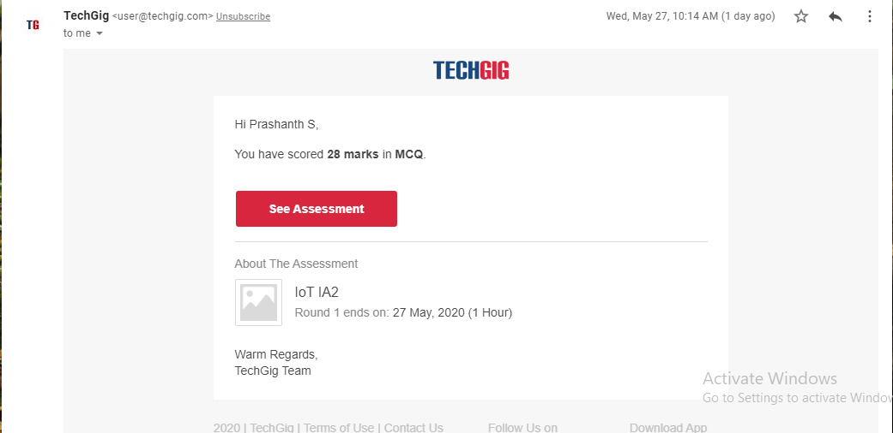

Certification Course Details: (Attach the snapshot and briefly write the report for the same)

Coding Challenges Details: (Attach the snapshot and briefly write the report for the same)

Completed

Coding was given n it was uploaded for github and slack

PROGRAM1

string=input(("Enter a string:"))

if(string==string[::-1]):

print("The string is a palindrome")

else:

print("Not a palindrome")