**DAILY ONLINE ACTIVITIES SUMMARY**

|  |  |  |  |  |  |  |  |  |
| --- | --- | --- | --- | --- | --- | --- | --- | --- |
| **Date:** | **28-05-2020** | | | | | **Name:** | **Prashanth S** | |
| **Sem & Sec** | **8th sem B sec** | | | | | **USN:** | **4AL16CS069** | |
| **Online Test Summary** | | | | | | | | |
| **Subject** | | **SMS** | | | | | | |
| **Max. Marks** | | **60** | | **Score** | | | **48** | |
| **Certification Course Summary** | | | | | | | | |
| **Course** | **Introduction to Ethical hacking** | | | | | | | |
| **Certificate Provider** | | | **Great learning website** | | **Duration** | | | **6hr** |
| **Coding Challenges** | | | | | | | | |
| **Problem Statement: Palindrome in python** | | | | | | | | |
| **Status: completed** | | | | | | | | |
| **Uploaded the report in Github** | | | | | **yes** | | | |
| **If yes Repository name** | | | | | **prashanth** | | | |
| **Uploaded the report in slack** | | | | | **yes** | | | |

Online Test Details: (Attach the snapshot and briefly write the report for the same)

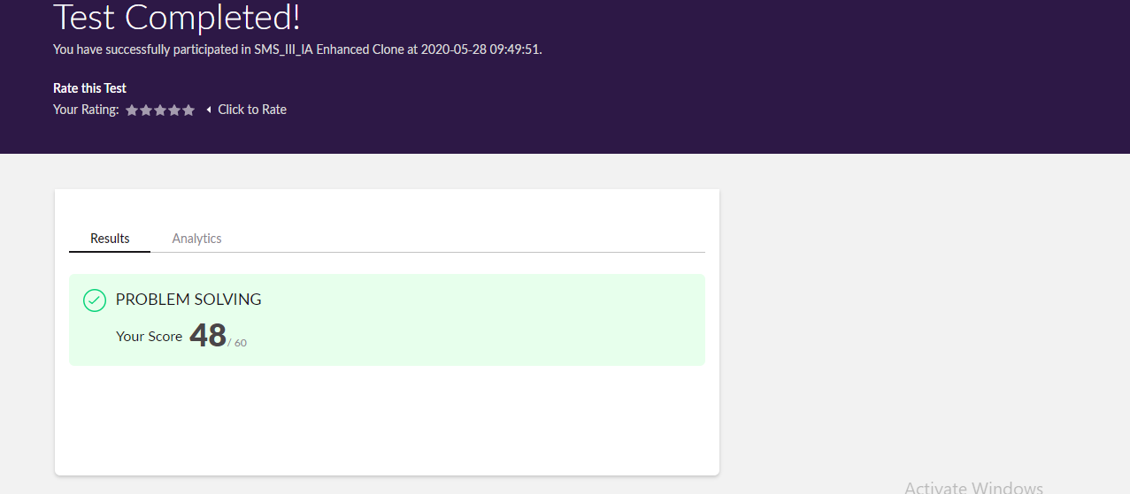

Certification Course Details: (Attach the snapshot and briefly write the report for the same)

Completed

Coding Challenges Details: (Attach the snapshot and briefly write the report for the same)

Coding was given n it was uploaded for github and slack

PROGRAM1

l=list()

c=0

n=int(input())

for i in range(0,n):

l=int(input())

for i in range(0,len(l)-1):

if l[i]<=l[i+1]:

c=1

else:

c=0

break

if c==0:

print('Pink is Happy')

else:

print('Pink is Sad')