DAILY ASSESSMENT

Morning session

|  |  |  |  |
| --- | --- | --- | --- |
| **Date:** | **10-6-2020** | **Name:** | **Rashmi KB** |
| **Course:** | **VLSI** | **USN:** | **4al16EC056** |
| **Topic:** | **MOS transistor basics-I** | **Semester & Section:** | **8th B** |
| **Github**  **Repositor y:** | **rashmikb** |  |  |

|  |
| --- |
| **FORENOON SESSION DETAILS** |
| **Image of session**  C:\Users\Rakesh Kiran M G\Downloads\20200610_114331.jpg  **Fig : MOS transistor basics-I** |
| **MOS transistor basics-I**  **MOSFET as a switch**  MOSFET’s make very good electronic switches for controlling loads and in CMOS digital circuits as they operate between their cut-off and saturation regions.  https://www.electronics-tutorials.ws/wp-content/uploads/2013/09/tran57.gif?fit=267%2C146 |

|  |
| --- |
| **MOSFET Characteristics Curves**  enhancement mode mosfet  The minimum ON-state gate voltage required to ensure that the MOSFET remains “ON” when carrying the selected drain current can be determined from the V-I transfer curves above. When VIN is HIGH or equal to VDD, the MOSFET Q-point moves to point A along the load line.  The drain current ID increases to its maximum value due to a reduction in the channel resistance. ID becomes a constant value independent of VDD, and is dependent only on VGS. Therefore, the transistor behaves like a closed switch but the channel ON- resistance does not reduce fully to zero due to its RDS(on) value, but gets very small  1. **Cut**-**off Region**  Here the operating conditions of the transistor are zero input gate voltage ( VIN ), zero drain current ID and output voltage VDS = VDD. Therefore for an enhancement type MOSFET the conductive channel is closed and the device is switched “OFF”. |

|  |  |  |  |
| --- | --- | --- | --- |
|  | Cut-off Characteristics  mosfet switch cut-off  **2. Saturation Region**  In the saturation or linear region, the tra amount of gate voltage is applied to t resistance RDS(on being as small as possibl the MOSFET switch. Therefore for the channel is open and the device is switched  Saturation Characteristics | * The input and Gate are grounded ( 0V ) * Gate-source voltage less than threshold voltage VGS < VTH * MOSFET is “OFF” ( Cut-off region ) * No Drain current flows ( ID = 0 Amps ) * VOUT = VDS = VDD = ”1″ * MOSFET operates as an “open switch”   nsistor will be biased so that the maximum he device which results in the channel e with maximum drain current flowing through enhancement type MOSFET the conductive  “ON”. |  |
|  |  | * The input and Gate are connected to VDD * Gate-source voltage is much greater than threshold voltage VGS > VTH * MOSFET is “ON” ( saturation region ) |  |

|  |  |  |  |
| --- | --- | --- | --- |
|  |  | * Max Drain current flows ( ID = VDD / RL ) * VDS = 0V (ideal saturation) * Min channel resistance RDS(on) < 0.1Ω * VOUT = VDS ≅ 0.2V due to RDS(on) * MOSFET operates as a low resistance “closed switch” |  |
| **MOSFET Structure**    **Types of MOSFET**  The MOSFET is classified into two types such as;   * Depletion mode MOSFET * Enhancement mode MOSFET | | | |

Depletion Mode: When there is zero voltage on the gate terminal, the channel shows its maximum conductance. As the voltage on the gate is negative or positive, then decreases the channel conductivity.

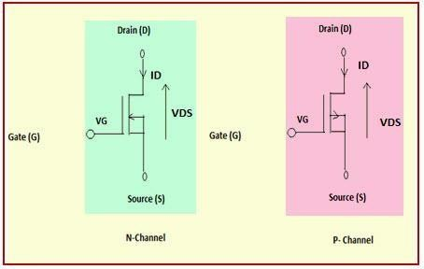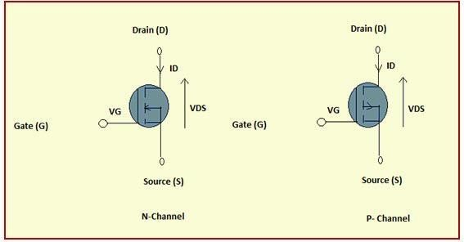

# Depletion Mode MOSFET

**Enhancement Mode**

When there is no voltage on the gate terminal the device does not conduct. More voltage applied on the gate terminal, the device has good conductivity

# Enhance Mode MOSFET Threshold voltge of MOSFET

VTH is the value of VG that will cause the interface potential to be equal in magnitude and opposite in sign to the substrate potential ϕp . Physically this mean that

there would now be a mobile electron concentration at the surface that is equal in magnitude to the mobile hole concentration is the p-substrate. When this happens we say that the surface is INVERTED, and the electron channel at the surface is called the inversion layer. So define threshold voltage as V V G TH = when ϕs = −ϕ p (21) Substituting in VTH and ϕs , we obtain the following expression for the threshold voltage in nchannel MOSFETs. 1 1 2 = 4 | | + 2 - C TH Si A p p bi ox V qN ⎡ ⎤ ε ϕ ϕϕ

# Current-voltage characteristics

**n-channel Enhancement-type MOSFET**

Figure 1a shows the transfer characteristics of n-channel Enhancement-type MOSFETs. From this, it is evident that the current through the device will be zero until the VGS exceeds the value of threshold voltage VT. This is because under this state, the device will be void of channel which will be connecting the drain and the source terminals. Under this condition, even an increase in VDS will result in no current flow as indicated by the corresponding output characteristics shown by Figure 1b. As a result this state represents nothing but the cut-off region of MOSFET’s operation.

Next, once VGS crosses VT, the current through the device increases with an increase in IDS initially and then saturates to a value as determined by the VGS i.e. as VGS increases**,** even the saturation current flowing through the device also increases. This is evident by Figure 1b where IDSS2 is greater than IDSS1 as VGS2 > VGS1, IDSS3 is greater than IDSS2 as VGS3 > VGS2, so on and so forth. Further, Figure 1b also shows the locus of pinch- off voltage , from which VP is seen to increase with an increase in VGS

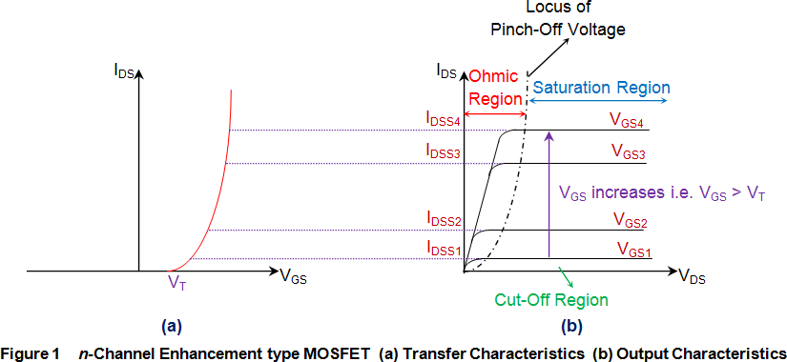

# hannel Enhancement-type MOSFET

Figure 2a shows the transfer characteristics of p-type enhancement MOSFETs from which it is evident that IDS remains zero (cutoff state) untill VGS becomes equal to -VT. This is because, only then the channel will be formed to connect the drain terminal of the device with its source terminal. After this, the IDS is seen to increase in reverse direction (meaning an increase in ISD, signifying an increase in the device current which will flow from source to drain) with the decrease in the value of VDS. This means that the device is functioning in its ohmic region wherein the current through the device increases with an increase in the applied voltage (which will be VSD).

However as VDS becomes equal to –VP, the device enters into saturation during which a saturated amount of current (IDSS) flows through the device, as decided by the value of VGS. Further it is to be noted that the value of saturation current flowing through the device is seen to increase as the VGS becomes more and more negative i.e. saturation current for VGS3 is greater than that for VGS2 and that in the case of VGS4 is much greater than both of them as VGS3 is more negative than VGS2 while VGS4 is much more negative when compared to either of them (Figure 2b). In addition, from the locus of the pinch- off voltage it is also clear that as VGS becomes more and more negative, even the negativity of VP also increases.

# Transfer charactersitcs and sub-threshold slope Transfer Characteristics

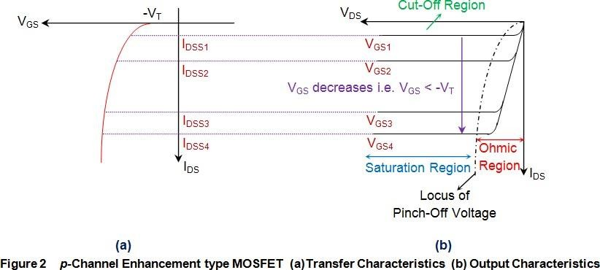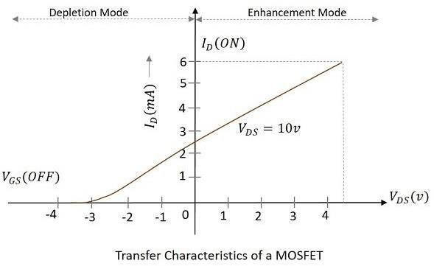

Transfer characteristics define the change in the value of VDS with the change in ID and VGS in both depletion and enhancement modes. The below transfer characteristic curve is drawn for drain current versus gate to source voltage.

The subthreshold slope is a feature of a [MOSFET'](https://en.wikipedia.org/wiki/MOSFET)s [current–voltage characteristic](https://en.wikipedia.org/wiki/Current%E2%80%93voltage_characteristic).

In the [subthreshold](https://en.wikipedia.org/wiki/Subthreshold_conduction) region, the [drain](https://en.wikipedia.org/wiki/Field-effect_transistor#Basic_information) current behaviour – though being controlled by the [gate](https://en.wikipedia.org/wiki/Field-effect_transistor#Basic_information) terminal – is similar to the exponentially decreasing current of a [forwardbiased](https://en.wikipedia.org/wiki/Diode#Current.E2.80.93voltage_characteristic) [diode](https://en.wikipedia.org/wiki/Diode#Current.E2.80.93voltage_characteristic). Therefore a plot of drain current versus gate voltage with drain, [source](https://en.wikipedia.org/wiki/Field-effect_transistor#Basic_information),

and [bulk](https://en.wikipedia.org/wiki/Field-effect_transistor#More_about_terminals) voltages fixed will exhibit approximately log linear behaviour in this MOSFET operating regime. Its slope is the subthreshold slope.

The subthreshold slope is also the [reciprocal value](https://en.wikipedia.org/wiki/Reciprocal_(mathematics)) of the subthreshold swing *Ss-th* which is usually given as:

* [Depletion layer](https://en.wikipedia.org/wiki/Depletion_region) capacitance
* Gate-oxide capacitance
* Thermal Voltage

**AFTERNOON SESSION DETAILS**

|  |  |  |  |
| --- | --- | --- | --- |
| **Date:** | **10-6-2020** | **Name:** | **Rashmi KB** |
| **Course:** | **Java** | **USN:** | **4al16EC056** |
| **Topic:** | **Array of strings,multi-dimensional arrays,classes and object,methods,getters and return values,method parameter,setters and**  **“this”,constructors,static,string builder and string formatting** | **Semest er & Section:** | **8th B** |
| **Github**  **Repositor y:** | **rashmikb** |  |  |

|  |
| --- |
| **Image of session**  C:\Users\Rakesh Kiran M G\Downloads\20200610_114656.jpg |
| **Array of strings**  Java String array is used to hold fixed number of Strings. [String](https://www.journaldev.com/16928/java-string) [array](https://www.journaldev.com/16851/java-array) is very common in [simple java programs](https://www.journaldev.com/17757/simple-java-programs), specially among beginners to java and to test some specific scenarios. Even [java main method](https://www.journaldev.com/12552/public-static-void-main-string-args-java-main-method) argument is string array – public static void |

main(String[] args). So today we will look into different aspects of java string array with example programs.

* + - Java String array is basically an array of objects.
    - There are two ways to declare string array – declaration without size and declare with size.
    - There are two ways to initialize string array – at the time of declaration, populating values after declaration.
    - We can do different kind of processing on string array such as iteration, sorting, searching etc.

# Multidimensional Arrays

Multidimensional Arrays can be defined in simple words as array of arrays.

Data in multidimensional arrays are stored in tabular form (in row major order).

Syntax:

data\_type[1st dimension][2nd dimension][]..[Nth dimension] array\_name = new data\_type[size1][size2]….[sizeN];

where:

* + - data\_type: Type of data to be stored in the array. For example: int, char, etc.
    - dimension: The dimension of the array created.For example: 1D, 2D, etc.
    - array\_name: Name of the array
    - size1, size2, …, sizeN: Sizes of the dimensions respectively.

# Classes and Object

A Class is like an object constructor, or a "blueprint" for creating objects.

# Create a Class

To create a class, use the keyword class: MyClass.java

Create a class named "MyClass" with a variable x: public class MyClass {

int x = 5;

}

# Create an Object

In Java, an object is created from a class. We have already created the class named MyClass, so now we can use this to create objects.

To create an object of MyClass, specify the class name, followed by the object name, and use the keyword new:

Example

Create an object called "myObj" and print the value of x: public class MyClass {

int x = 5;

public static void main(String[] args) { MyClass myObj = new MyClass(); System.out.println(myObj.x);

}

}

# Getters and return values

The get method returns the variable value, and the set method sets the value. Syntax for both is that they start with either get or set, followed by the name of the variable, with the first letter in upper case:

Example

public class Person {

private String name; // private = restricted access

// Getter

public String getName() { return name;

}

// Setter

public void setName(String newName) { this.name = newName;

}

}

# Method parameter

In Java, parameters sent to methods are passed-by-value: What is passed "to" a method is referred to as an "argument". The "type" of data that a method can receive is referred to as a "parameter".

Pass-by-value means that when a method is called, a copy of the value of each argument is passed to the method. This copy can be changed inside the method, but such a change will have NO effect on the argument.

# Constructors

A Java constructor is special method that is called when an object is instantiated. In other words, when you use the new keyword. The purpose of a Java constructor is to initializes the newly created object before it is used. This Java constructors tutorial will explore Java constructors in more detail.Here is a simple example that creates an object, which results in the class constructor being called:

MyClass myClassObj = new MyClass(); Here is a simple Java constructor declaration example.

public class MyClass {

public MyClass() {

}

}

# Static

In Java, static keyword is mainly used for memory management. It can be used

with [variables](https://www.edureka.co/blog/java-tutorial/#variables), methods, blocks and nested [classes](https://www.edureka.co/blog/java-tutorial/#obj). It is a keyword which is used to share the same variable or method of a given class. Basically, static is used for a constant variable or a method that is same for every [instance of a class](https://www.edureka.co/blog/instance-variable-in-java/).

# String builder and string formatting

**StringBuilder**: private static final String PROFILE\_PICTURE\_URL\_BASE = "https://cdn.myapp.com/user/";

private static final String PROFILE\_PICTURE\_URL\_EXTENSION = ".png"; Long userId = ...;

StringBuilder sb = new StringBuilder(PROFILE\_PICTURE\_URL\_BASE); sb.append(userId);

sb.append(PROFILE\_PICTURE\_URL\_EXTENSION);

String profilePictureUrl = sb.toString();

**String.format:** private static final String PROFILE\_PICTURE\_URL = "https://cdn.myapp.com/user/%d.png";

Long userId = ...;

String profilePictureUrl = String.format(PROFILE\_PICTURE\_URL, userId);