*DAILY ASSESSMENTFORMAT*

|  |  |  |  |
| --- | --- | --- | --- |
| ***Date:*** | *11 June 2020* | ***Name:*** | *Rashmi KB* |
| ***Course:*** | *VLSI* | ***USN:*** | *4AL16EC056* |
| ***Topic:*** | *MOS transistor basics - II & III* | ***Semester & Section:*** | *8thsem “B”section* |
| ***Github Repository:*** | *rashmikb* |  |  |

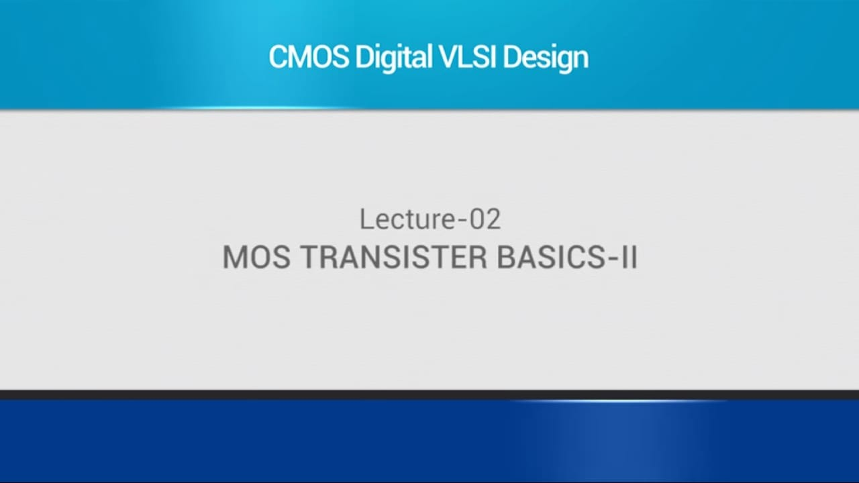

***FORENOON SESSION DETAILS***

° T0 #6£iYP I-'\/ CbdfdCt8riStiCS, WP lTId#6 tW0 0bSPfVdti00-

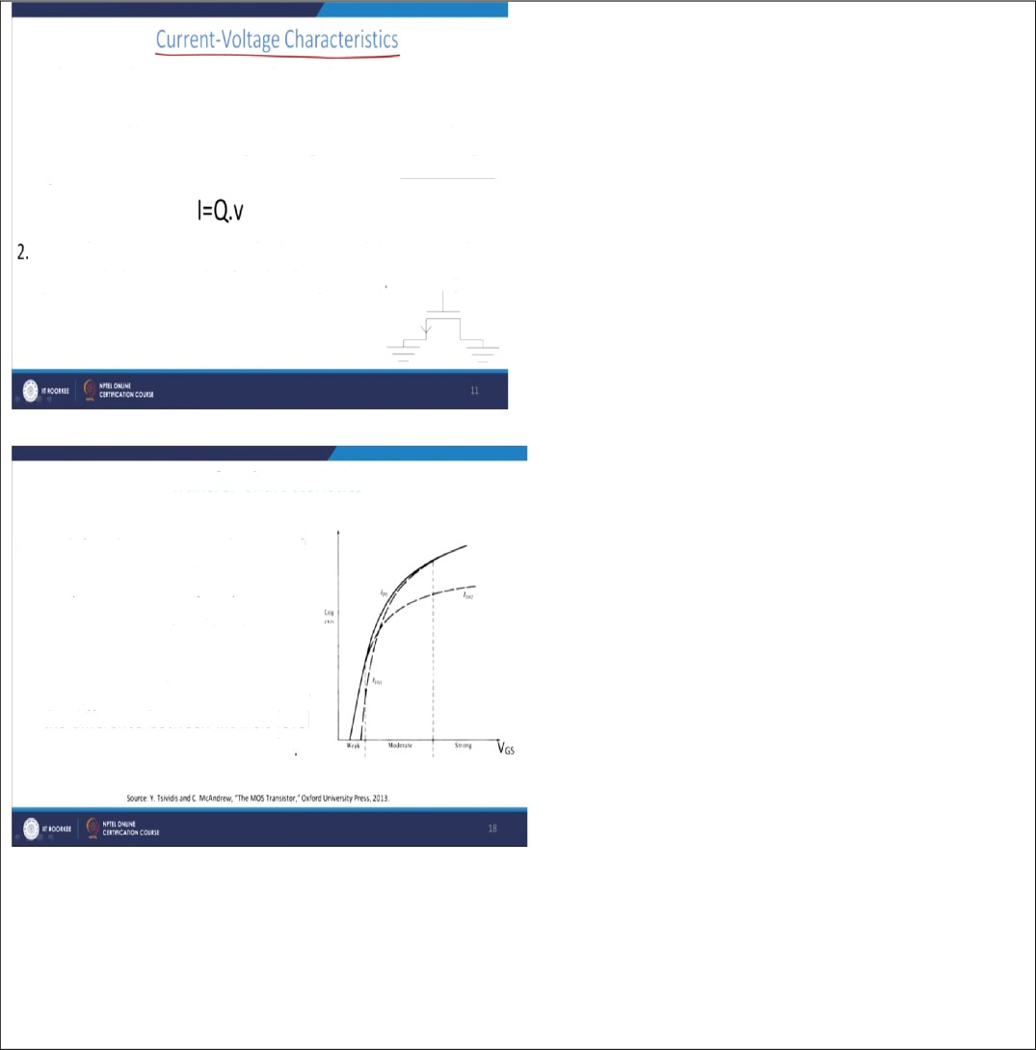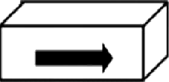

1.Thecurrent(I)f!0Winginasemit0hdUctoristhe§f0dUCt0fCLdfgo dentity alongthedirectionofcurrentflowandthevelocityofthe chargecarriers.

Considerann-M0fFETwhosebothsourceanddrainterminalsare grounded.Thenweneedtofindthechargedensity ve

Transfer Characteristics

* We define the inversion in threeparts-

1. Weak Inversion - 6 ‹{«20
2. Moderate Inversi00 - $-20d
3. ftrong Inversion - } • b028

whereisthesurfacepotential,0is the difference between intrinsic level andfermiIevel,d0-6010iT/q

Edit with WPS Office

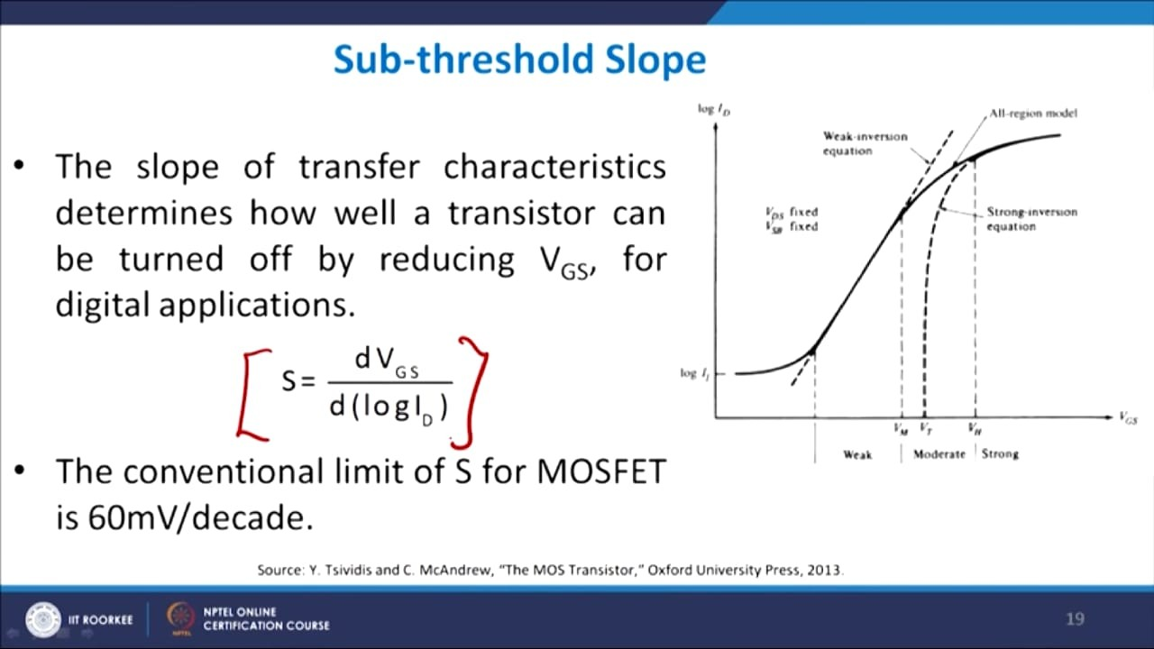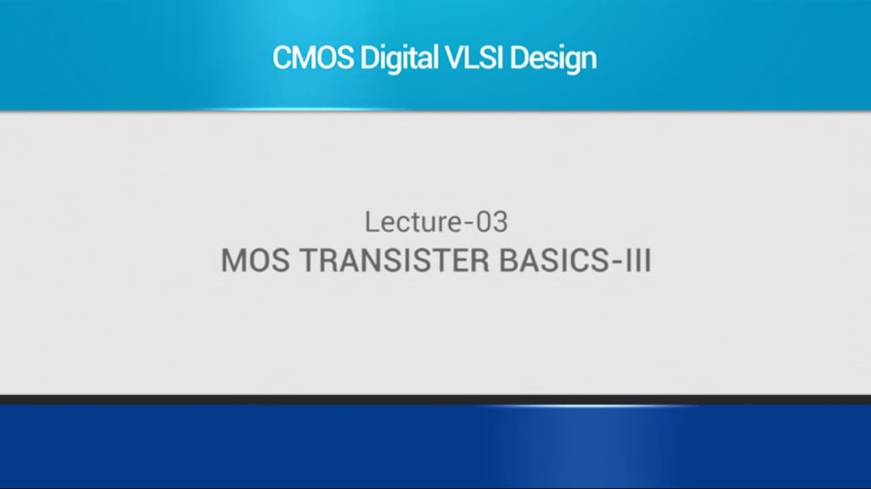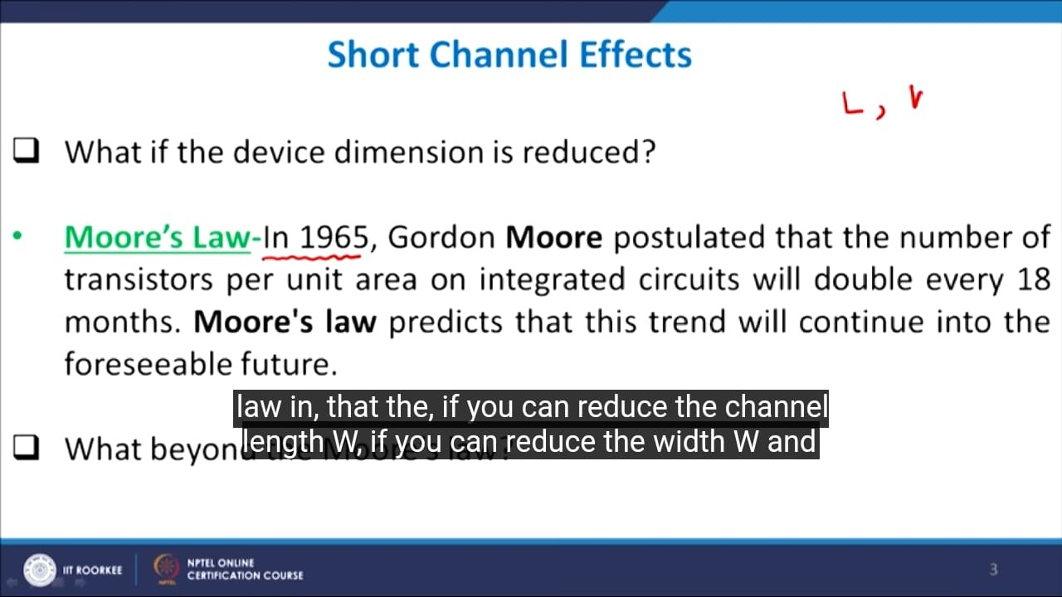

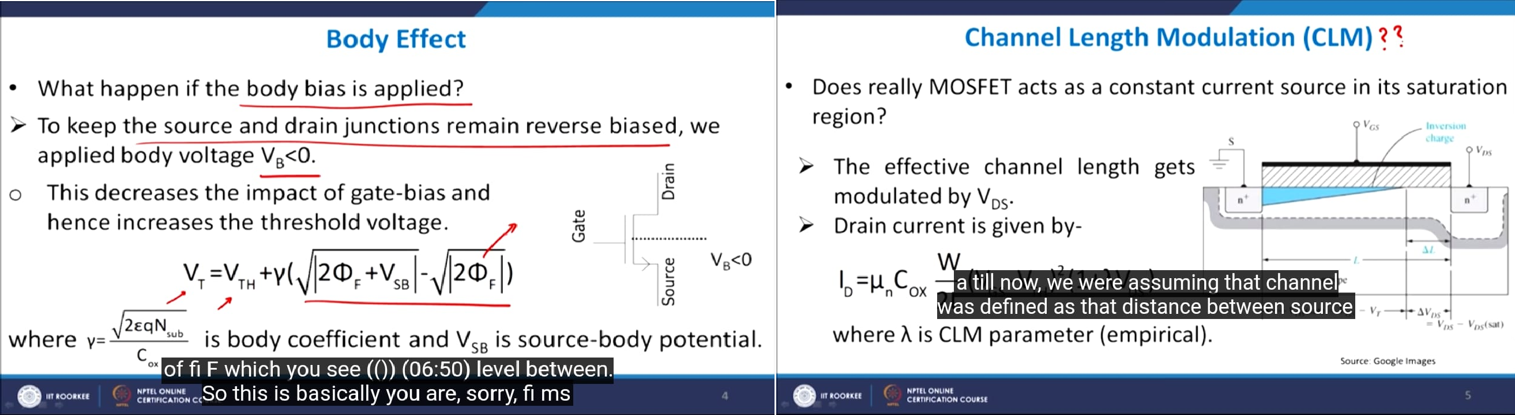

*A****current–voltagecharacteristic****or****I–Vcurve****(current–voltagecurve)isarelationship,*typicallyrepresentedasachartorgraph,betweentheelectriccurrentthroughacircuit,device, ormaterial,andthecorrespondingvoltage,orpotentialdifferenceacrossit.Inelectronics,the

*relationshipbetween the direct current (DC) through an electronic device and the* DC voltage across its terminalsis called a current–voltage characteristic of the device.Electronicengineersusethesechartstodeterminebasicparametersofadeviceandto modelitsbehaviorinanelectricalcircuit.ThesecharacteristicsarealsoknownasI–Vcurves, referringtothestandardsymbolsforcurrentandvoltage.

*Inelectroniccomponentswithmorethantwoterminals,suchasvacuumtubesandtransistors,* thecurrent-voltagerelationshipatonepairofterminalsmaydependonthecurrentorvoltage onathirdterminal.Thisisusuallydisplayedonamorecomplexcurrent–voltagegraphwith multiplecurves,eachonerepresentingthecurrent-voltagerelationshipatadifferentvalueof currentorvoltageonthethirdterminal.[1]

*For example the diagram at right shows a family of I–V curves for a MOSFET as a function of* drainvoltagewithovervoltage(VGS−Vth)asaparameter.

*The simplest I–V curve is that of a resistor, which according to Ohm's law exhibits*alinearrelationshipbetweentheappliedvoltageandtheresultingelectriccurrent;thecurrent is proportional to the voltage, so the I–V curve is a straight line through the origin with positiveslope.Thereciprocaloftheslopeisequaltotheresistance.

*TheI–Vcurveofanelectricalcomponentcanbemeasuredwithaninstrumentcalledacurve* tracer. The transconductance and Early voltage of a transistor are examples ofparameters traditionallymeasuredfromthedevice'sI–Vcurve.

*The* ***subthreshold slope*** *is a feature of a MOSFET's current–voltage characteristic.*

*In the subthreshold region, the drain current behaviour – though being controlled by*thegateterminal–issimilartotheexponentiallydecreasingcurrentofaforwardbiaseddiode. Thereforeaplotofdraincurrentversusgatevoltagewithdrain,source,andbulkvoltagesfixed willexhibitapproximatelyloglinearbehaviourinthisMOSFEToperatingregime.Itsslopeisthe subthresholdslope.

*Thesubthresholdslopeisalsothereciprocalvalueofthe****subthresholdswing****Ss-thwhichisusually given as:*

*depletion layer capacitance* gate-oxide capacitance thermal Voltage

*The minimum subthreshold swing of a conventional device can be found by letting and/or*

*, which yield (known as thermionic limit) and 60 mV/dec at room temperature (300* K). A typical experimental subthreshold swing for a scaled MOSFET at room temperatureis

*~70mV/dec,slightlydegradedduetoshort-channelMOSFETparasitics.*Adec(decade)correspondstoa10timesincreaseofthedraincurrentID.

*A device characterized by steep subthreshold slope exhibits a faster transition between off* (low current) and on (high current)states.

***Short-channel effects*** *occur when the channel length is the same order of magnitude as the* depletion-layer widths of the source and drain junction. In MOSFETs, channel lengths must be greater than the sum of the drain and source depletion widths to avoid edge effects. Otherwise, a number of effectsappear.

*Amongthereportedeffectscitedbyanumberofresearchersatuniversitiesaroundtheglobe* are:

1. *“Off-state” leakagecurrent.*
2. *Impactionization,inwhichachargecarriercanbeaffectedbyotherchargecarriers;*
3. *Velocity saturation/mobilitydegradation;*
4. *Drain-inducedbarrierlowering(DIBL),whichiscausedbyencroachmentofthedrain depletion region into thechannel;*
5. *Drainpunchthrough,wherebycurrentflowsregardlessofgatevoltage-aphenomenonthat can occur if the drain is at high enough voltage compared to the source and the depletion regionaroundthedrainextendstothesource;*
6. *Surfacescattering;*
7. *Channel lengthmodulation;*
8. *Threshold voltageroll-off.*

*AnalysisofMOSFETcircuitsisbasedonthreepossibleoperatingmodes:cutoff,triode(aka* linear),andsaturation.(Thesubthresholdregionisafourthmode,butwedon’tneedtoworry about that for thisarticle.)

*In cutoff, the gate-to-source voltage is not greater than the threshold voltage, and the MOSFET* is inactive.

*Intriode,thegate-to-sourcevoltageishighenoughtoallowcurrentflowfromdraintosource,* and the nature of the induced channel is such that the magnitude of the drain current is influenced by the gate-to-source voltage and the drain-to-source voltage. As the drain-to- sourcevoltageincreases,thetrioderegiontransitionstothesaturationregion,inwhichdrain current is (ideally) independent of drain-to-source voltage and thus influenced only by the physicalcharacteristicsoftheFETandthegate-to-sourcevoltage.

*Thesaturation-regionrelationshipbetweengate-to-sourcevoltage(VGS)anddraincurrent(ID)is* expressed asfollows:

*ID=12μnCoxWL(VGS−VTH)2ID=12μnCoxWL(VGS−VTH)2*

*Thetransitiontosaturationmodeoccursbecausethechannelgets“pinchedoff”atthedrain* end:

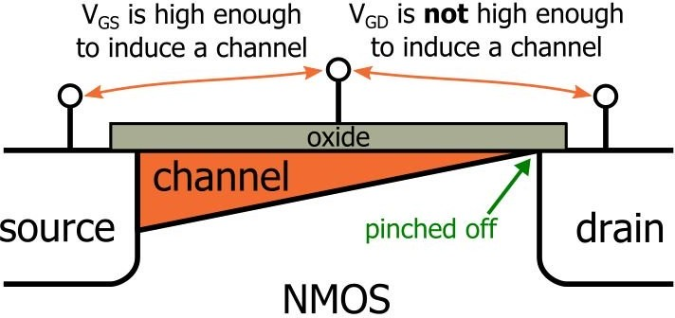

*Unfortunately, the “pinching off” isn’t the end of the influence exerted by the drain-to-source* voltage. Further increases continue to affect the channel because the pinch-off point moves closer to the source:

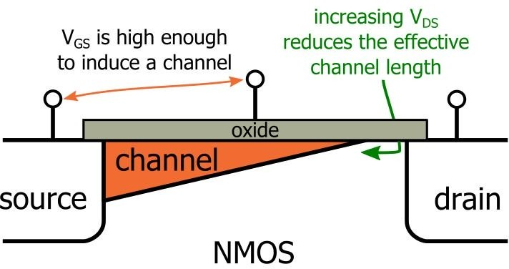

*Theresistanceofthechannelisproportionaltoitswidth-to-lengthratio;reducingthelength* leadstodecreasedresistanceandhencehighercurrentflow.Thus,channel-lengthmodulation means that the saturation-region drain current will increase slightly as the drain-to-source voltageincreases.

*Soweneedtomodifythesaturation-regiondrain-currentexpressiontoaccountforchannel-* lengthmodulation.Wedothisbyincorporatingtheincrementalchannel-lengthreductioninto the originalexpression:

|  |  |  |  |
| --- | --- | --- | --- |
| ***Date:*** | *11 June 2020* | ***Name:*** | *Rashmi KB* |
| ***Course:*** | *JavaTutorialforComplete Beginners* | ***USN:*** | *4AL16EC056* |
| ***Topic:*** | *Programming core java*   1. *The toStringMethod* 2. *Inheritance* 3. *Packages* 4. *Interfaces* 5. *Public, Private,Protected* 6. *Polymorphism* 7. *Encapsulation and the API Docs* 8. *Casting NumericalValues* 9. *Upcasting andDowncasting* 10. *UsingGenerics* | ***Semester & Section:*** | *8thsem “B"section* |
| ***Github Repository:*** | *rashmikb* |  |  |
| ***AFTERNOON SESSION DETAILS*** | | | |

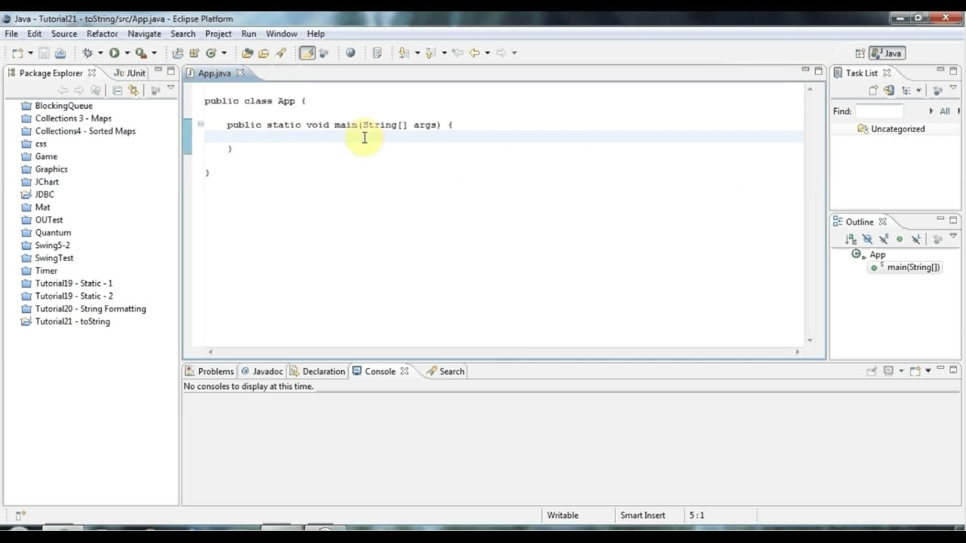

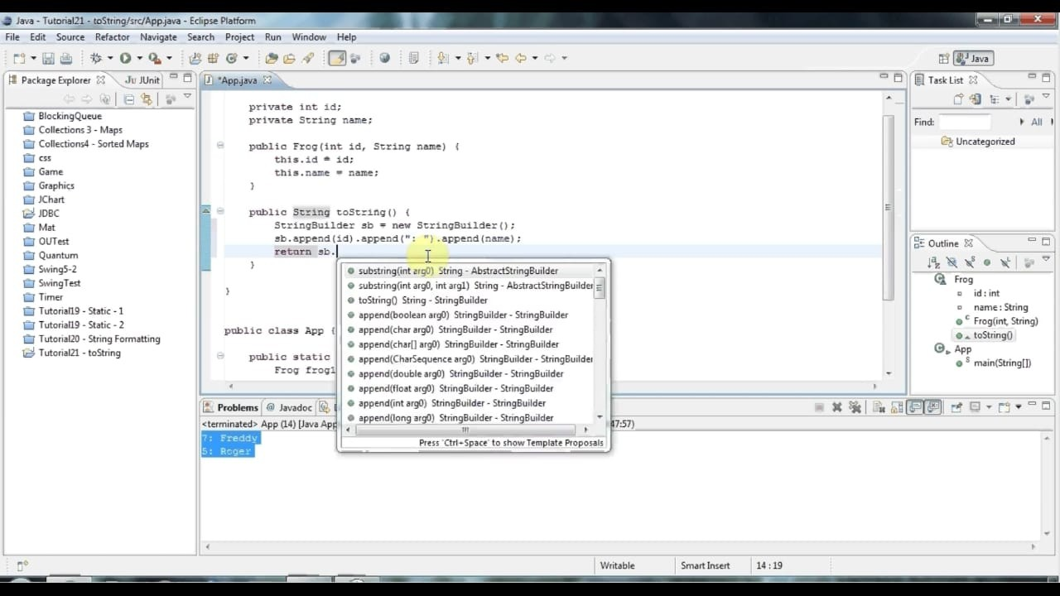

# *Java toString() method*

*Ifyouwanttorepresentanyobjectasastring,****toString()method****comesintoexistence.* ThetoString()methodreturnsthestringrepresentationoftheobject.

*Ifyouprintanyobject,javacompilerinternallyinvokesthetoString()methodontheobject.So* overridingthetoString()method,returnsthedesiredoutput,itcanbethestateofanobjectetc. depends on yourimplementation.

*Advantage of Java toString() method*

*By overriding the toString() method of the Object class, we can return values of the object, so* we don't need to write much code.

*Understanding problem without toString() method* Let's see the simple code that prints reference.

***class*** *Student{* ***int*** *rollno;* String name; String city;

*Student(****int****rollno,Stringname,Stringcity){* ***this****.rollno=rollno;*

***this****.name=name;* ***this****.city=city;*

*}*

# *Private access modifier*

*The scope of private modifier is limited to the class only.*

* 1. *PrivateDatamembersandmethodsareonlyaccessiblewithintheclass*
  2. *ClassandInterfacecannotbedeclaredasprivate*
  3. *If a class has private constructorthen you cannot create the object of that class from outside of theclass.*

*Let’s see an example to understandthis:*

# *Privateaccessmodifierexampleinjava*

*This example throws compilation error because we are trying to access the private data* member and method of class ABC in the class Example. The private data member and method are only accessible within the class.

*class ABC{*

*private double num = 100;* private int square(int a){

*return a*a;*

*}*

*}*

*public class Example{*

*public static void main(String args[]){* ABC obj = new ABC(); System.out.println(obj.num);

*System.out.println(obj.square(10));*

*}*

*}*

# *Protected Access Modifier*

*Protected data member and method are only accessible by the classes of the same package* and the subclasses present in any package. You can also say that the protected access modifier is similar to default access modifier with one exception that it has visibility in sub classes.

*Classes cannot be declared protected. This access modifier is generally used in a parent child* relationship.

# *Protected access modifier example in Java*

*In this example the class Test which is present in another package is able to call* the addTwoNumbers()method, which is declared protected. This is because the Test class extends class Addition and the protected modifier allows the access of protected members in subclasses (in anypackages).

# *Addition.java*

*package abcpackage;* public class Addition {

*protected int addTwoNumbers(int a, int b){*

*return a+b;*

*}*

*}*

***Test.java***

*package xyzpackage;* import abcpackage.*;

*class Test extends Addition{*

*publicstaticvoidmain(Stringargs[]){* Testobj=newTest();

*System.out.println(obj.addTwoNumbers(11, 22));*

*}*

*}*

***Public access modifier***

*The members, methods and classes that are declared public can be accessed from anywhere.* This modifier doesn’t put any restriction on the access.

# *public access modifier example in java*

*Lets take the same example that we have seen above but this time the method* addTwoNumbers() has public modifier and class Test is able to access this method without even extending the Addition class. This is because public modifier has visibility everywhere.

*Addition.java*

*package abcpackage;* public class Addition {

*public int addTwoNumbers(int a, int b){* return a+b;

*}*

*}*

*Test.java*

*packagexyzpackage;* import abcpackage.*; classTest{

*publicstaticvoidmain(Stringargs[]){* Additionobj=newAddition();

*System.out.println(obj.addTwoNumbers(100, 1));*

*}*

*}*

***public static void*** *main(String args[]){*

*Student s1=****new*** *Student(101,"Raj","lucknow");* Student s2=***new*** *Student(102,"Vijay","ghaziabad");*

*System.out.println(s1);//compiler writes here s1.toString()* System.out.println(s2);//compiler writes here s2.toString()

*}*

*}*