DAILYONLINEACTIVITIESSUMMARY

|  |  |  |  |  |  |  |  |
| --- | --- | --- | --- | --- | --- | --- | --- |
| Date: | 01-06-2020 | | | | Name: | **Safeeq Bidarkundi** | |
| Sem&Sec | 8th,A | | | | USN: | 4AL15CS111 | |
| OnlineTestSummary | | | | | | | |
| Subject | | SMS | | | | | |
| Max.Marks | | 60 | | Score | | 60 | |
| CertificationCourseSummary | | | | | | | |
| Course | PENTESTER ACADEMY | | | | | | |
| CertificateProvider | | | PENTESTER ACADEMY | Duration | | | 3Hour |
| CodingChallenges | | | | | | | |
| ProblemStatement:Cprogamtoprintrightangledtraigle numbersstarpattern | | | | | | | |
| Status:Solved | | | | | | | |
| UploadedthereportinGithub | | | | Yes | | | |
| IfyesRepositoryname | | | | shaima | | | |
| Uploadedthereportinslack | | | | Yes | | | |

OnlineTestDetails:(Attachthesnapshotandbrieflywritethereportforthesame) CertificationCourseDetails:(Attachthesnapshotandbrieflywritethereportfor thesame)CodingChallengesDetails:(Attachthesnapshotandbrieflywritethe reportforthesame)

1)OnlineTestDetails:

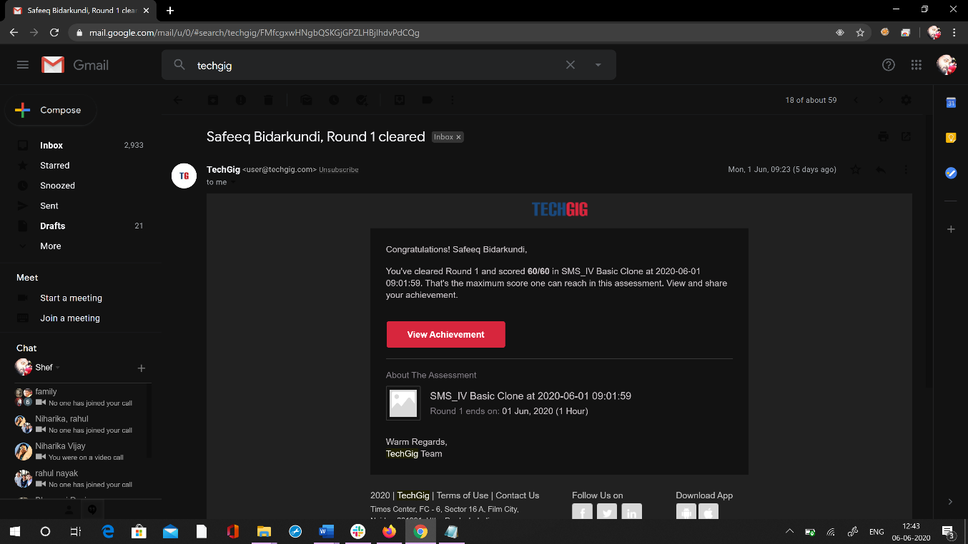

2)CertificationCourseDetails: 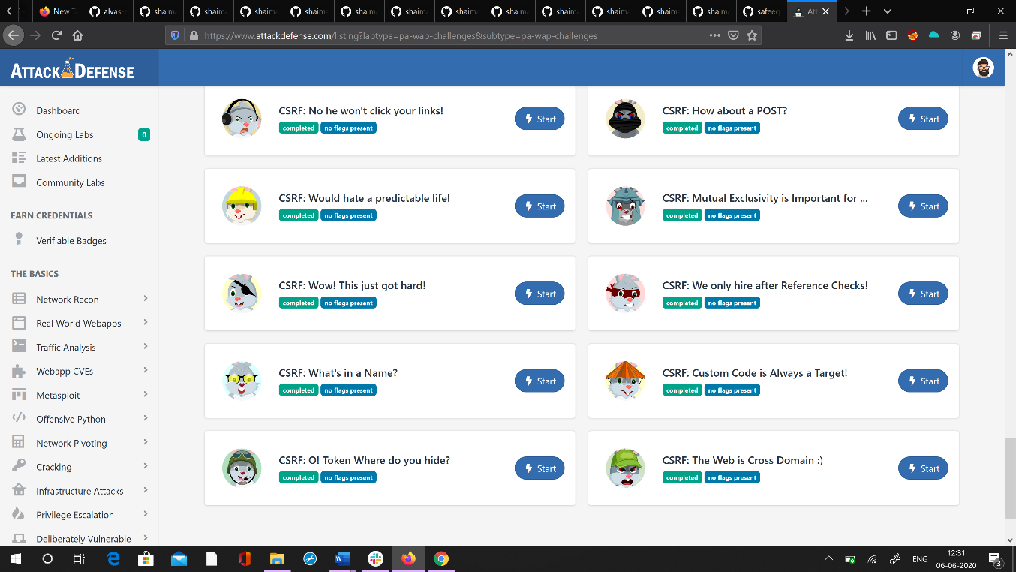

3)CodingChallenges:

Program1:

Cprogamtoprintrightangledtraiglenumbersstar patternintmain()

{

intRows,i,j; printf("PleaseEntertheNumberofRows:

");scanf("%d",&Rows);

printf("\nPrintingRightAngledTriangle\n\n");

{

for(j=1;j<=i;j++)

{

printf("*");

}

printf("\n");

}

return0;