DAILYONLINEACTIVITIESSUMMARY

|  |  |  |  |  |  |  |  |
| --- | --- | --- | --- | --- | --- | --- | --- |
| Date: | 02-06-2020 | | | | Name: | Safeeq Bidarkundi | |
| Sem&Sec | 8th,BSec | | | | USN: | 4AL15cs111 | |
| OnlineTestSummary | | | | | | | |
| Subject | | NotConducted | | | | | |
| Max.Marks | | - | | Score | | - | |
| CertificationCourseSummary | | | | | | | |
| Course | PENTESTER ACADEMY | | | | | | |
| CertificateProvider | | | PENTESTER ACADEMY | Duration | | | 2Hrs |
| CodingChallenges | | | | | | | |
| ProblemStatement:c++progtofindsumofdigitsuntilthenumberisasingledigits | | | | | | | |
| Status:Solved | | | | | | | |
| UploadedthereportinGithub | | | | Yes | | | |
| IfyesRepositoryname | | | | SAFEEQ | | | |
| Uploadedthereportinslack | | | | Yes | | | |

OnlineTestDetails:(Attachthesnapshotandbrieflywritethereportforthesame)

CertificationCourseDetails:(Attachthesnapshotandbrieflywritethereportfor thesame)CodingChallengesDetails:(Attachthesnapshotandbrieflywritethe reportforthesam

1)CertificationCourseDetails:

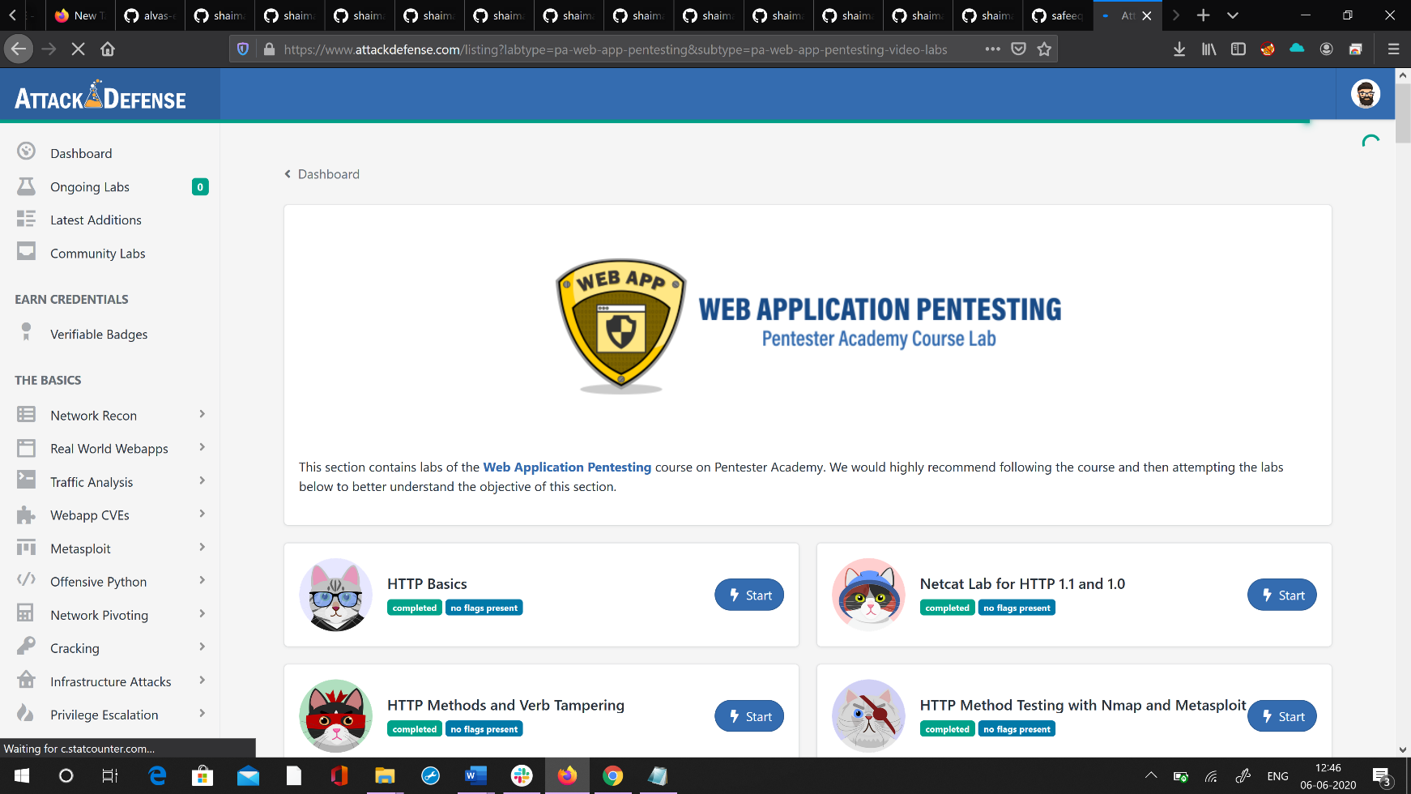

2)CodingChallenges:

#include <iostream>using namespacestd; intmain()

{

intnumber=147;//Any number.intres;

if(number)

res=number%9==0?9:number%9;

else res=0;

//printthe result cout<<res;

return0;

}