DAILYONLINEACTIVITIESSUMMARY

|  |  |  |  |  |  |  |  |
| --- | --- | --- | --- | --- | --- | --- | --- |
| Date: | 04-06-2020 | | | | Name: | **Safeeq Bidarkundi** | |
| Sem& Sec | VIIISemester&ASection | | | | USN: | 4AL15CS111 | |
| OnlineTestSummary | | | | | | | |
| Subject | | SMS5 | | | | | |
| Max.Marks | | 60 | | Score | | 60 | |
| CertificationCourseSummary | | | | | | | |
| Course | PENTESTER ACADEMY | | | | | | |
| CertificateProvider | | | PENTESTER ACADEMY | Duration | | | 12Hours |
| CodingChallenges | | | | | | | |
| ProblemStatement:ProgramtofindHCFoftwonumbers. | | | | | | | |
| Status:COMPLETED | | | | | | | |
| UploadedthereportinGithub | | | | YES | | | |
| IfyesRepositoryname | | | | SAFEEQ | | | |
| Uploadedthereportinslack | | | | YES | | | |

OnlineTestDetails:

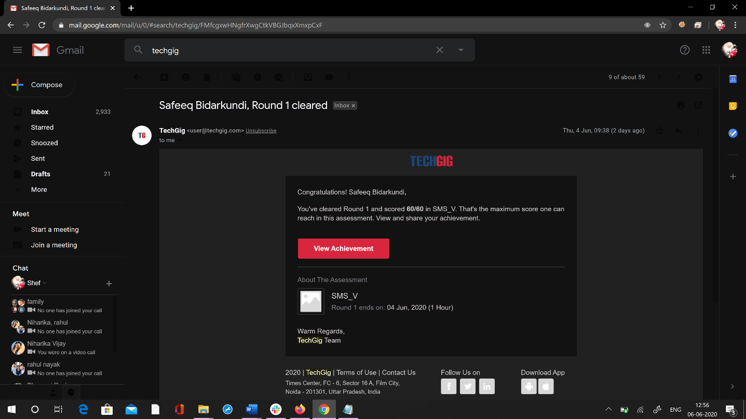

CertificationCourseDetails:

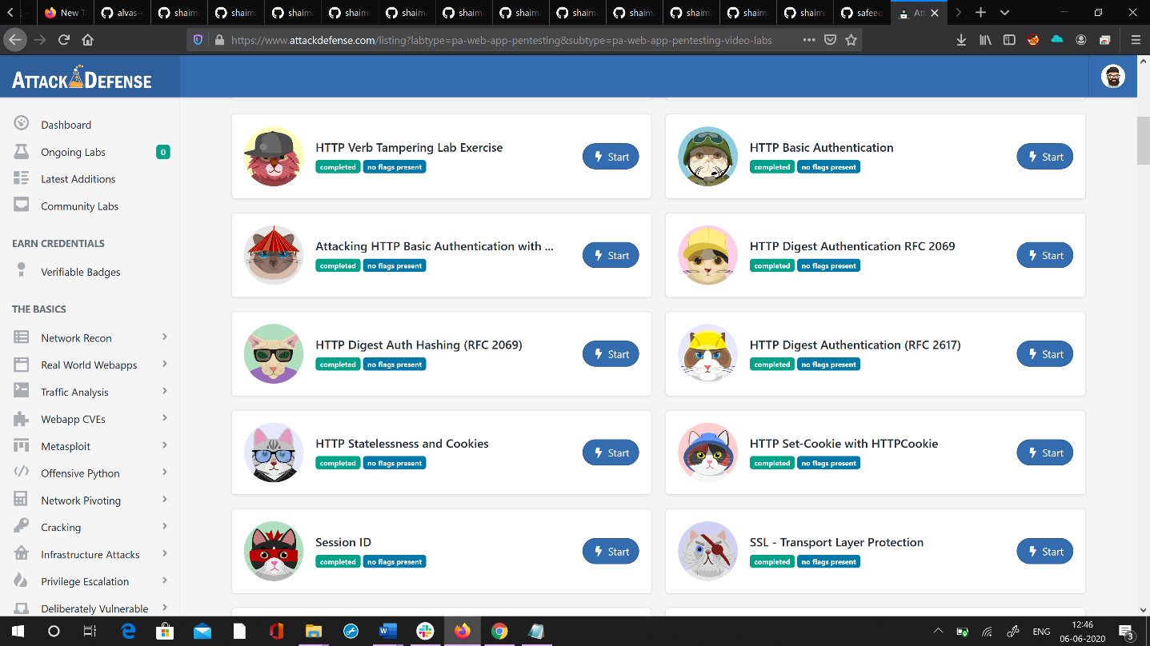

Codingchallengesonlinedetails: PythonprogramtofindH.C.Foftwonumbers

defcompute_hcf(x,y): ifx>y:

smaller=y

else: smaller=x

foriinrange(1,smaller+1): if((x%i==0)and(y%i==0)):

hcf=i

returnhcf

num1=54

num2=24

print("TheH.C.F.is",compute_hcf(num1,num2))