DAILYONLINEACTIVITIESSUMMARY

|  |  |  |  |  |  |  |  |
| --- | --- | --- | --- | --- | --- | --- | --- |
| Date: | 05-06-2020 | | | | Name: | Safeeq Bidarkundi | |
| Sem& Sec | VIIISemester&ASection | | | | USN: | 4AL15CS111 | |
| OnlineTestSummary | | | | | | | |
| Subject | | BDA | | | | | |
| Max.Marks | | 30 | | Score | | 16 | |
| CertificationCourseSummary | | | | | | | |
| Course | PENTESTER ACADEMY | | | | | | |
| CertificateProvider | | | PENTESTER ACADEMY | Duration | | | 4Hrs |
| CodingChallenges | | | | | | | |
| ProblemStatement:WriteaPythonprogramtoconvertsecondstoday, hour,minutesandseconds | | | | | | | |
| Status:COMPLETED | | | | | | | |
| UploadedthereportinGithub | | | | YES | | | |
| IfyesRepositoryname | | | | SAFEEQ | | | |
| Uploadedthereportinslack | | | | YES | | | |

OnlineTestDetails:



CertificationCourseDetails:

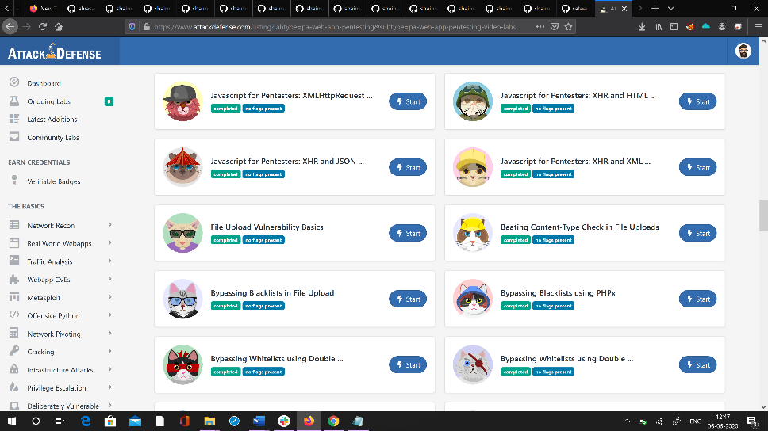

Codingchallengesonlinedetails:

WriteaPythonprogramtoconvertsecondstoday,hour,minutesand seconds

time=float(input("Inputtimeinseconds:")) day=time//(24*3600)

time=time%(24*3600)

hour=time//3600

time%=3600

minutes=time//60

time%=60

seconds=time

print("day:->%d"%(day))

print("hour:->%d"%(hour))

print("minutes:->%d"%(minutes))

print("seconds:->%d"%(seconds))