DAILYONLINEACTIVITIESSUMMARY

|  |  |  |  |  |  |  |  |
| --- | --- | --- | --- | --- | --- | --- | --- |
| Date: | 06-06-2020 | | | | Name: | Safeeq bidarkundi | |
| Sem& Sec | VIIISemester&BSection | | | | USN: | 4AL15cs111 | |
| OnlineTestSummary | | | | | | | |
| Subject | | IOT4 | | | | | |
| Max.Marks | | 30 | | Score | | 30 | |
| CertificationCourseSummary | | | | | | | |
| Course | Pentester academy | | | | | | |
| CertificateProvider | | | Pentester academy | Duration | | | 7Hrs |
| CodingChallenges | | | | | | | |
| ProblemStatement:WriteaprograminCtorotateanarraybyNpositions | | | | | | | |
| Status:COMPLETED | | | | | | | |
| UploadedthereportinGithub | | | | YES | | | |
| IfyesRepositoryname | | | | safeeq | | | |
| Uploadedthereportinslack | | | | YES | | | |

OnlineTestDetails:

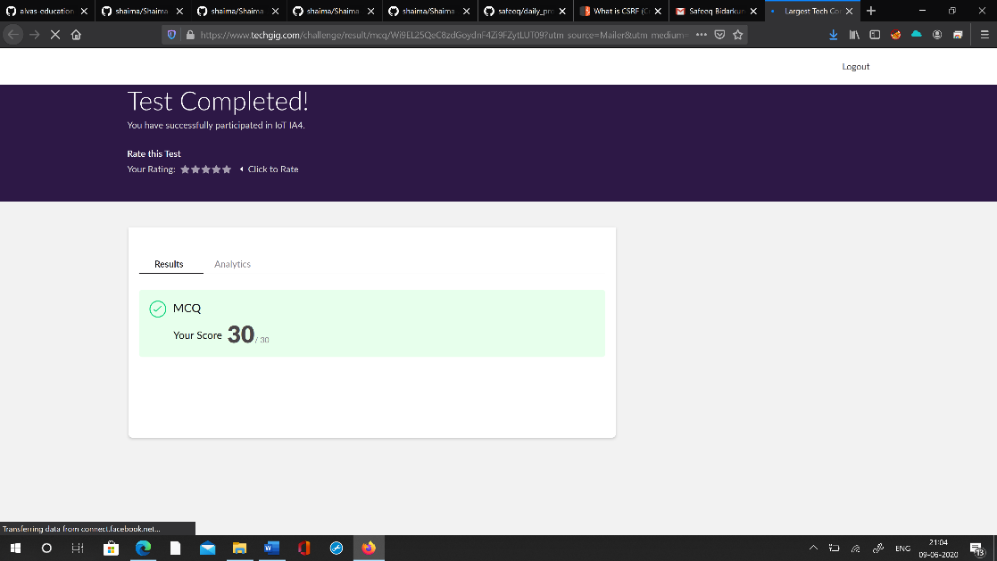

CertificationCourseDetails:



Codingchallengesonlinedetails:

#include<iostream> usingnamespacestd; intmain()

{

intarr[]={1,2,3,4,5,6,7,8,9,10}; inti,N,len,j;

N=3;

len=10; inttemp=0; for(i=0;i<N;i++)

{

intx=arr[0]; for(j=0;j<len;j++)

{

temp=arr[j]; arr[j]=arr[j+1]; arr[j+1]=temp;

}

arr[len-1]=x;

}

for(i=0;i<len;i++)

{

cout<<arr[i]<<"\t";

}

}