**DAILY ONLINE ACTIVITIES SUMMARY**

|  |  |  |  |  |  |  |  |
| --- | --- | --- | --- | --- | --- | --- | --- |
| **Date:** | **07-06-2020** | | | | **Name:** | **Safeeq bidarkundi** | |
| **Sem & Sec** | **VIII Semester & ASection** | | | | **USN:** | **4AL15cs111** | |
| **Online Test Summary** | | | | | | | |
| **Subject** | | **-** | | | | | |
| **Max. Marks** | | **-** | | **Score** | | **-** | |
| **Certification Course Summary** | | | | | | | |
| **Course** | **Pentester** | | | | | | |
| **Certificate Provider** | | | **pentesterAcademy** | **Duration** | | | **3 Hrs** |
| **Coding Challenges** | | | | | | | |
| **Problem Statement: Write a program in C to get and set system date time in Windows** | | | | | | | |
| **Status: COMPLETED** | | | | | | | |
| **Uploaded the report in Github** | | | | **YES** | | | |
| **If yes Repository name** | | | | **SAFEEQ** | | | |
| **Uploaded the report in slack** | | | | **YES** | | | |

**Online Test Details:**

**Certification Course Details:**

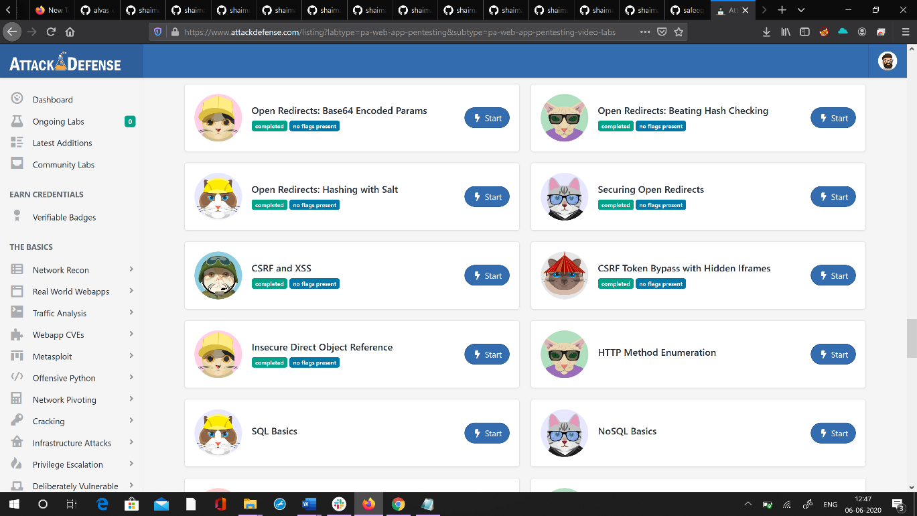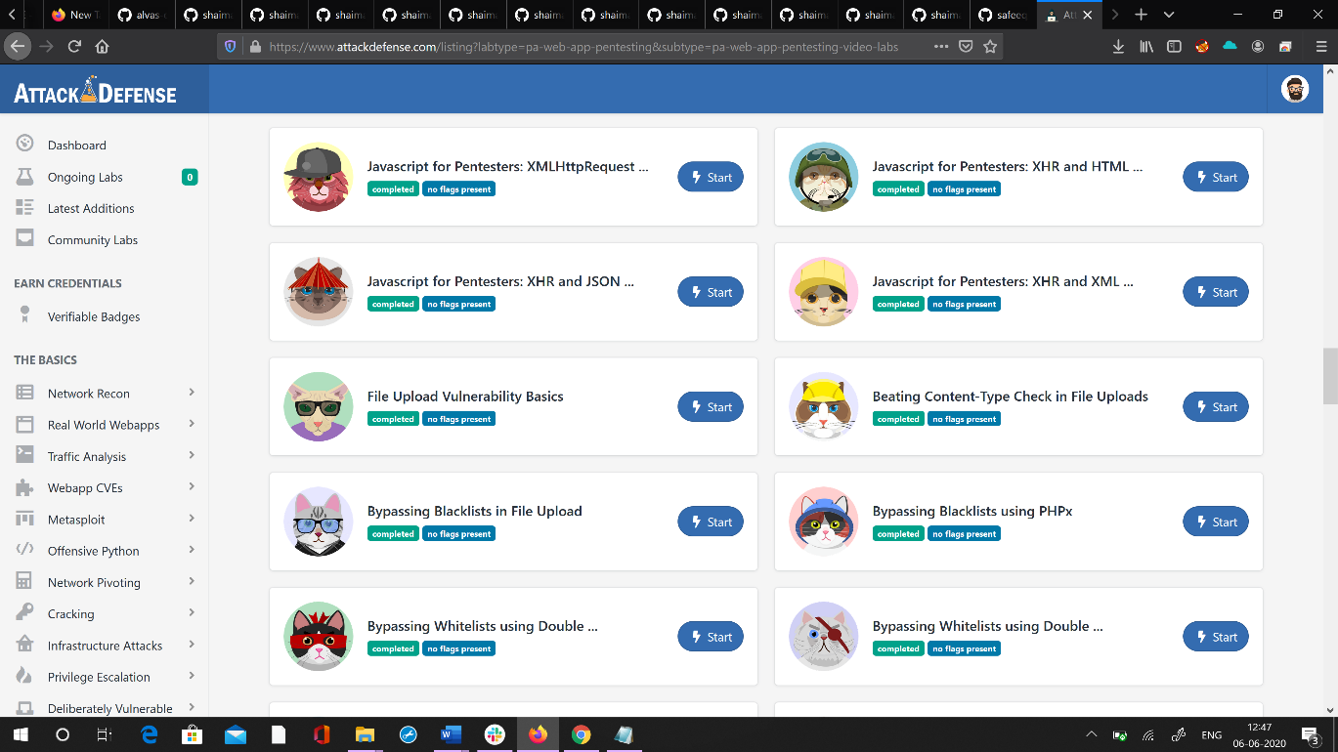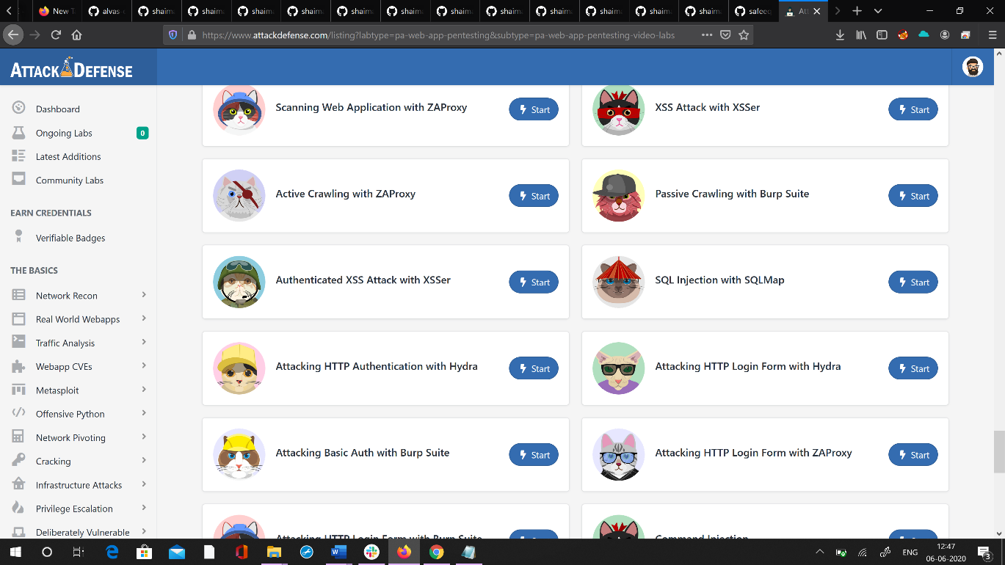

**Coding challenges online details :**

**#include <stdio.h> #include <dos.h>**

**int main()**

**{**

**char choice; struct dosdate_t date; /*predefine structure to get date*/**

**_dos_getdate(&date); printf("\nCurrent date is : %02d -%02d -%02d",date.day,date.month,date.year); printf("\nWant to change date (Y: yes):"); choice=getchar(); if(choice=='Y'||choice=='y'){ printf("Enter new date :\n");**

**printf("Enter day :"); scanf("%d",&date.day); printf("Enter month:"); scanf("%d",&date.month); printf("Enter year :"); scanf("%d",&date.year);**

**_dos_setdate(&date); printf("\nDate changed successfully.");**

**}**

**return 0;**

**}**