DAILY ONLINE ACTIVITIES SUMMARY

|  |  |  |  |  |  |  |  |
| --- | --- | --- | --- | --- | --- | --- | --- |
| Date: | 08-06-2020 | | | | Name: | SAFEEQ BODARKUNDI | |
| Sem & Sec | VIII Semester & ASection | | | | USN: | 4AL15CS111 | |
| Online Test Summary | | | | | | | |
| Subject | | SMS | | | | | |
| Max. Marks | | 60 | | Score | | 60 | |
| Certification Course Summary | | | | | | | |
| Course | Data visualization using python (Completed) | | | | | | |
| Certificate Provider | | | Great Learning Academy | Duration | | | 7 Hrs |
| Coding Challenges | | | | | | | |
| Problem Statement: Program to make a simple calculator | | | | | | | |
| Status: COMPLETED | | | | | | | |
| Uploaded the report in Github | | | | YES | | | |
| If yes Repository name | | | | safeeq | | | |
| Uploaded the report in slack | | | | YES | | | |

Online Test Details:

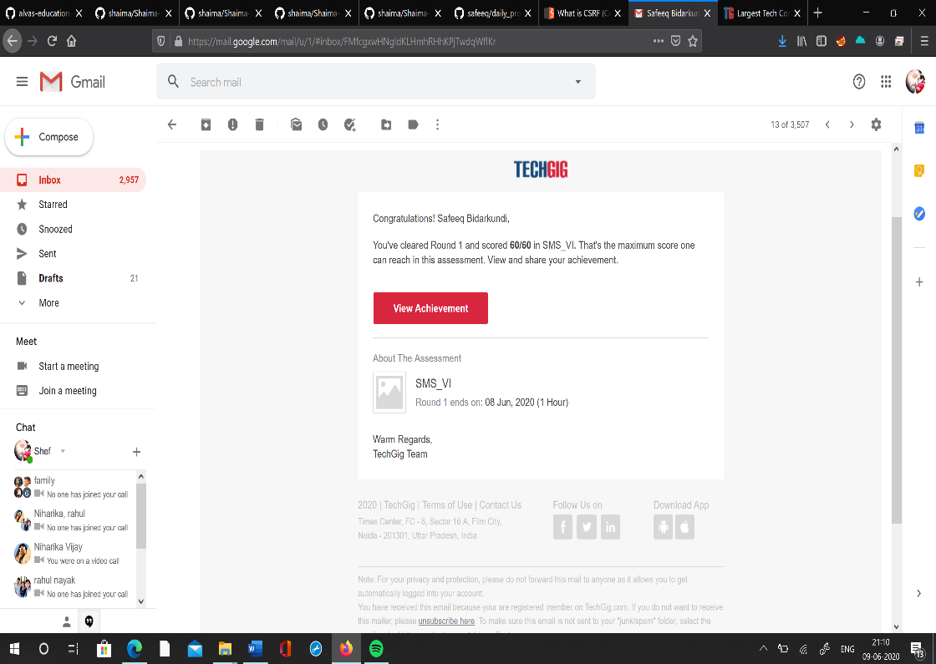

Certification Course Details:

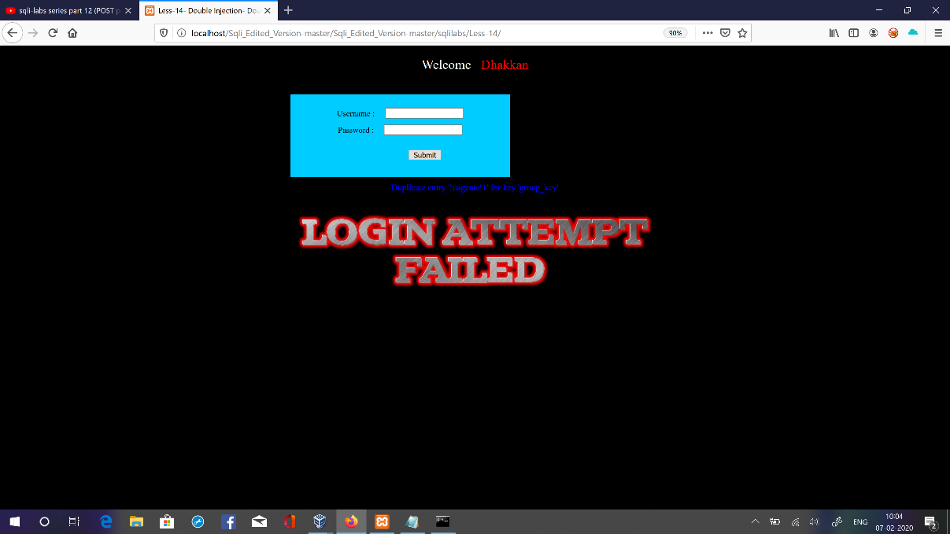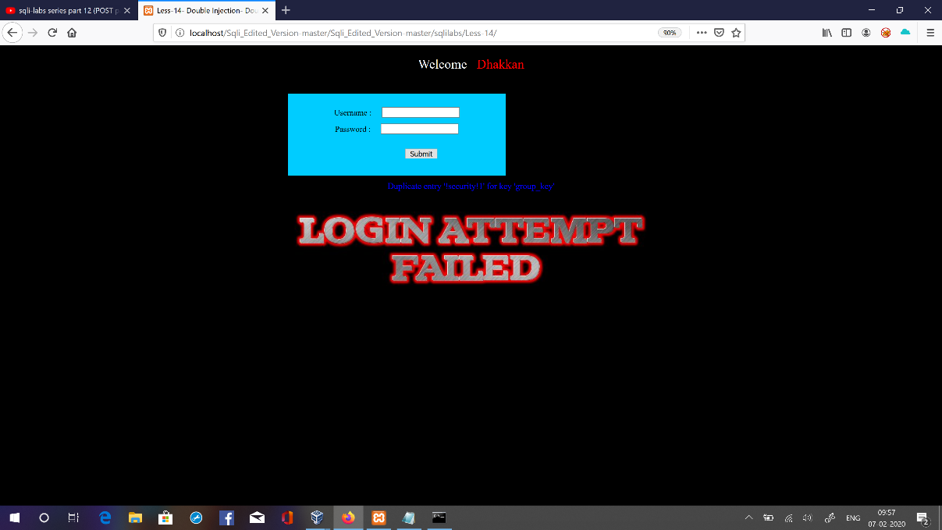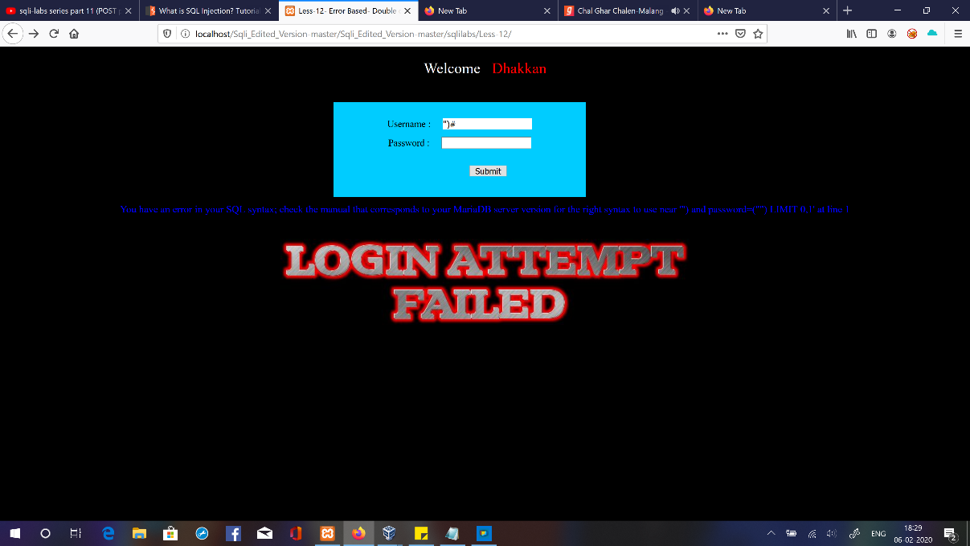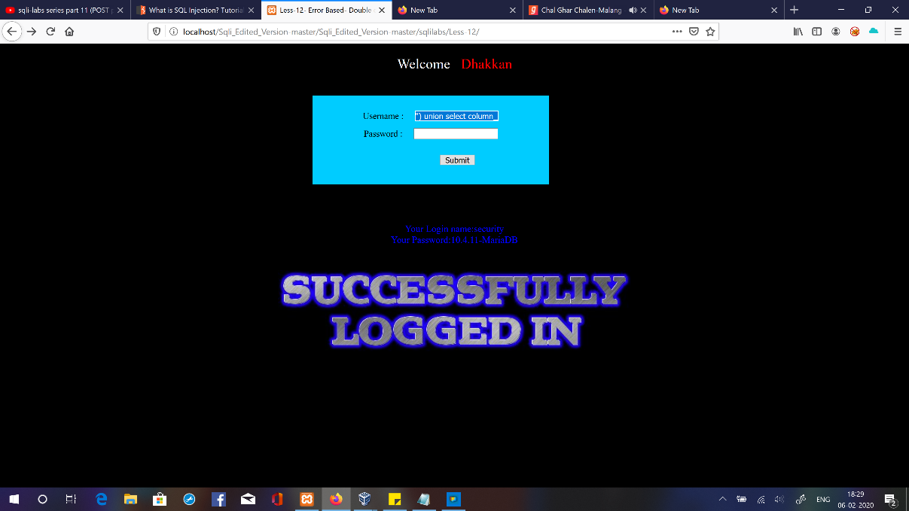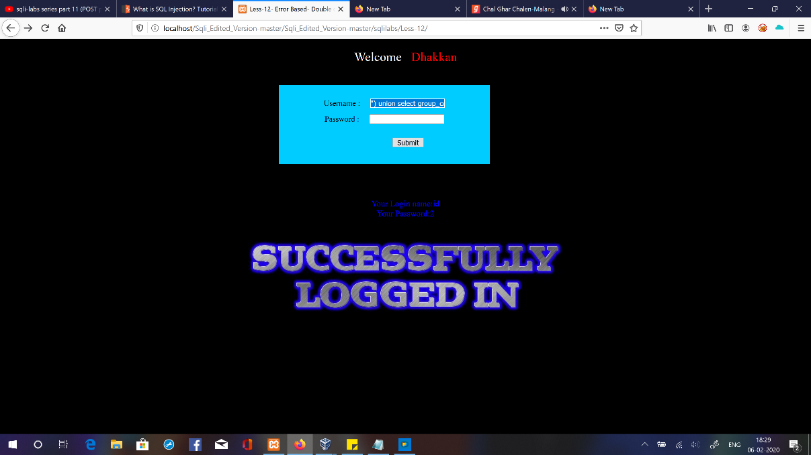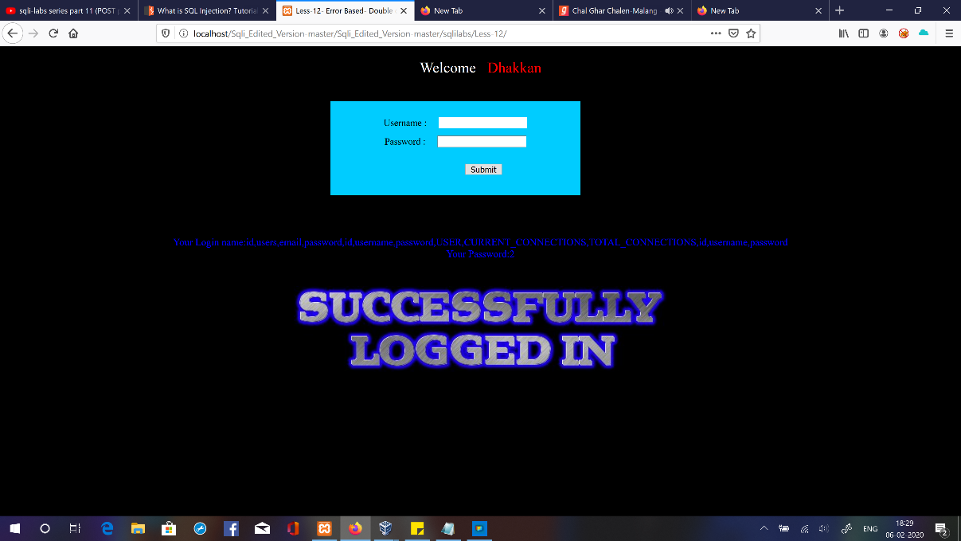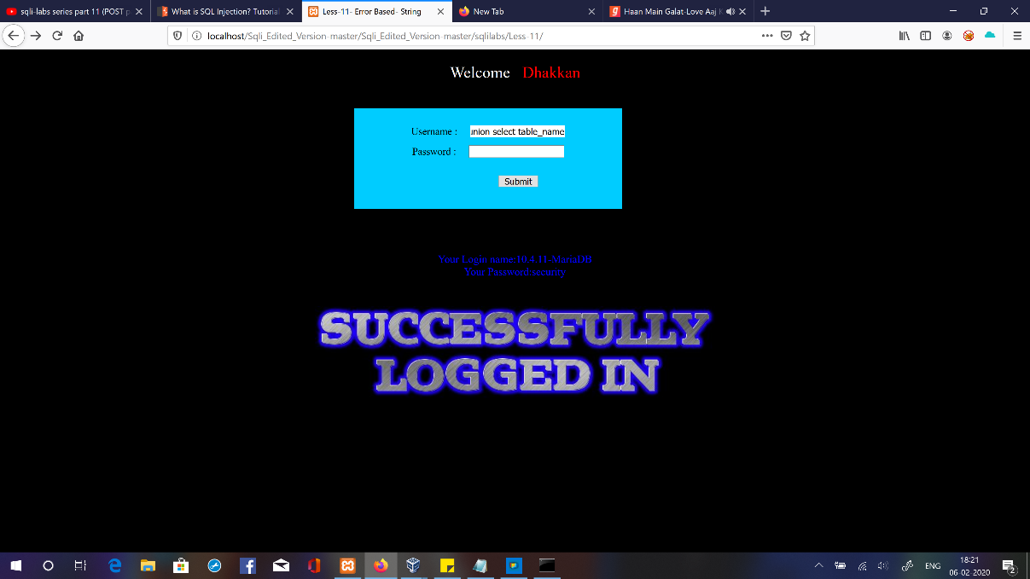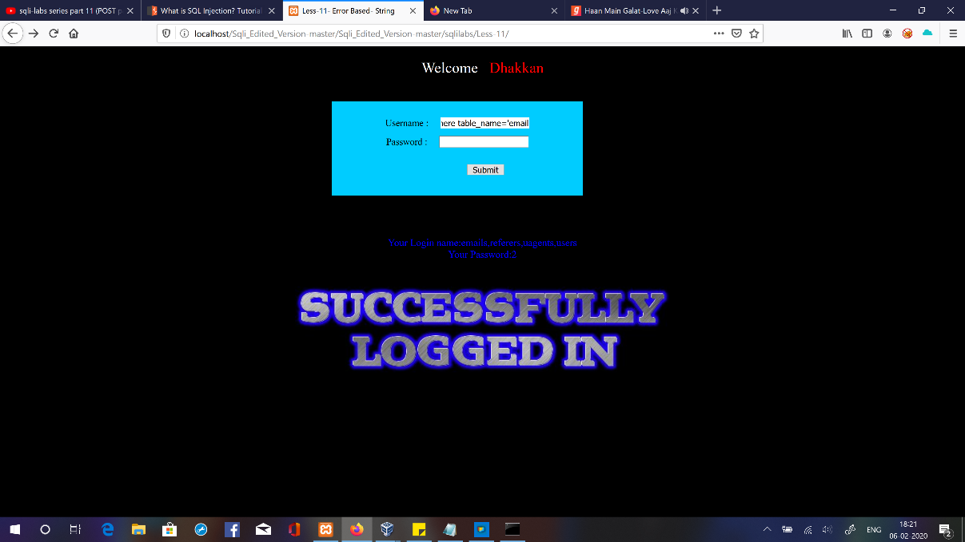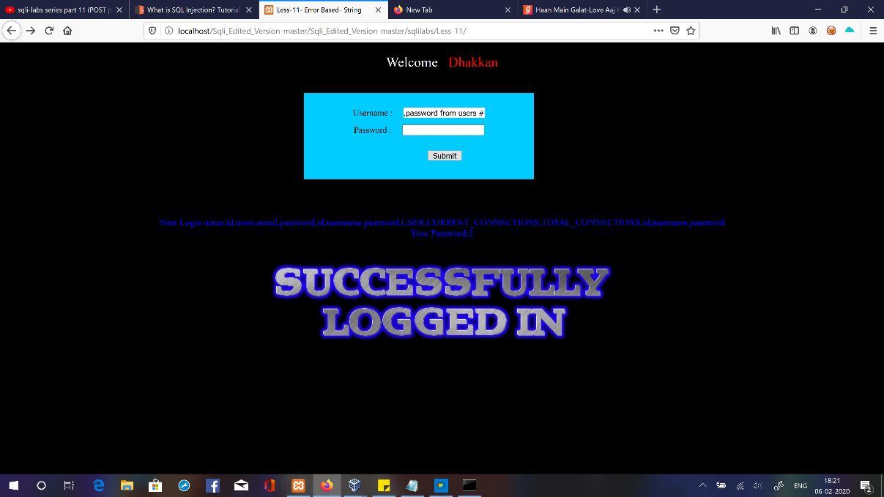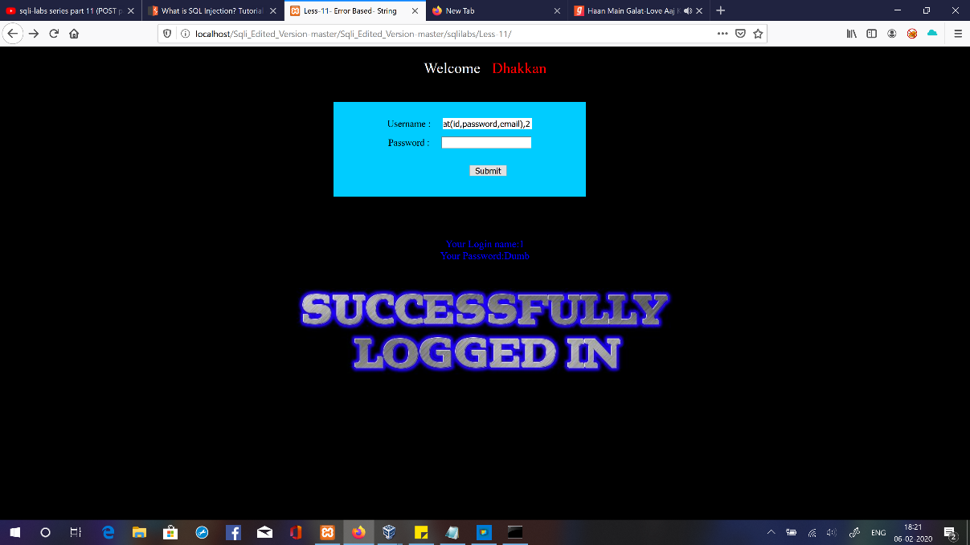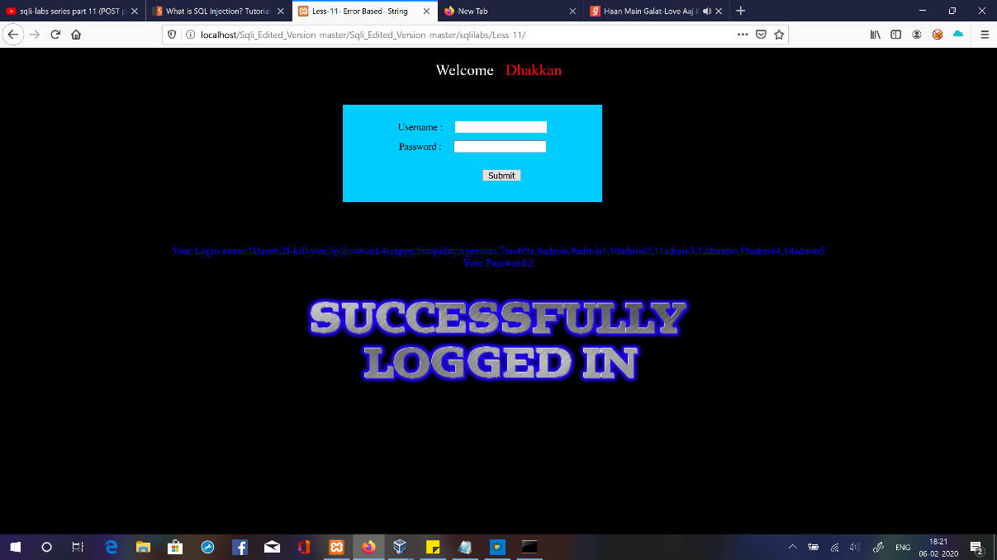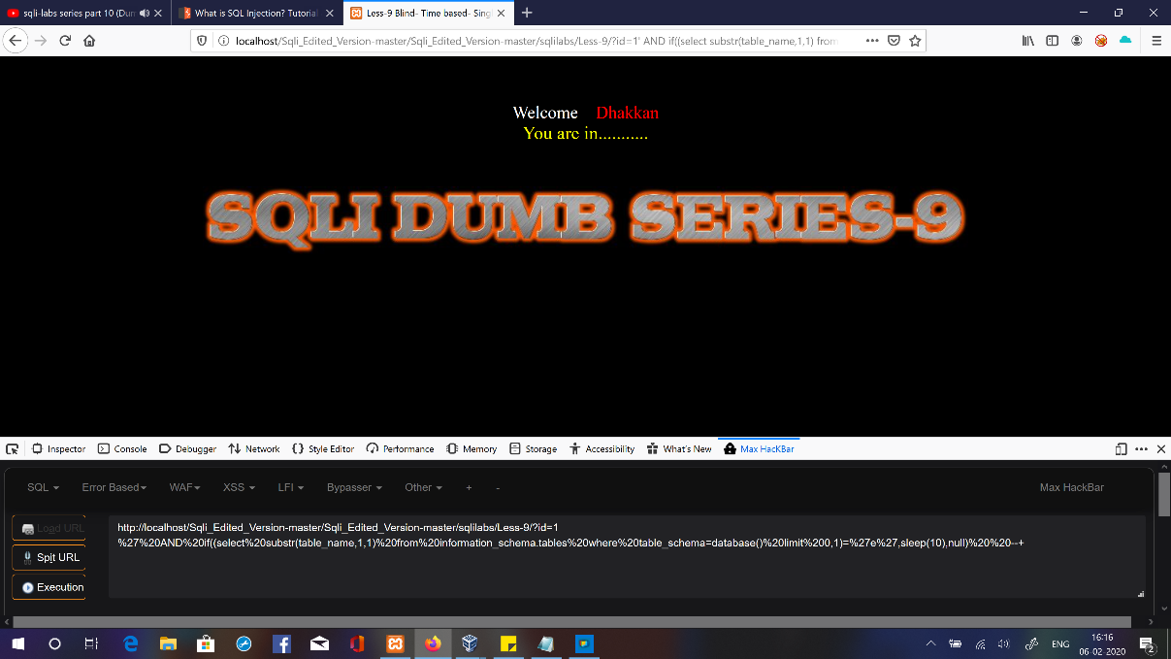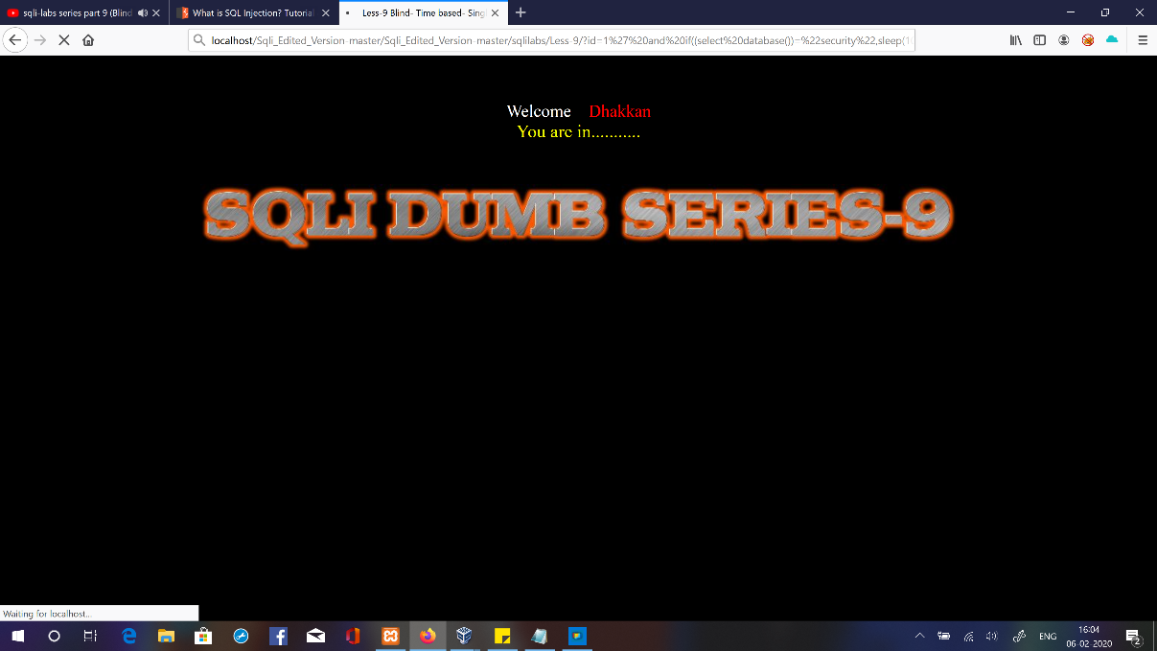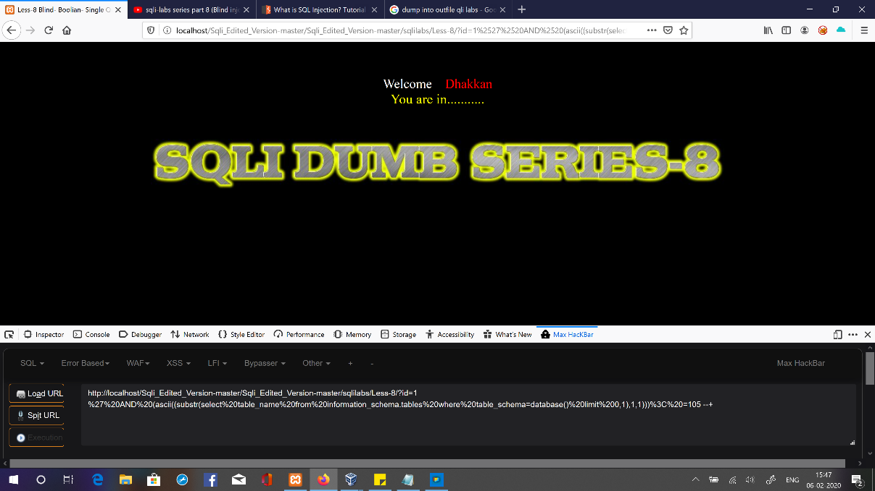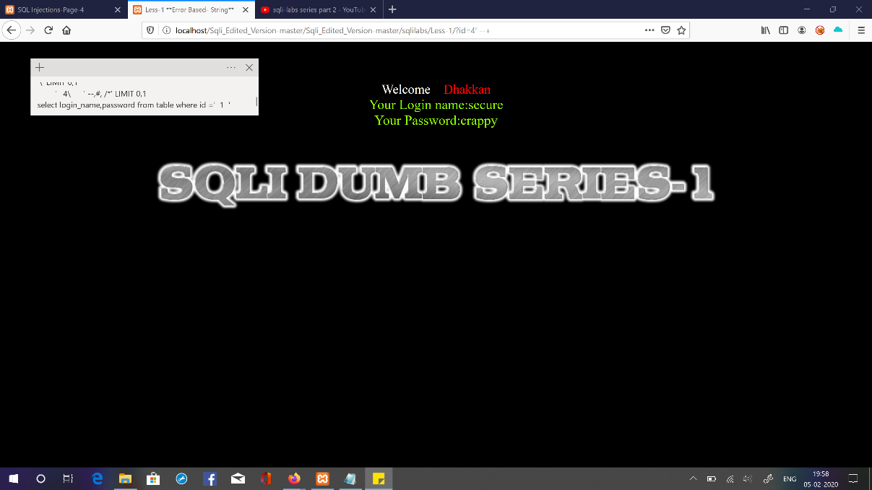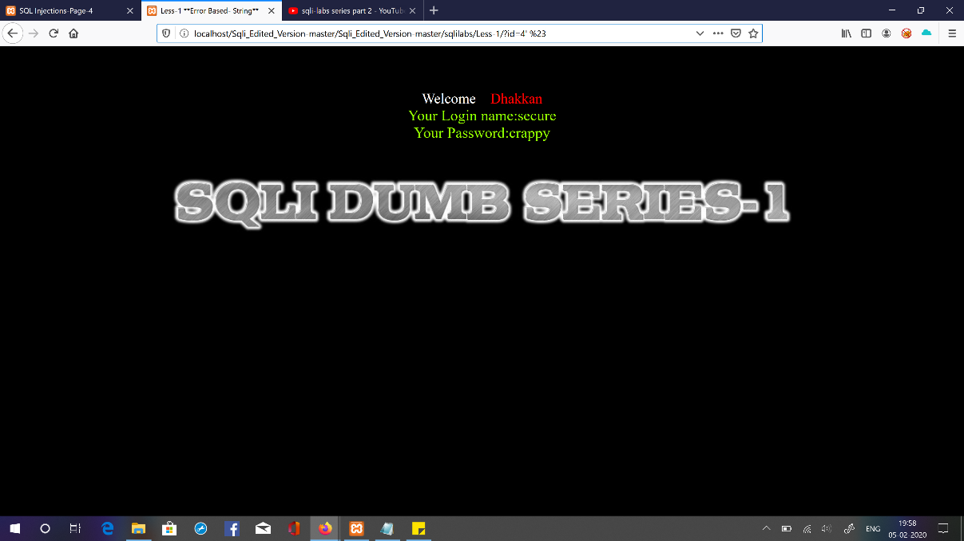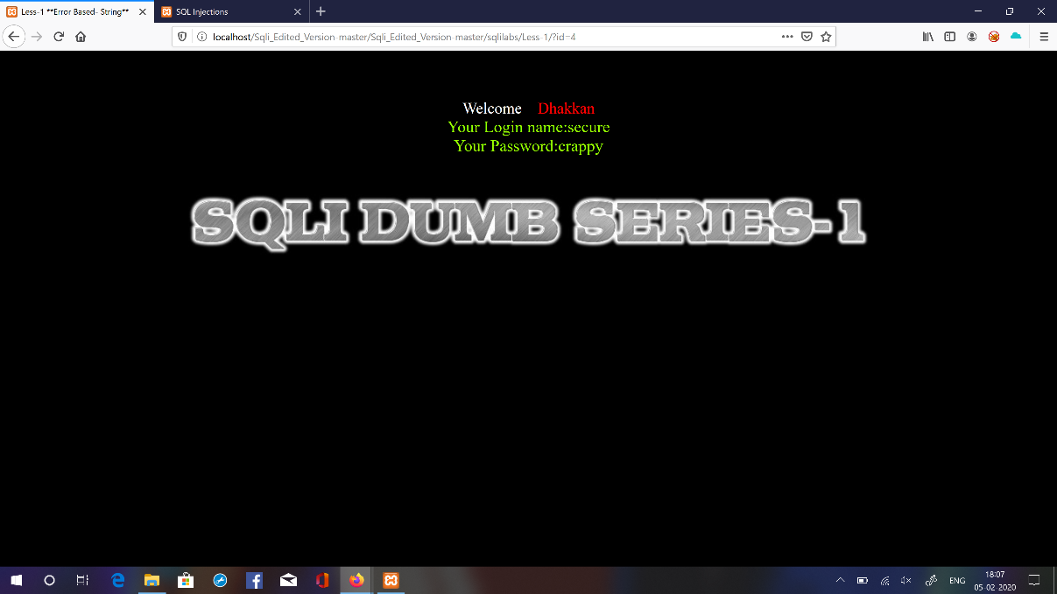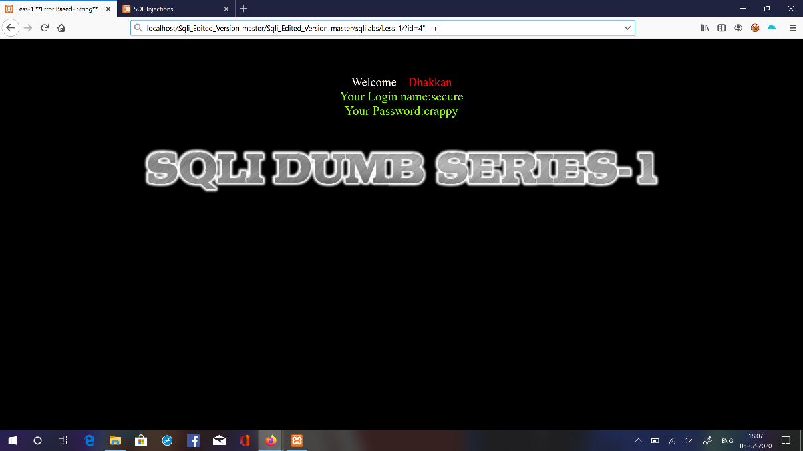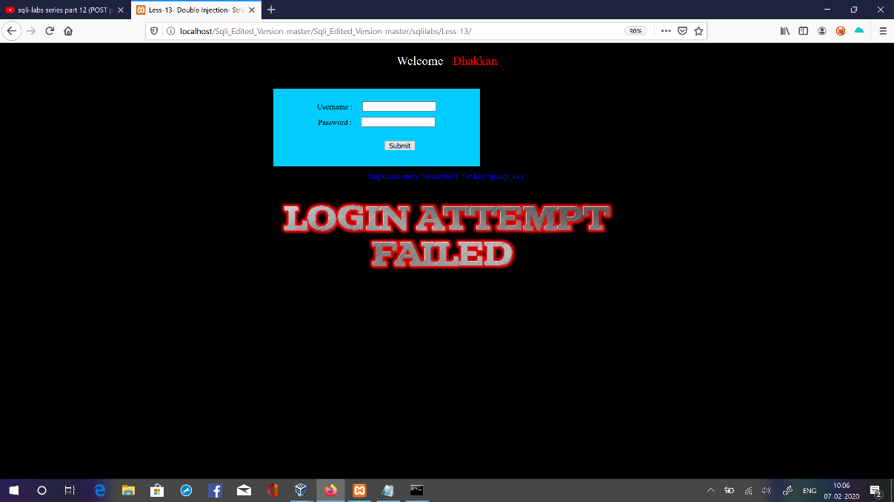

Coding challenges online details :

Program to make a simple calculator

def add(x, y): return x + y def subtract(x, y):

return x - y def multiply(x, y):

return x * y def divide(x, y): return x / y print("Select operation.") print("1.Add") print("2.Subtract") print("3.Multiply") print("4.Divide") while True:

choice = input("Enter choice(1/2/3/4): ")

if choice in ('1', '2', '3', '4'):

num1 = float(input("Enter first number: ")) num2 = float(input("Enter second number: "))

if choice == '1': print(num1, "+", num2, "=", add(num1, num2))

elif choice == '2': print(num1, "-", num2, "=", subtract(num1, num2))

elif choice == '3': print(num1, "*", num2, "=", multiply(num1, num2))

elif choice == '4':

print(num1, "/", num2, "=", divide(num1, num2)) break else: print("Invalid Input")