**DAILY ONLINE ACTIVITIES SUMMARY**

|  |  |  |  |  |  |  |  |
| --- | --- | --- | --- | --- | --- | --- | --- |
| **Date:** | **09-06-2020** | | | | **Name:** | **Safeeq bidarkundi** | |
| **Sem & Sec** | **VIII Semester & A Section** | | | | **USN:** | **4AL15cs111** | |
| **Online Test Summary** | | | | | | | |
| **Subject** | | **BDA** | | | | | |
| **Max. Marks** | | **30** | | **Score** | | **26** | |
| **Certification Course Summary** | | | | | | | |
| **Course** | **Pentester academy** | | | | | | |
| **Certificate Provider** | | | pentester | **Duration** | | | **3 Hrs** |
| **Coding Challenges** | | | | | | | |
| **Problem Statement: C Program to concatenate two strings.** | | | | | | | |
| **Status: COMPLETED** | | | | | | | |
| **Uploaded the report in Github** | | | | **YES** | | | |
| **If yes Repository name** | | | | **safeeq** | | | |
| **Uploaded the report in slack** | | | | **YES** | | | |

**Online Test Details:**

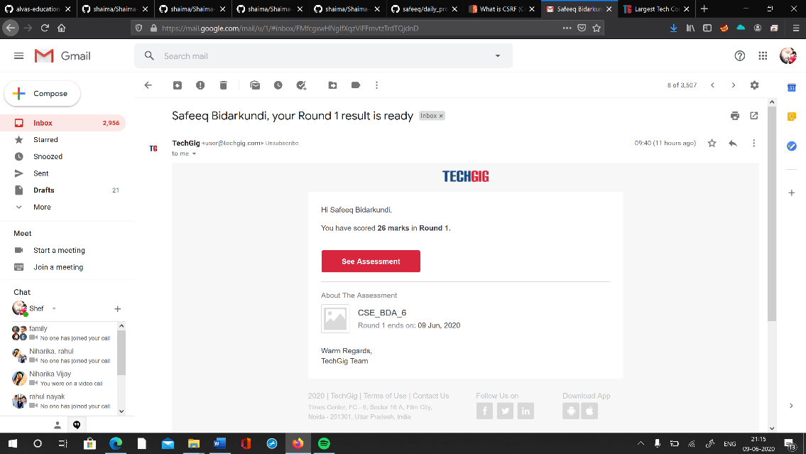

**Certification Course Details:**

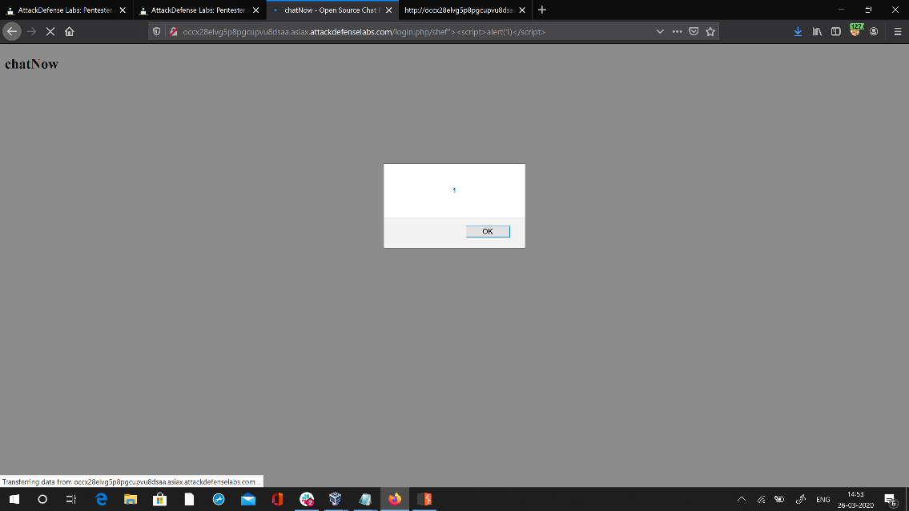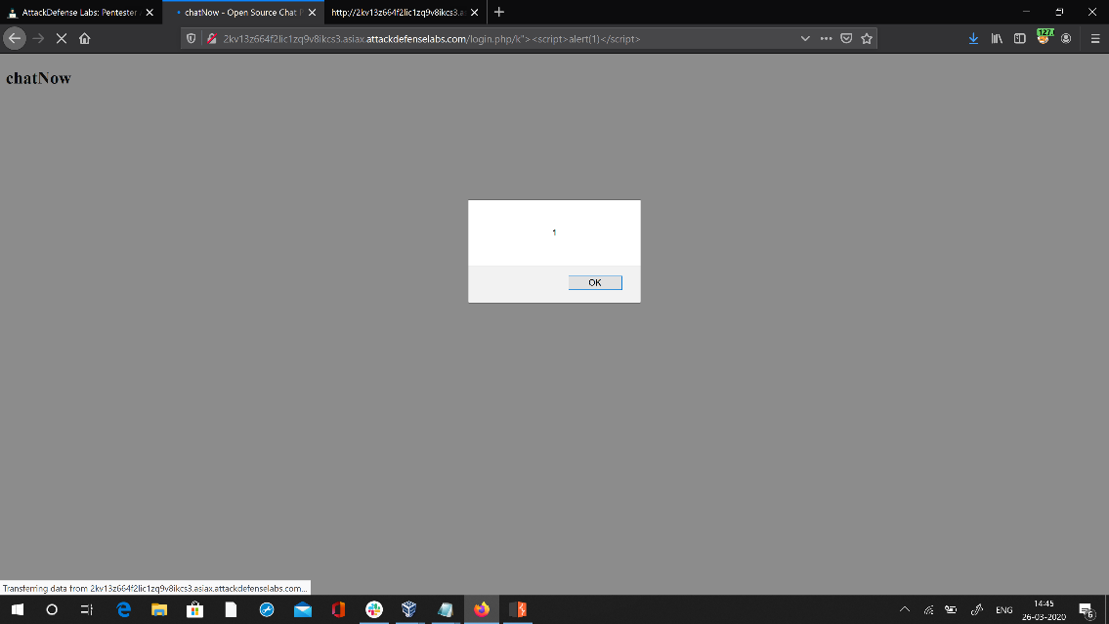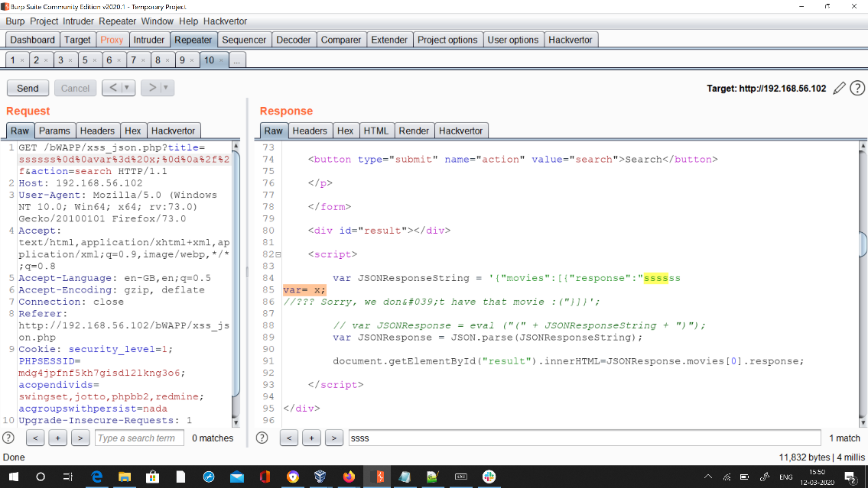

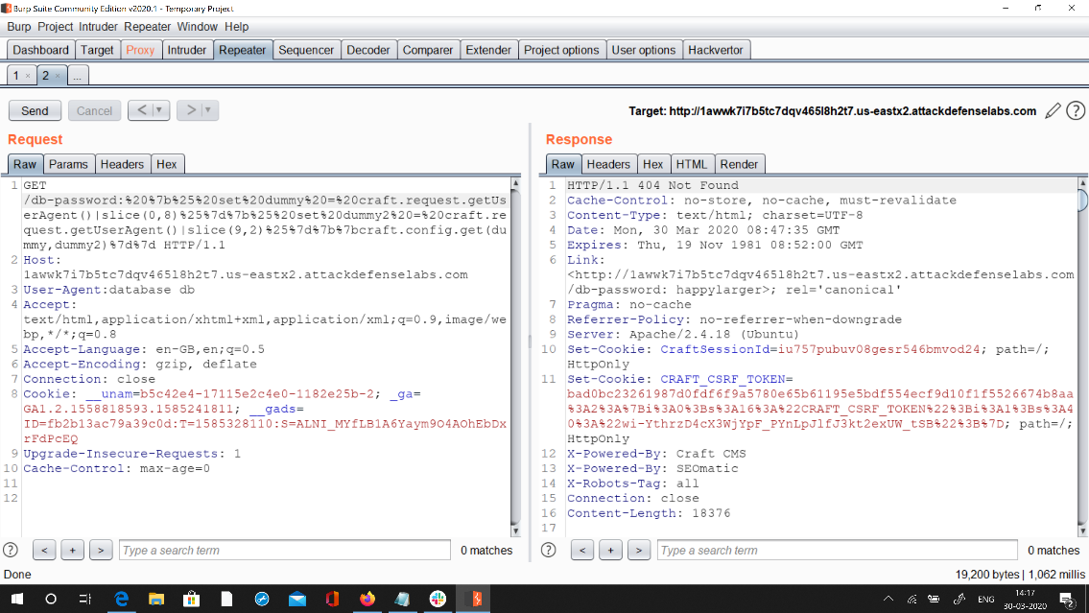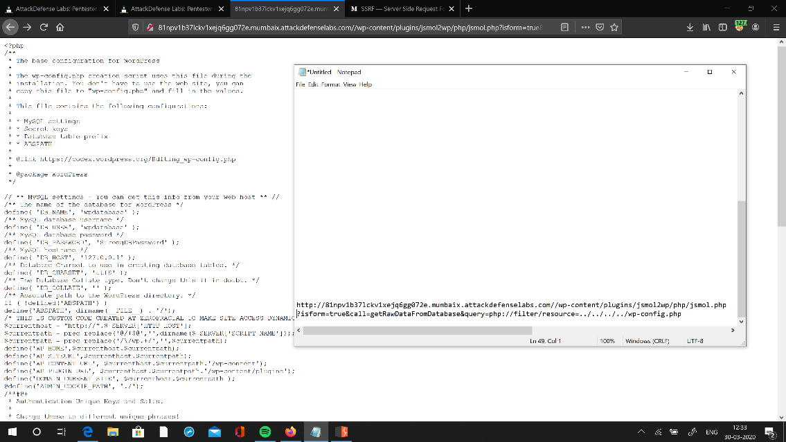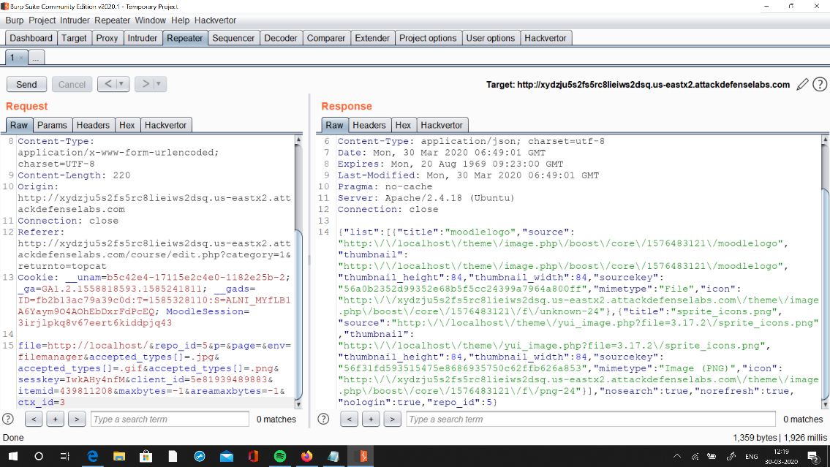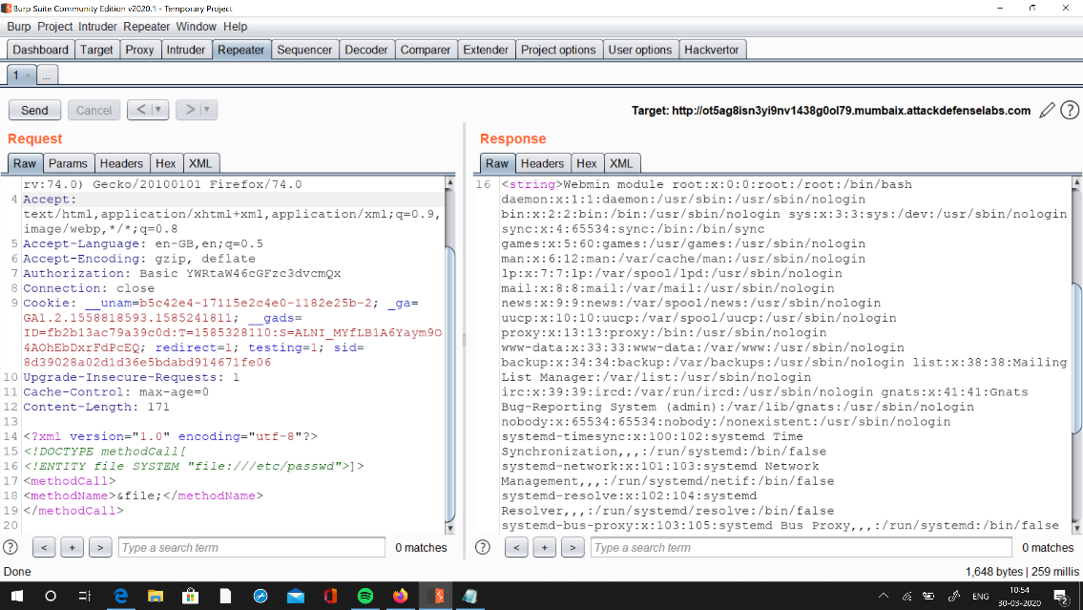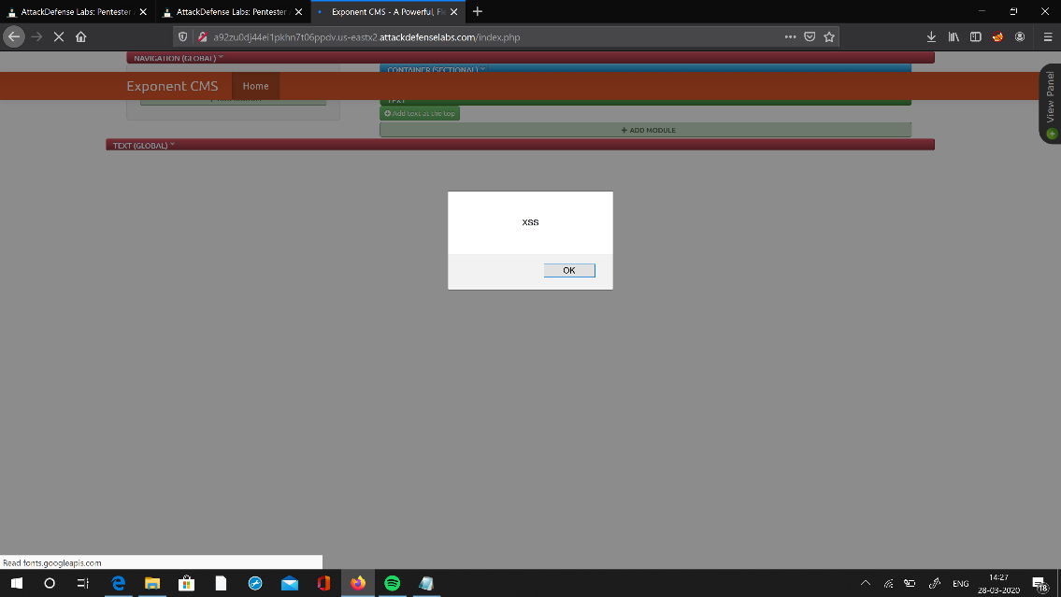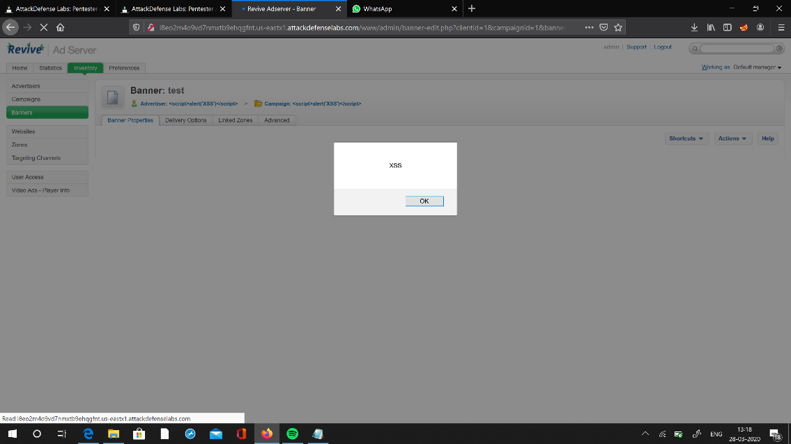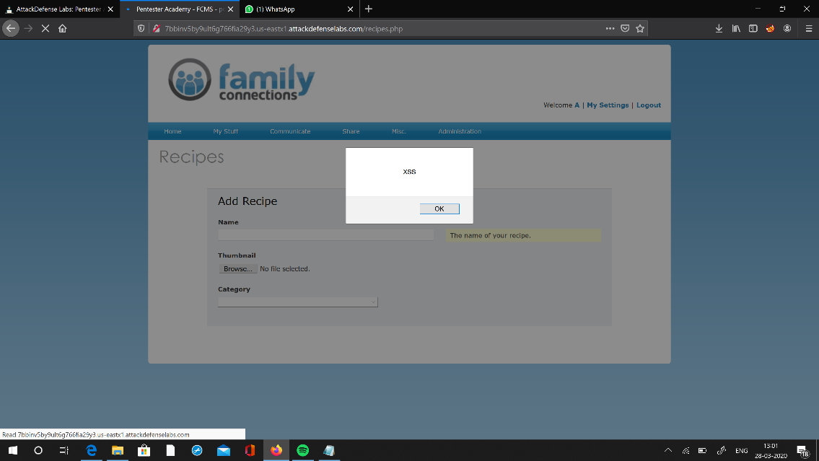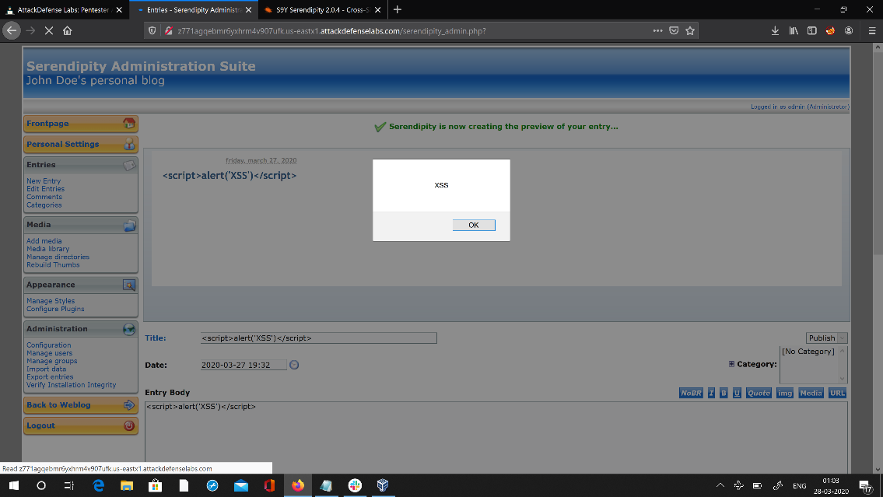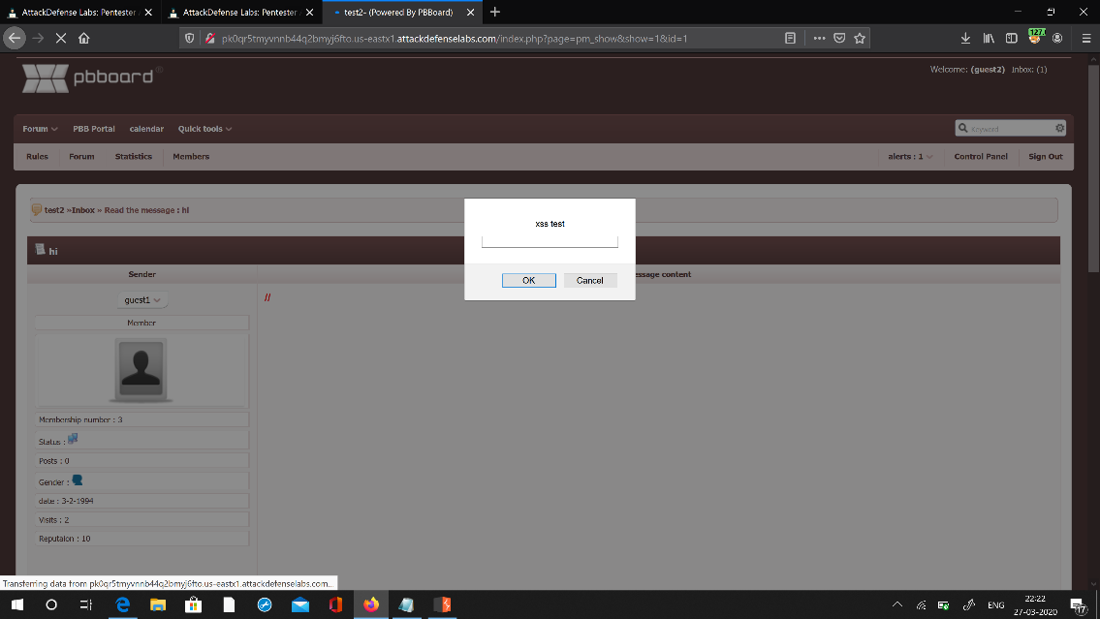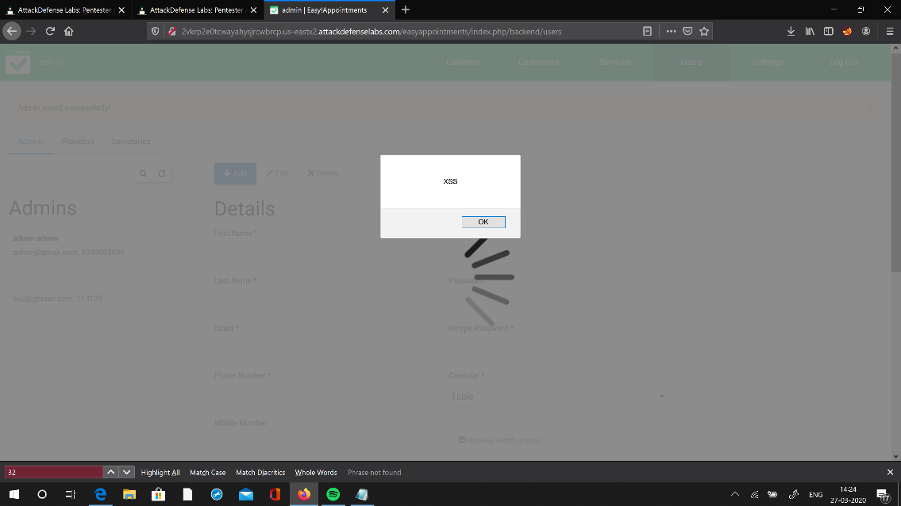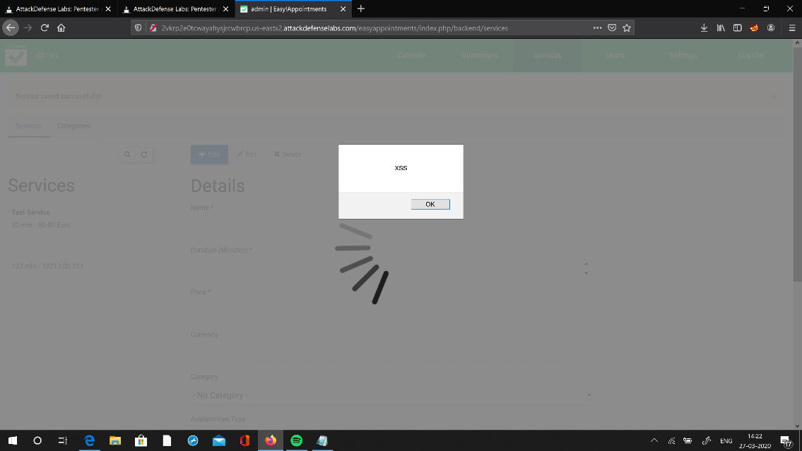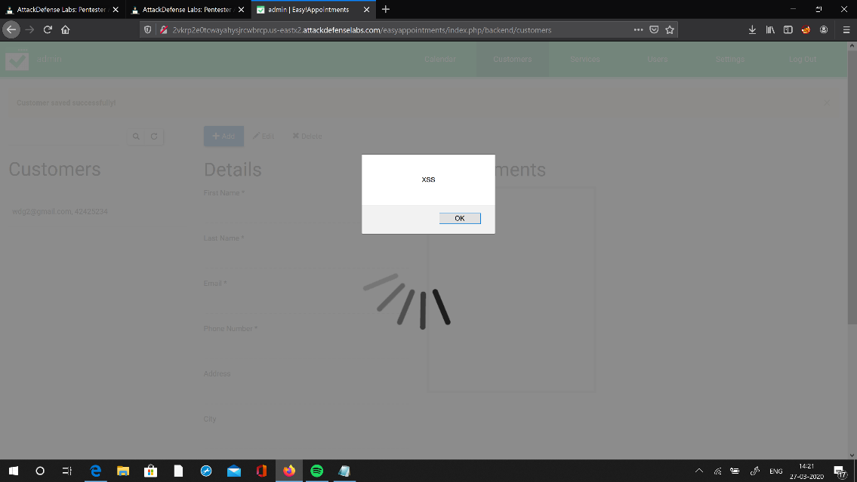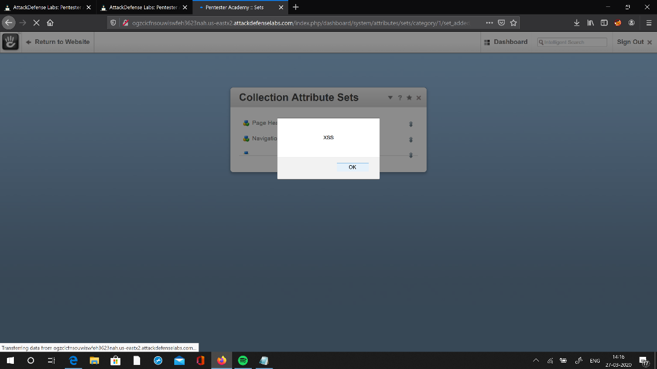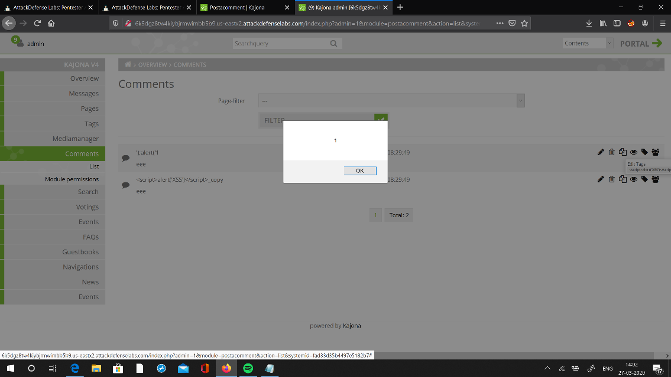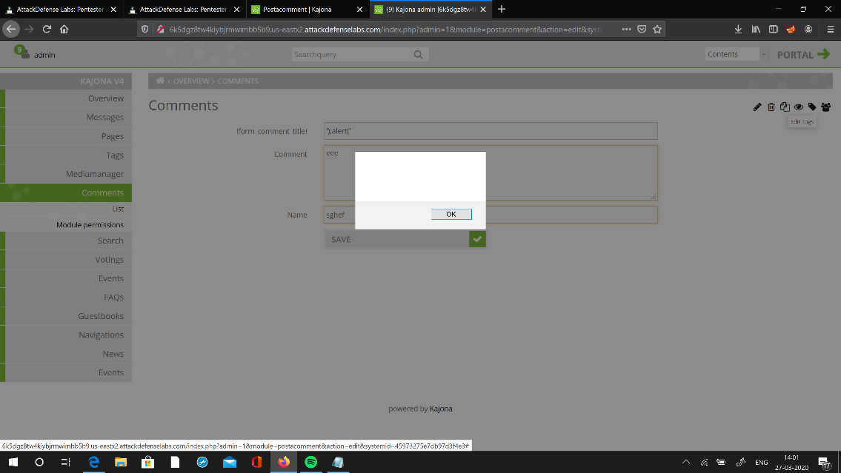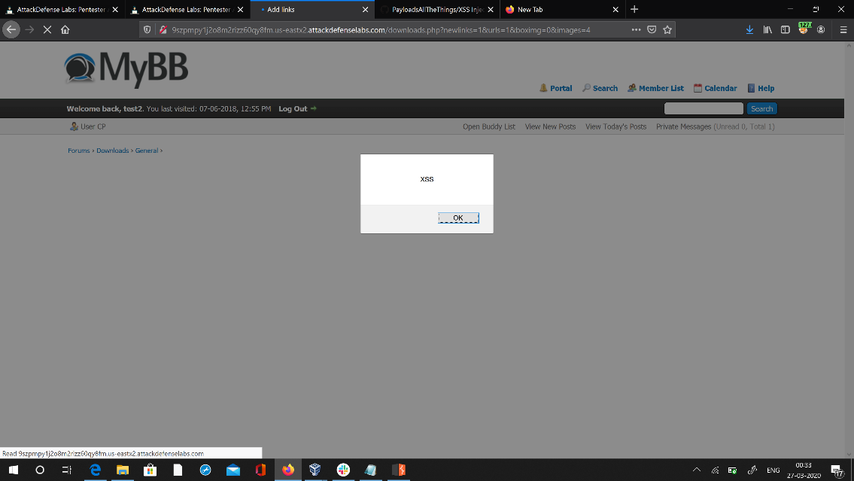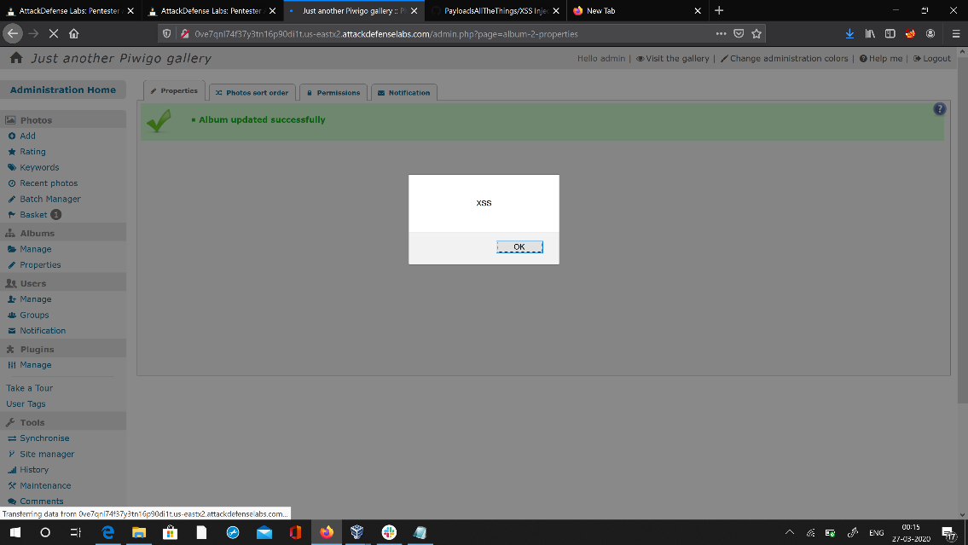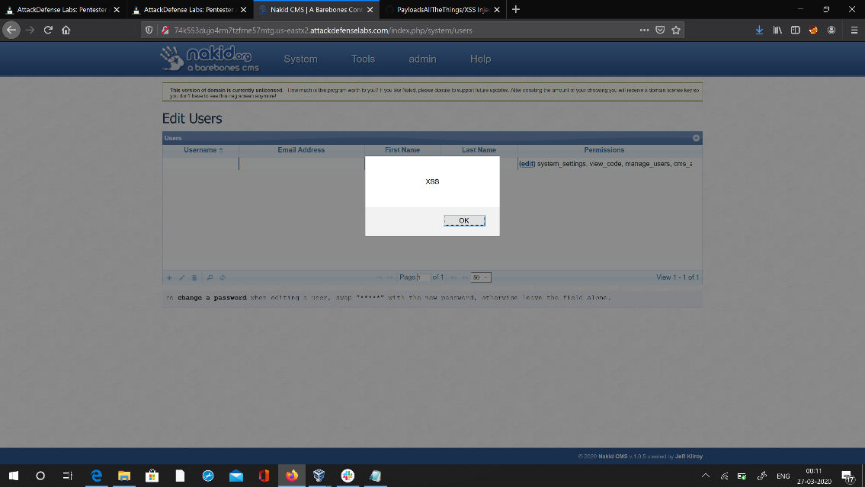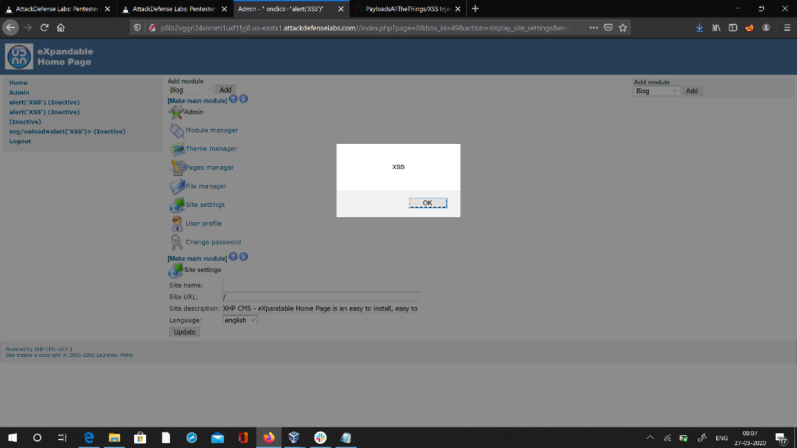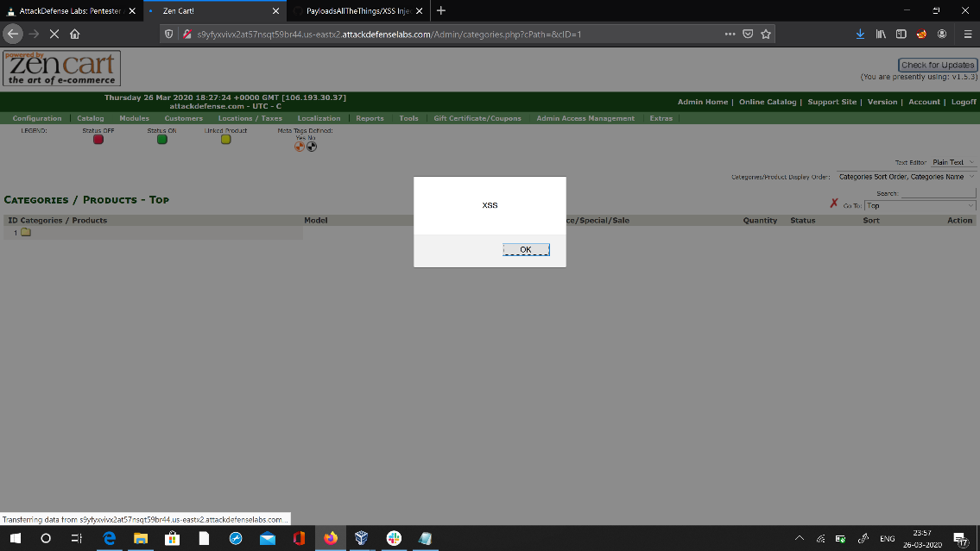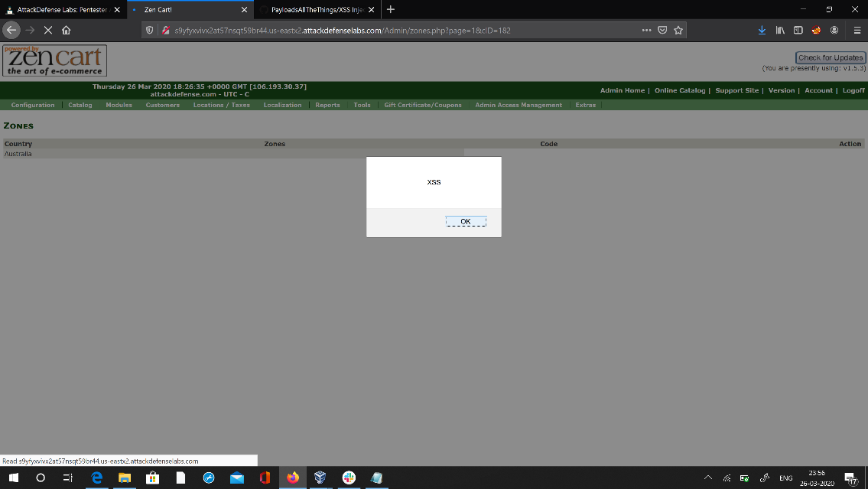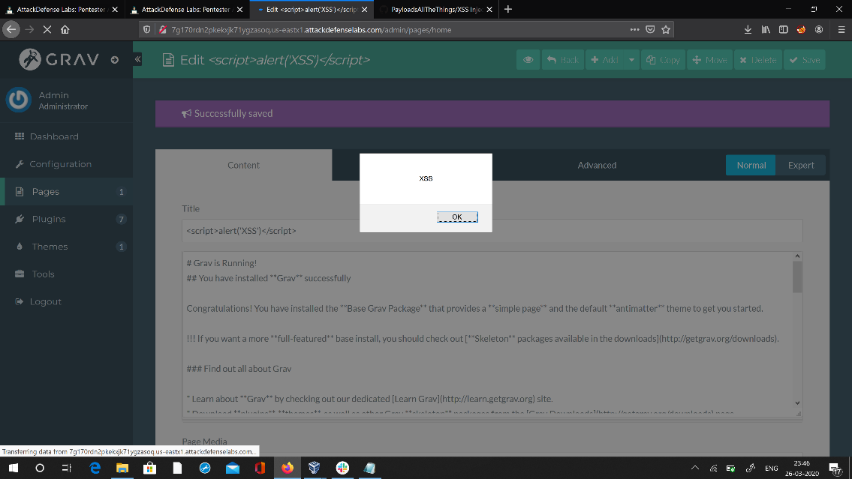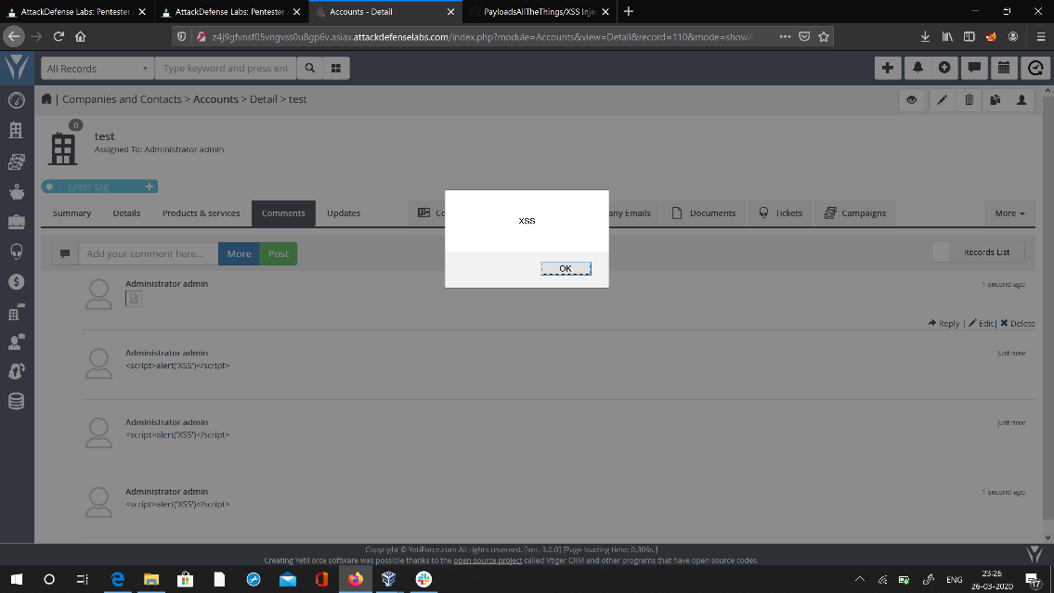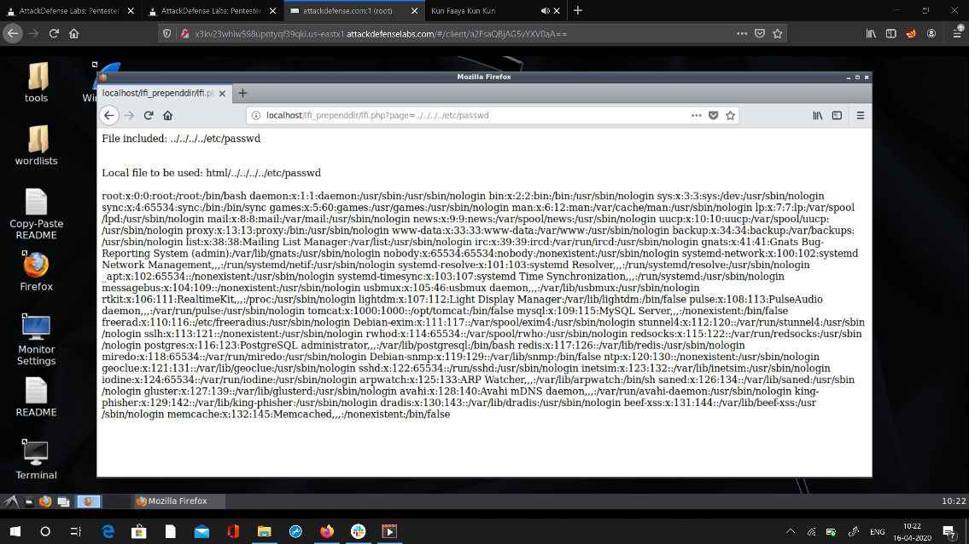

**Coding challenges online details :**

**#include <stdio.h> int main() { char s1[100] = "programming ", s2[] = "is awesome";**

**int i, j;**

**// length of s1 is stored in i for (i = 0; s1[i] != '\0'; ++i) { printf("i = %d\n", i);**

**}**

**// concatenating each character of s2 to s1**

**for (j = 0; s2[j] != '\0'; ++j, ++i) { s1[i] = s2[j];**

**}**

**// terminating s1 string**

**s1[i] = '\0';**

**printf("After concatenation: "); puts(s1);**

**return 0;**

**}**