**DAILY ASSESSMENT REPORT**

|  |  |  |  |
| --- | --- | --- | --- |
| **Date:** | **10 June 2020** | **Name:** | **Sampatkumar n m** |
| **Course:** | **PCB** | **USN:** | **4AL19EC401** |
| **GitHub Repository:** | **Sampatkumar1** | **Semester & Section:** | **4th Sem ‘A’ Sec** |

**FORENOON SESSION**

**Image of the session**

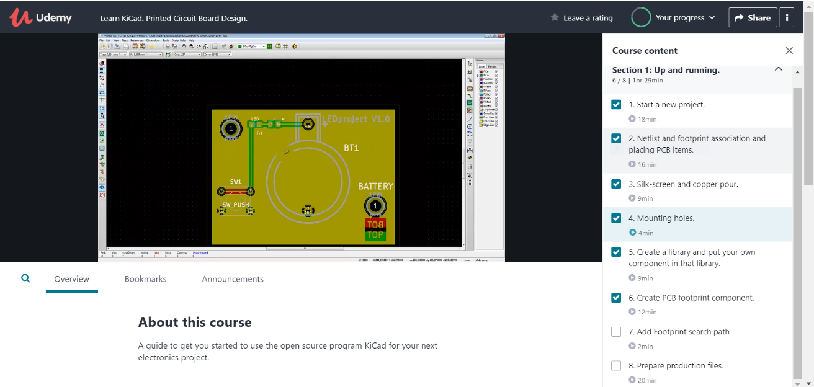

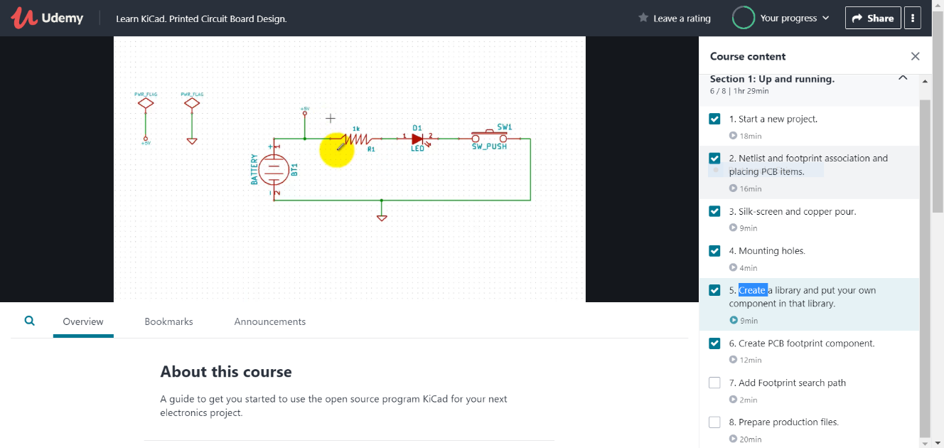

**PCB DESIGN:**

**1.Mounting holes**

**2.Create a library and put your own component in that library**

**3.Create PCB footprint component**

**AFTERNOON SESSION**

|  |  |  |  |
| --- | --- | --- | --- |
| **Date:** | **10 June 2020** | **Name:** | **Sampatkumar n m** |
| **Course:** | **JAVA** | **USN:** | **4AL19EC401** |
| **GitHub Repository:** | **Sampatkumar1** | **Semester & Section:** | **4th Sem ‘A’ Sec** |

**Image of the session**

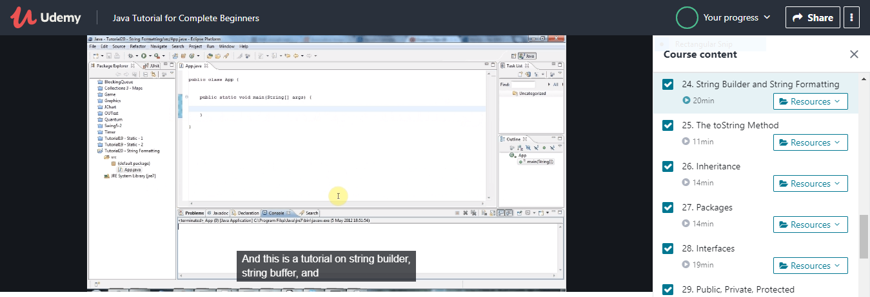

**REPORT:**

* **Arrays of strings**
* **Multi-dimensional Arrays**
* **Classes and objects**
* **Methods**
* **Getters and return values**
* **Method parameters**
* **Setters and "this"**
* **Constructors**
* **Static(and Final)**
* **String builder and string formatting**