**DAILY ASSESSMENT FORMAT**

|  |  |  |  |
| --- | --- | --- | --- |
| **Date:** | **04/06/2020** | **Name:** | **SAMPATKUMAR N M** |
| **Course:** | **Network Theory** | **USN:** | **4AL19EC401** |
| **Topic:** | **Open source circuit simulation** | **Semester & Section:** | **4th Sem**  **‘A’ Section** |
| **Github Repository:** | **Sampatkumar1** |  |  |

**FORENOON SESSION**

**Image of the session**

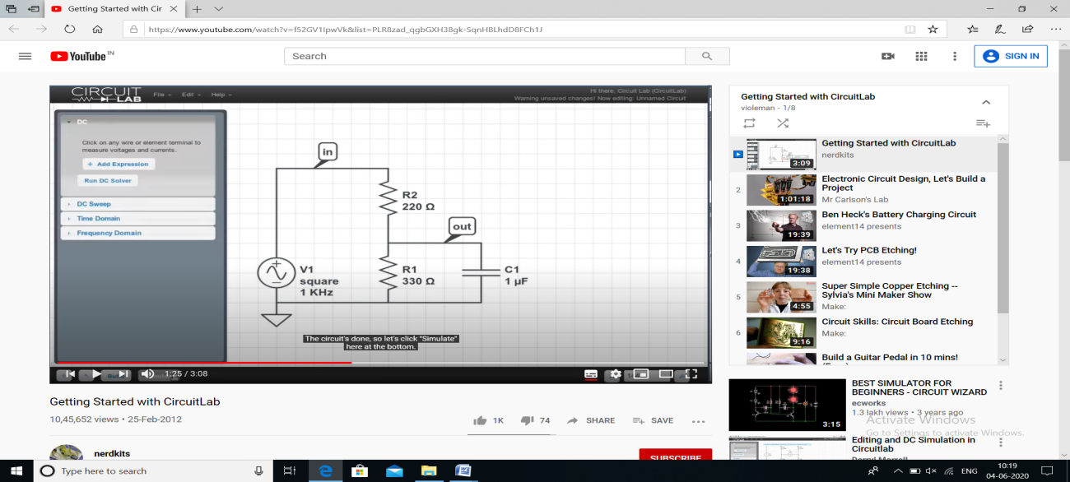

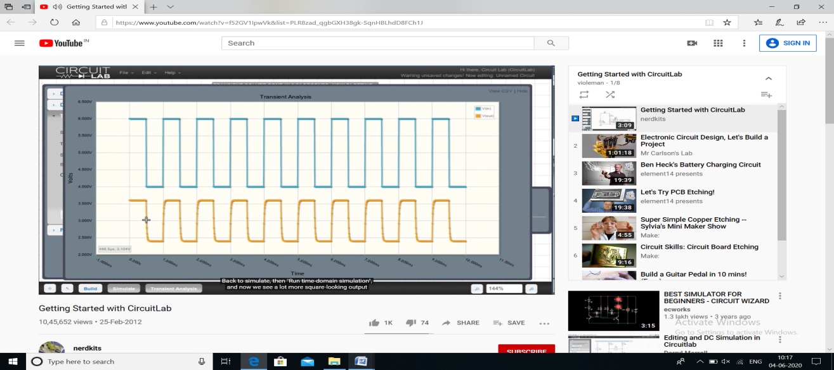

**REPORT**

* **Online open source circuit simulation**
* **Circuit Lab (Tutorials)**
* **Part Sim (Tutorials)**
* **Practice Mesh and Nodal analysis and network theorems using both the circuits.**
* **Example: RC Charging Circuit**

**It Shows a capacitor ( C ) in series with a resistor ( R ) forming an RC Charging Circuit connected across a DC battery supply (Vs). When the circuit simulates, the capacitor will gradually charge up through the resistor until the voltage across it reaches the supply voltage of the battery. The manner in which the capacitor charges up is also shown below.**