**DAILY ASSESSMENT REPORT**

|  |  |  |
| --- | --- | --- |
| **DATE** | **23/05/2020** | NAME Sampath n m |
| **COURSE** | Python for machine learning by Great learning | USN **4AL19EC401** |
| **TOPIC** | **1.Pandas** | **SEM 4th sem.A sec**  **sections** |
| **Github Repository** | Sampatkumar1 |  |

**FORENOON SESSION DETAILS**

**Image of session**

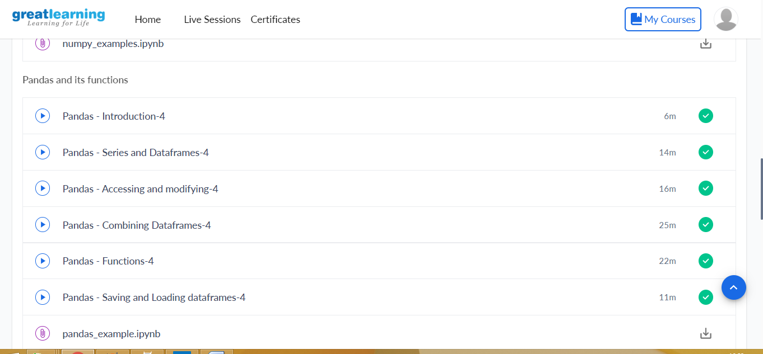

**TOPIC 1:Pandas functions**

**Saving and loading data frames**

**Accessing and modifying**

**Series and Dataframes**