**DAILY ONLINE ACTIVITIES SUMMARY**

|  |  |  |  |  |  |  |  |
| --- | --- | --- | --- | --- | --- | --- | --- |
| **Date:** | **04-07-2020** | | | | **Name:** | **Sannidhi P** | |
| **Sem & Sec** | **8th sem B sec** | | | | **USN:** | **4AL16CS084** | |
| **Online Test Summary** | | | | | | | |
| **Subject** | | **-----** | | | | | |
| **Max. Marks** | | **---** | | **Score** | | **----** | |
| **Certification Course Summary** | | | | | | | |
| **Course** | **SOLOLEARN** | | | | | | |
| **Certificate Provider** | | | **JAVASCRIPT Tutorial** | **Duration** | | | **2hrs** |
| **Coding Challenges** | | | | | | | |
| **Problem Statement-** :  **Program to find HCF of two numbers** | | | | | | | |
| **Status: completed** | | | | | | | |
| **Uploaded the report in Github** | | | | **yes** | | | |
| **If yes Repository name** | | | | **Sannidhi1** | | | |
| **Uploaded the report in slack** | | | | **yes** | | | |

**Certification Course Details:**

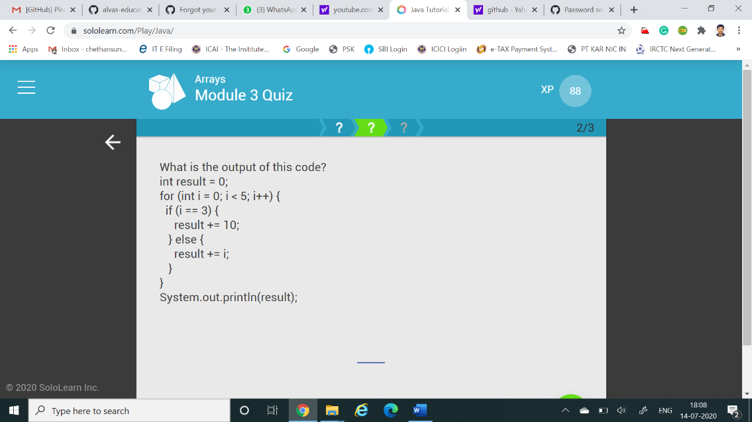

**.**

**Coding Challenges Details:**

**Python program to find H.C.F of two numbers defcompute_hcf(x,y): ifx>y: smaller=y else: smaller=x foriinrange(1,smaller+1): if((x%i==0)and(y%i==0)):**

**hcf=i return hcf num1=54 num2=24**

**print("TheH.C.F.is",compute_hcf(num1,num2))**