**DAILY ONLINE ACTIVITIES SUMMARY**

|  |  |  |  |  |  |  |  |
| --- | --- | --- | --- | --- | --- | --- | --- |
| **Date:** | **24-06-2020** | | | | **Name:** | **Sannidhi P** | |
| **Sem & Sec** | **8th sem B sec** | | | | **USN:** | **4AL16CS084** | |
| **Online Test Summary** | | | | | | | |
| **Subject** | | **-** | | | | | |
| **Max. Marks** | | **-** | | **Score** | | **-** | |
| **Certification Course Summary** | | | | | | | |
| **Course** | **SOLOLEARN** | | | | | | |
| **Certificate Provider** | | | **JAVASCRIPT Tutorial** | **Duration** | | | **2hr** |
| **Coding Challenges** | | | | | | | |
| **Problem Statement-Problem Statement-** :**# Python program to print all prime number in an interval** | | | | | | | |
| **Status: completed** | | | | | | | |
| **Uploaded the report in Github** | | | | **yes** | | | |
| **If yes Repository name** | | | | **Sannidhi1** | | | |
| **Uploaded the report in slack** | | | | **yes** | | | |

Online Test Details: (Attach the snapshot and briefly write the report for the same)

Certification Course Details: (Attach the snapshot and briefly write the report for the same)

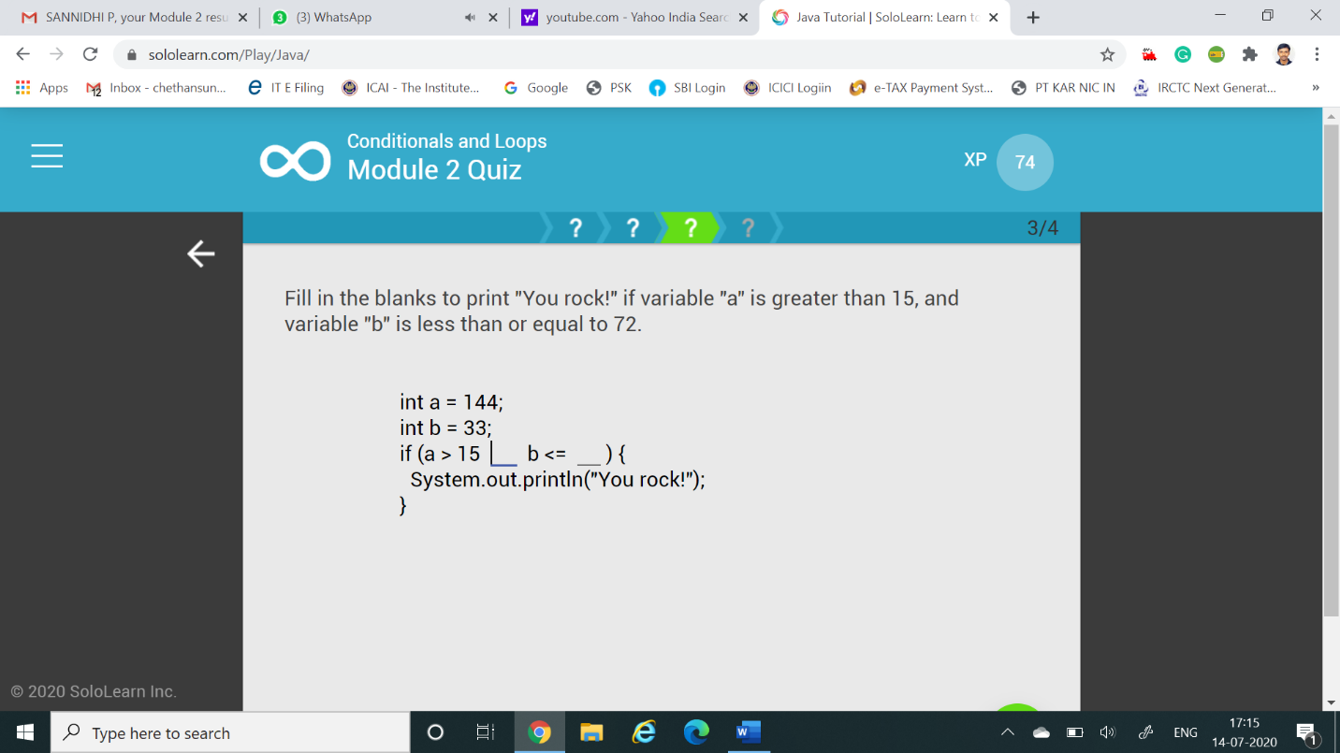

Coding Challenges Details: (Attach the snapshot and briefly write the report for the same)

Coding was given and it was uploaded for github and slack

**start = 11**

**end = 25**

**for val in range(start, end + 1):**

**if val > 1:**

**for n in range(2, val//2 + 2):**

**if (val % n) == 0:**

**break**

**else:**

**if n == val//2 + 1:**

**print(val)**