**DAILY ONLINE ACTIVITIES SUMMARY**

|  |  |  |  |  |  |  |  |
| --- | --- | --- | --- | --- | --- | --- | --- |
| **Date:** | **25-06-2020** | | | | **Name:** | **Sannidhi P** | |
| **Sem & Sec** | **8th B** | | | | **USN:** | **4AL16CS084** | |
| **Online Test Summary** | | | | | | | |
| **Subject** | | **SMS** | | | | | |
| **Max. Marks** | | **30** | | **Score** | | **Mail not recived** | |
| **Certification Course Summary** | | | | | | | |
| **Course** | **SOLOLEARN** | | | | | | |
| **Certificate Provider** | | | **JAVASCRIPT Tutorial** | **Duration** | | | **2hrs** |
| **Coding Challenges** | | | | | | | |
| **Problem Statement-** : C program to print right angled triangle numbers star pattern | | | | | | | |
| **Status: completed** | | | | | | | |
| **Uploaded the report in Github** | | | | **yes** | | | |
| **If yes Repository name** | | | | **Sannidhi1** | | | |
| **Uploaded the report in slack** | | | | **yes** | | | |

**Online Test Details:**

**Certification Course Details:**

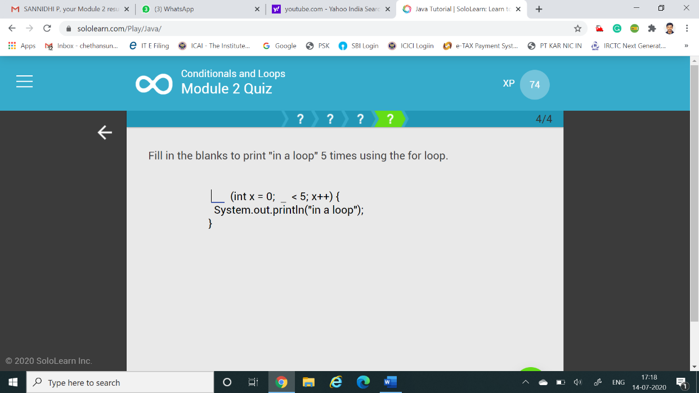

**Coding Challenges Details:**

**C program to print right angled triangle numbers star pattern**

int main()

{

int Rows, i, j; printf("Please Enter the Number of Rows: "); scanf("%d", &Rows); printf("\n Printing Right Angled Triangle \n \n"); for ( i = 1 ; i <= Rows; i++ )

{ for ( j = 1 ; j <= i; j++ )

{

printf("* ");

}

printf("\n");

}

return 0;

}

int main()

{

int Rows, i, j; printf("Please Enter the Number of Rows: "); scanf("%d", &Rows); printf("\nPrinting Right Angled Triangle \n \n"); for ( i = 1 ; i <= Rows; i++ )

{ for ( j = 1 ; j <= i; j++ )

{

printf("* ");

}

printf("\n");

}

return 0;

}