**DAILY ONLINE ACTIVITIES SUMMARY**

|  |  |  |  |  |  |  |  |
| --- | --- | --- | --- | --- | --- | --- | --- |
| **Date:** | **26-06-2020** | | | | **Name:** | **Sannidhi P** | |
| **Sem & Sec** | **8th sem B sec** | | | | **USN:** | **4AL16CS084** | |
| **Online Test Summary** | | | | | | | |
| **Subject** | | **-** | | | | | |
| **Max. Marks** | | **-** | | **Score** | | **-** | |
| **Certification Course Summary** | | | | | | | |
| **Course** | **SOLOLEARN** | | | | | | |
| **Certificate Provider** | | | **JAVASCRIPT Tutorial** | **Duration** | | | **2hr** |
| **Coding Challenges** | | | | | | | |
| **Problem Statement-Problem Statement- #Python program to remove duplicates from a list.** | | | | | | | |
| **Status: completed** | | | | | | | |
| **Uploaded the report in Github** | | | | **yes** | | | |
| **If yes Repository name** | | | | **Sannidhi1** | | | |
| **Uploaded the report in slack** | | | | **yes** | | | |

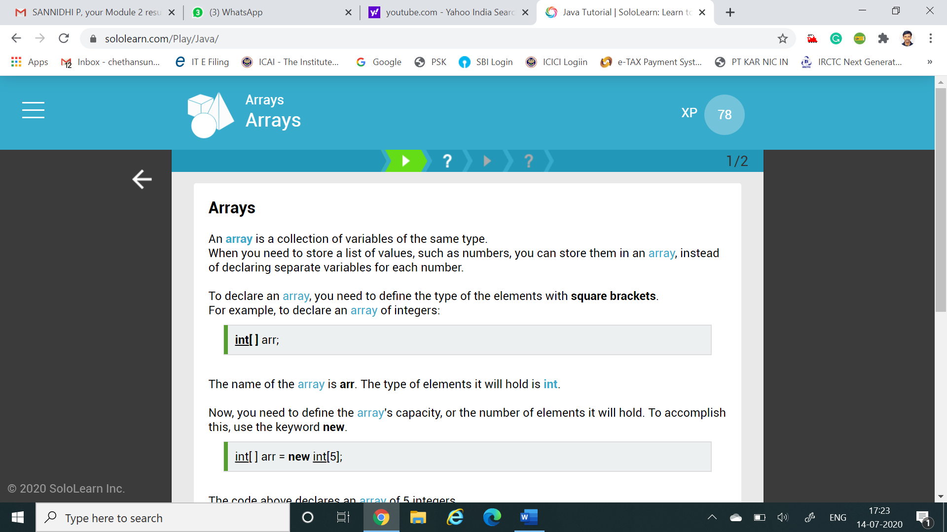

Online Test Details: (Attach the snapshot and briefly write the report for the same)

Certification Course Details: (Attach the snapshot and briefly write the report for the same)

Coding Challenges Details: (Attach the snapshot and briefly write the report for the same)

Coding was given and it was uploaded for github and slack

**a = [10,20,30,20,10,50,60,40,80,50,40]**

**dup_items = set()**

**uniq_items = []**

**for x in a:**

**if x not in dup_items:**

**uniq_items.append(x)**

**dup_items.add(x)**

**print(dup_items)**