**DAILY ONLINE ACTIVITIES SUMMARY**

|  |  |  |  |  |  |  |
| --- | --- | --- | --- | --- | --- | --- |
| **Date:** | **23/05/2020** | | | **Name:** | **Rakshith Rai** | |
| **Sem & Sec** | **8th- B** | | | **USN:** | **4AL16CS075** | |
| **Certification Course Summary** | | | | | | |
| **Course** | **Python Programming in Hindi** | | | | | |
| **platform** | | **GreatLearning** | **Duration** | | | **4:30 hrs** |
| **Coding Challenges** | | | | | | |
| **Problem Statement:**  **1) Given the cost of each balloon print the minimum price**. | | | | | | |
| **Status: Executed** | | | | | | |
| **Uploaded the report in Github** | | | **Yes** | | | |
| **If yes Repository name** | | | Shashikant_chavan | | | |
| **Uploaded the report in slack** | | | **Yes** | | | |

Certification:

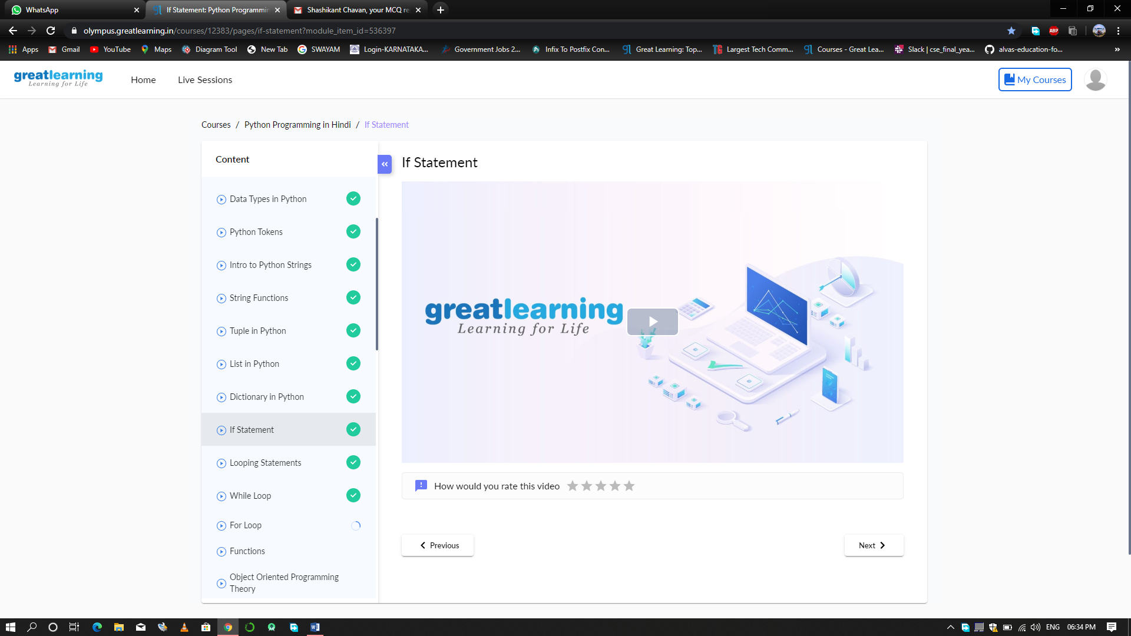

Coding Challenges Details:

