**DAILY ONLINE ACTIVITIES SUMMARY**

|  |  |  |  |  |  |  |  |
| --- | --- | --- | --- | --- | --- | --- | --- |
| **Date:** | **26-05-2020** | | | | **Name:** | **Shashikant Chavan** | |
| **Sem & Sec** | **8th sem B sec** | | | | **USN:** | **4AL16CS090** | |
| **Online Test Summary** | | | | | | | |
| **Subject** | | **BDA** | | | | | |
| **Max. Marks** | | **40** | | **Score** | | **28** | |
| **Certification Course Summary** | | | | | | | |
| **Course** | **Python Programming in Hindi** | | | | | | |
| **Certificate Provider** | | | **https://www.greatlearning.in/academy** | **Duration** | | | **4:5 hrs** |
| **Coding Challenges** | | | | | | | |
| **Problem Statement: write a python program to check a) number is palindrome**  **b)to read a number and print the series "1+2.."**  **c) print all numbers which aren't divisible by 2 or 3 and lie between 1-50** | | | | | | | |
| **Status: completed** | | | | | | | |
| **Uploaded the report in Github** | | | | **yes** | | | |
| **If yes Repository name** | | | | **Shashikant_chavan** | | | |
| **Uploaded the report in slack** | | | | **yes** | | | |

YOnline Test Details: (Attach the snapshot and briefly write the report for the same)

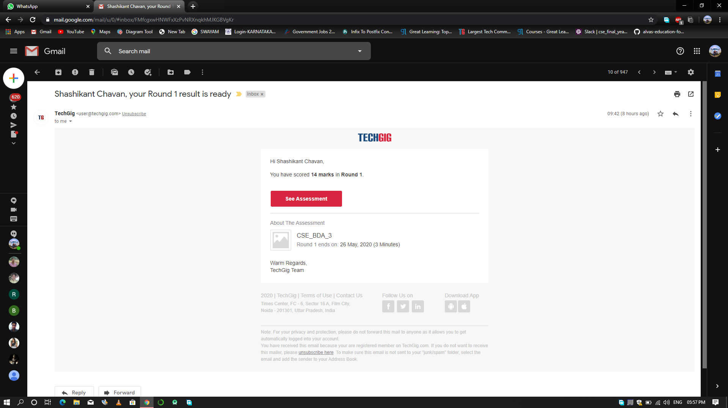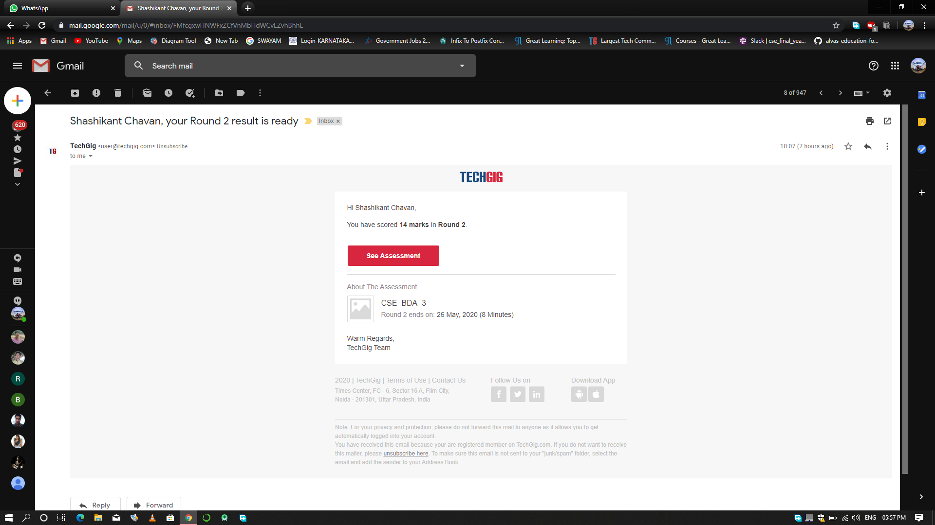

Certification Course Details: (Attach the snapshot and briefly write the report for the same)

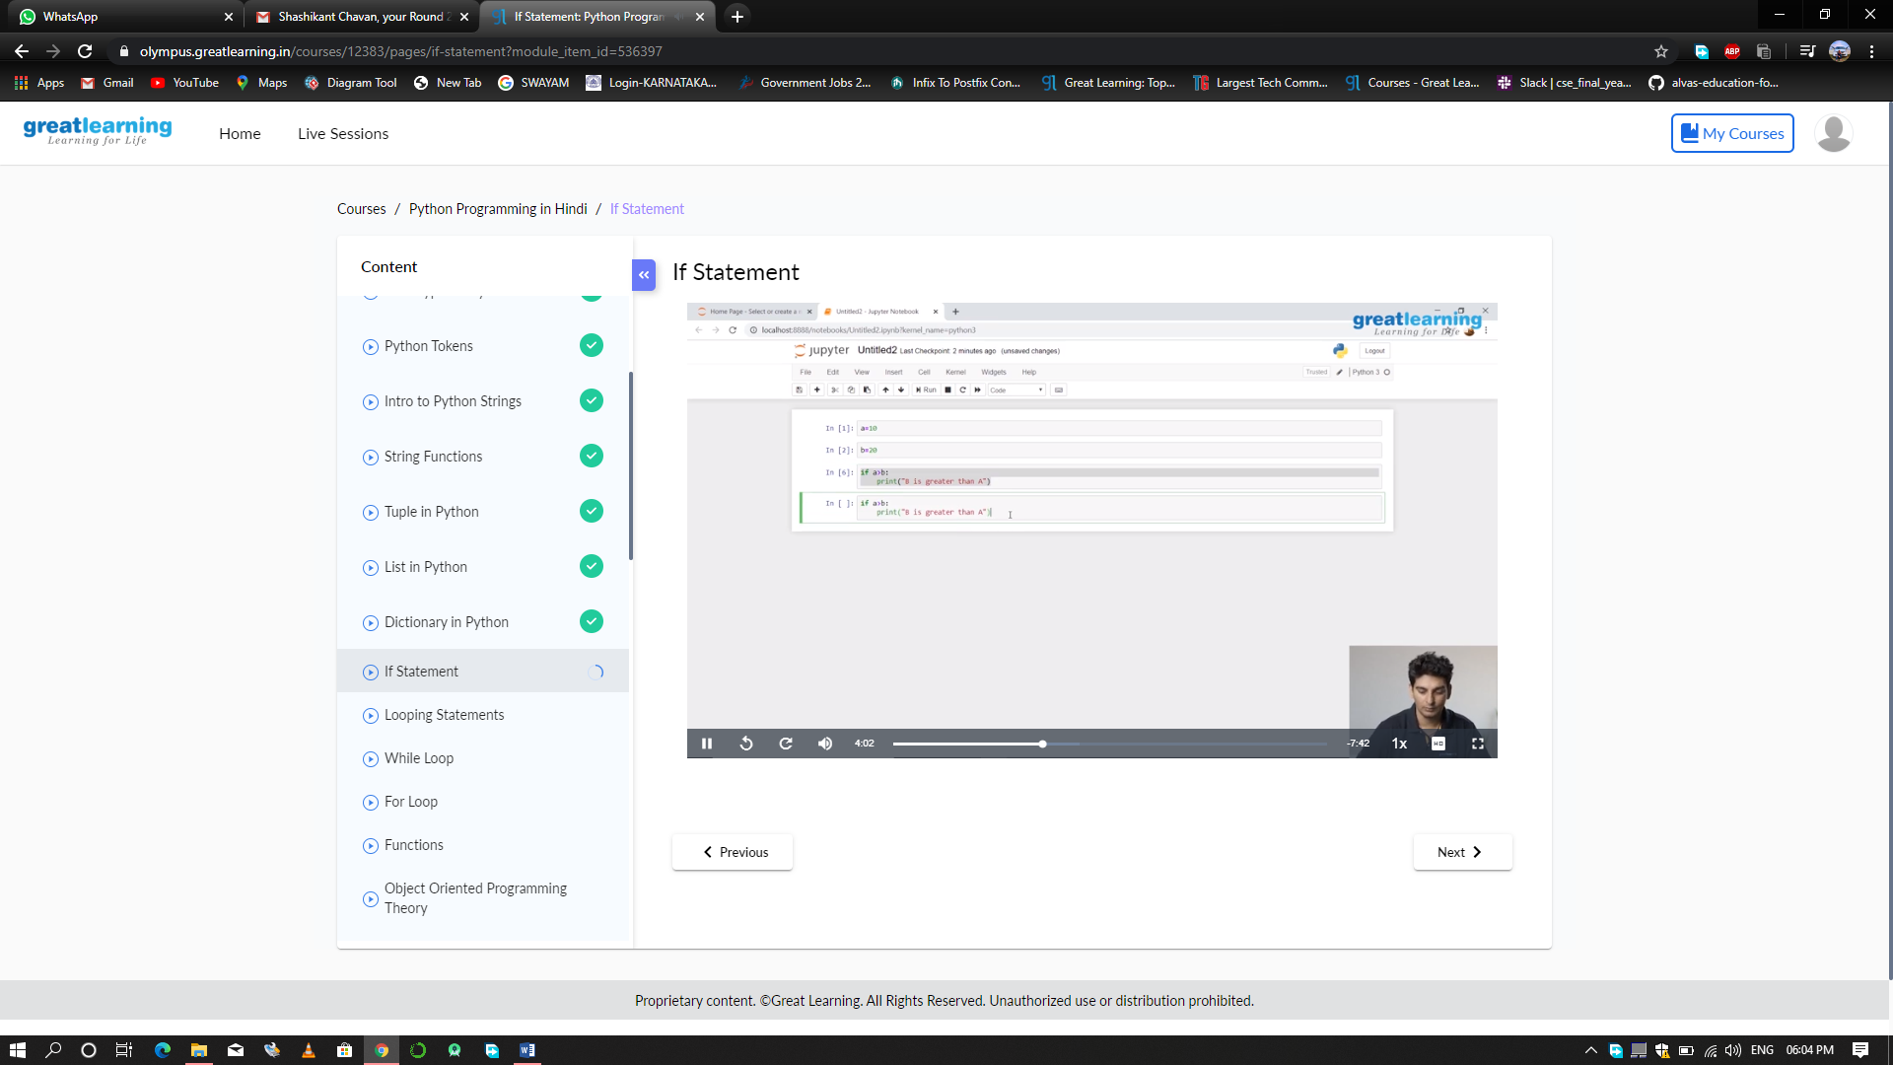

Coding Challenges Details: (Attach the snapshot and briefly write the report for the same)

Coding was given n it was uploaded for github and slack

PROGRAM1

n=int(input("Enter number:"))

temp=n

rev=0

while(n>0):

dig=n%10

rev=rev*10+dig

n=n//10

if(temp==rev):

print("The number is a palindrome!")

else:

print("The number isn't a palindrome!")

PROGRAM 2

n = int(input("Enter a Number : "))

series_sum = []

for i in range(1,n+1):

series_sum.append(i)

if i==n:

print(i, end='')

else:

print(i,end=' + ')

print(' = ', sum(series_sum), sep='')

PROGRAM 3

for i in range(0,51):

if(i%2!=0&i%3!=0):

print(i)