**DAILY ONLINE ACTIVITIES SUMMARY**

|  |  |  |  |  |  |  |  |
| --- | --- | --- | --- | --- | --- | --- | --- |
| **Date:** | **11/06/2020** | | | | **Name:** | **Shashikant Chavan** | |
| **Sem & Sec** | **8 B** | | | | **USN:** | **4AL16CS090** | |
| **Online Test Summary** | | | | | | | |
| **Subject** | | **SMS** | | | | | |
| **Max. Marks** | | **60** | | **Score** | | **60** | |
| **Certification Course Summary(Internship)** | | | | | | | |
| **Task** | program to find the fibbonnacci series | | | | | | |
| **Company** | | | **www.greatlearning.in** | **Duration** | | | **3.5hr** |
| **Coding Challenges** | | | | | | | |
| program to find the fibbonnacci series | | | | | | | |
| **Status:completed** | | | | | | | |
| **Uploaded the report in Github** | | | | **Yes** | | | |
| **If yes Repository name** | | | | SHahsikant_chavan | | | |
| **Uploaded the report in slack** | | | | **Yes** | | | |

ONLINE TEST

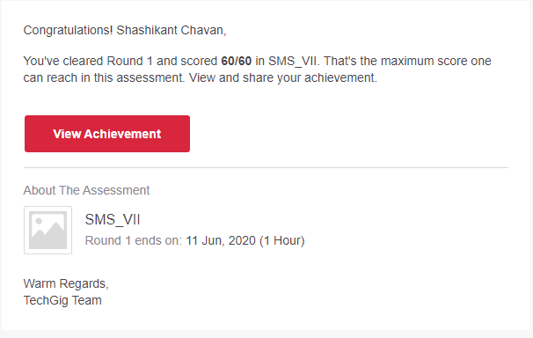

**Certification**

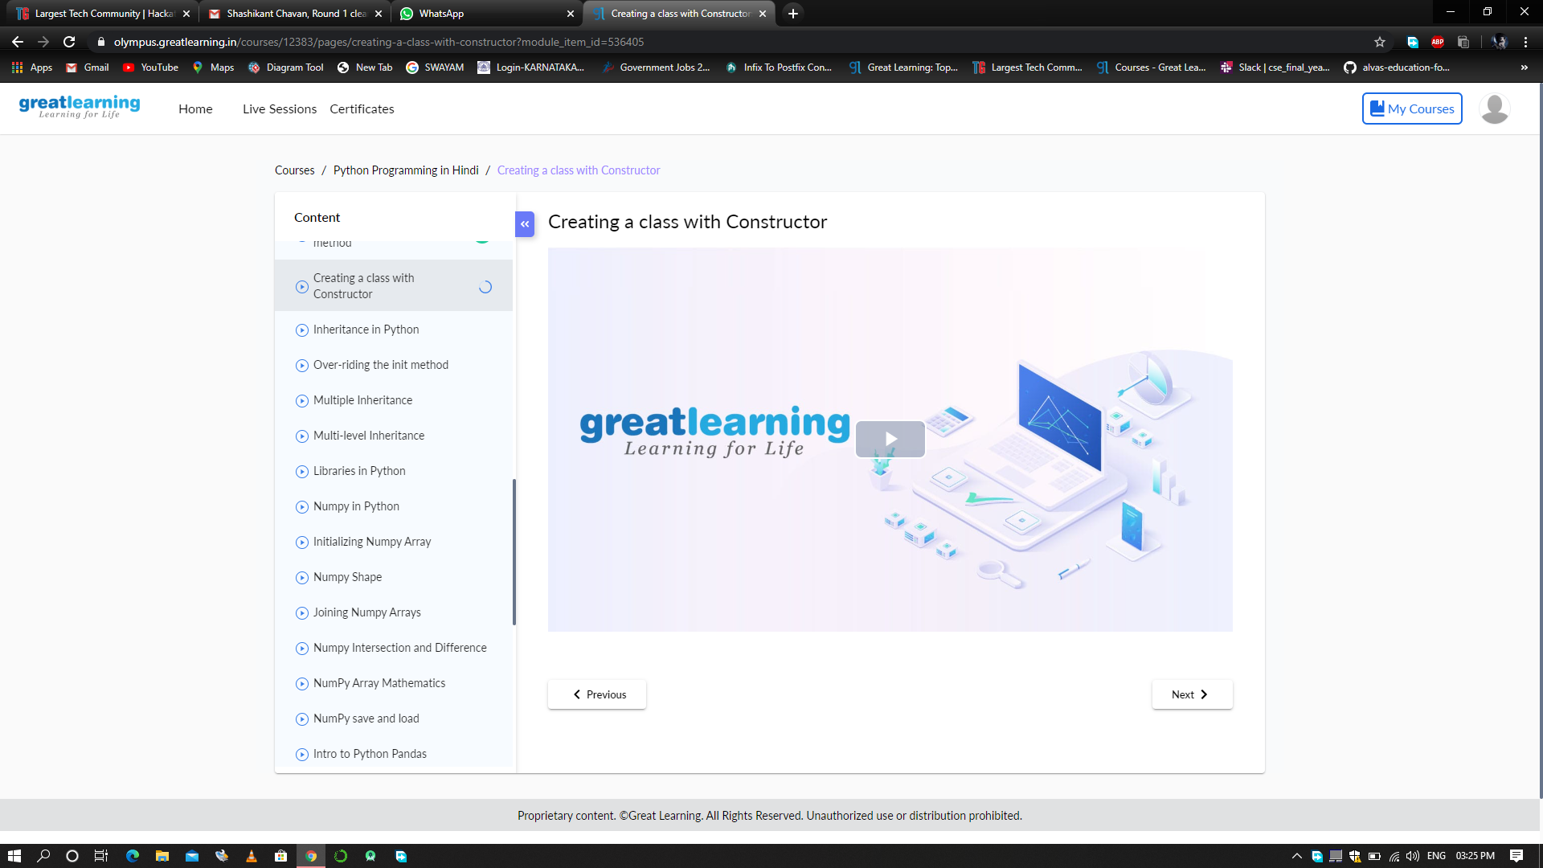

CODING CHALLENGE:

# Python program to display the Fibonacci sequence

def recur_fibo(n):

if n <= 1:

return n

else:

return(recur_fibo(n-1) + recur_fibo(n-2))

nterms = 10

if nterms <= 0:

print("Plese enter a positive integer")

else:

print("Fibonacci sequence:")

for i in range(nterms):

print(recur_fibo(i))