**DAILY ONLINE ACTIVITIES SUMMARY**

|  |  |  |  |  |  |  |  |  |
| --- | --- | --- | --- | --- | --- | --- | --- | --- |
| **Date:** | **26-06-2020** | | | | | **Name:** | **Shashikant Chavan** | |
| **Sem & Sec** | **8th sem B sec** | | | | | **USN:** | **4AL16CS090** | |
| **Online Test Summary** | | | | | | | | |
| **Subject** | | **-** | | | | | | |
| **Max. Marks** | | **-** | | **Score** | | | **-** | |
| **Certification Course Summary(Internship)** | | | | | | | | |
| **Course** | **Python Programming in hindi** | | | | | | | |
| **Certificate Provider** | | | **GreatLearning** | | **Duration** | | | **3 hours** |
| **Coding Challenges** | | | | | | | | |
| **Problem Statement: Python program to remove duplicates from a list.** | | | | | | | | |
| **Status: completed** | | | | | | | | |
| **Uploaded the report in Github** | | | | | **yes** | | | |
| **If yes Repository name** | | | | | **alvas-education-foundation/Shashikant_chavan** | | | |
| **Uploaded the report in slack** | | | | | **yes** | | | |

Online Test Details: (Attach the snapshot and briefly write the report for the same)

Certification Course Details: (Attach the snapshot and briefly write the report for the same)

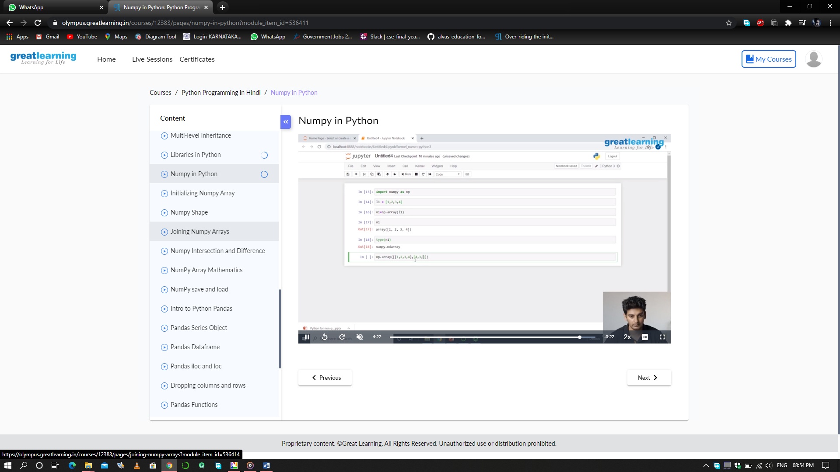

Coding Challenges Details: (Attach the snapshot and briefly write the report for the same)

Coding was given n it was uploaded for github and slack

PROGRAM1

|  |
| --- |
|  |

a = [10,20,30,20,10,50,60,40,80,50,40]

dup_items = set()

uniq_items = []

for x in a:

if x not in dup_items:

uniq_items.append(x)

dup_items.add(x)

print(dup_items)