**DAILY ONLINE ACTIVITIES SUMMARY**

|  |  |  |  |  |  |  |  |  |
| --- | --- | --- | --- | --- | --- | --- | --- | --- |
| **Date:** | **20-05-2020** | | | | | **Name:** | **Shashaikant Chavan** | |
| **Sem & Sec** | **8th sem B sec** | | | | | **USN:** | **4AL16CS090** | |
| **Online Test Summary** | | | | | | | | |
| **Subject** | | **IOT** | | | | | | |
| **Max. Marks** | | **30** | | **Score** | | | **26** | |
| **Certification Course Summary** | | | | | | | | |
| **Course** | **Python Programming** | | | | | | | |
| **Certificate Provider** | | | **Great learning website** | | **Duration** | | | **10-12.30** |
| **Coding Challenges** | | | | | | | | |
| **Problem Statement: c programming question** | | | | | | | | |
| **Status: completed** | | | | | | | | |
| **Uploaded the report in Github** | | | | | **yes** | | | |
| **If yes Repository name** | | | | | **Academic** | | | |
| **Uploaded the report in slack** | | | | | **yes** | | | |

Online Test Details: (Attach the snapshot and briefly write the report for the same)

Test was good and was not able to see the platform properly as the platform was not that good

Certification Course Details: (Attach the snapshot and briefly write the report for the same)

Saw videos related to Hadoop n introduction was given to haddop about using Hadoop

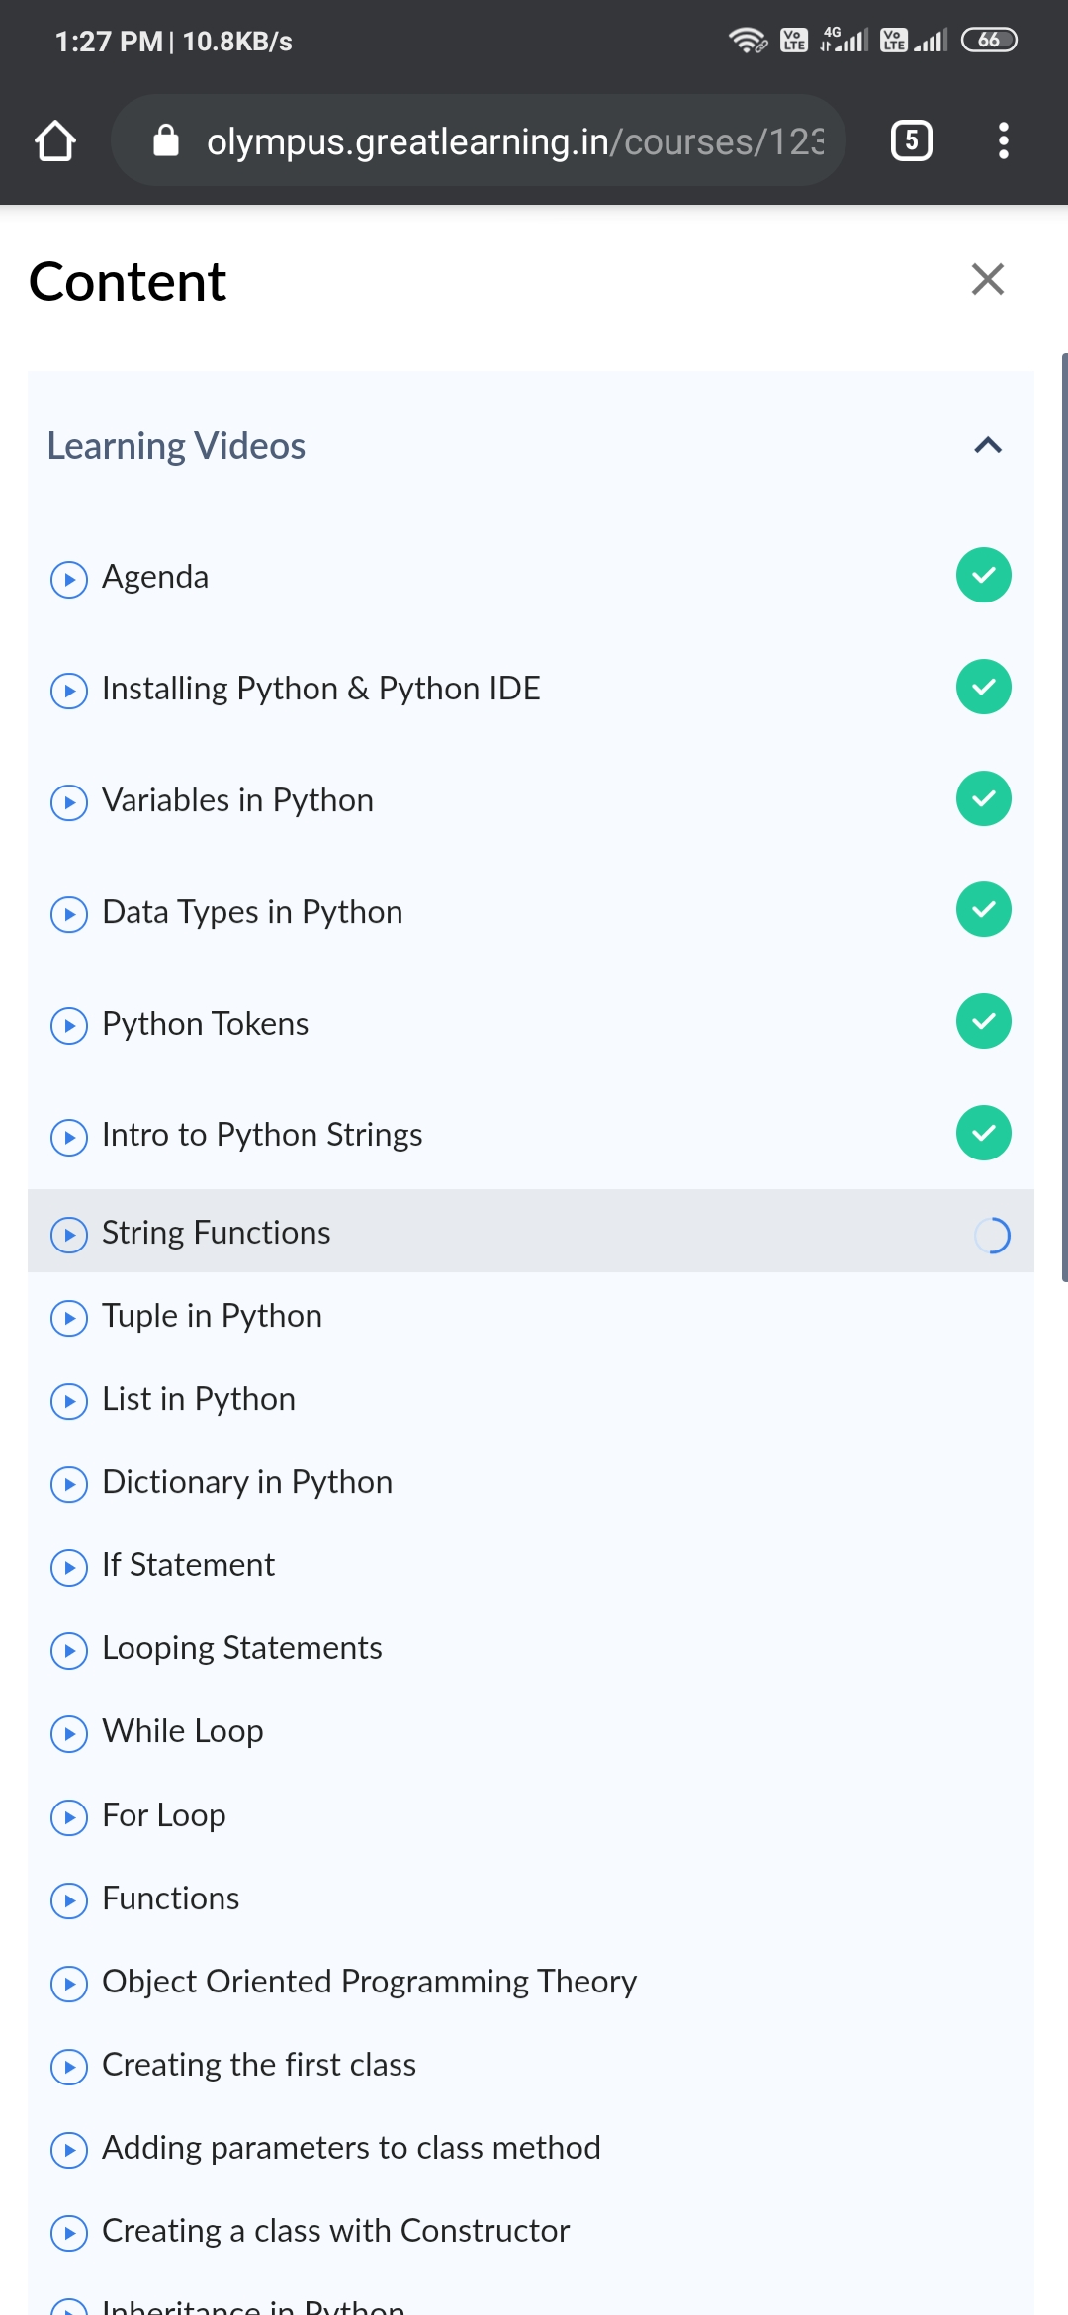

Coding Challenges Details: (Attach the snapshot and briefly write the report for the same)

Coding was given n it was uploaded for github and slack

PROGRAM1

struct Node  
{  
int data;  
struct Node* next;  
};

pointer to the new head node. */  
struct Node reverse (struct Node head, int k)  
{  
struct Node current = head;  
struct Node next = NULL;  
struct Node* prev = NULL;  
int count = 0;

while (current != NULL && count < k)

{

next = current->next;

current->next = prev;

prev = current;

current = next;

count++;

}

if (next != NULL)

head->next = reverse(next, k);

return prev;

}

void push(struct Node** head_ref, int new_data)  
{  
struct Node* new_node =  
(struct Node*) malloc(sizeof(struct Node));

new_node->data = new_data;

new_node->next = (*head_ref);

(*head_ref) = new_node;

}

void printList(struct Node *node)  
{  
while (node != NULL)  
{  
printf("%d ", node->data);  
node = node->next;  
}  
}

int main(void)  
{  
struct Node* head = NULL;  
push(&head, 8);  
push(&head, 7);  
push(&head, 6);  
push(&head, 5);  
push(&head, 4);  
push(&head, 3);  
push(&head, 2);  
push(&head, 1);

printf("\nGiven linked list \n");

printList(head);

head = reverse(head, 2);

printf("\nReversed Linked list \n");

printList(head);

return(0);