**DAILY ASSESSMENT FORMAT**

|  |  |  |  |
| --- | --- | --- | --- |
| **Date:** | **12-Jun 2020** | **Name:** | **Sindhu S** |
| **Course:** | **Java** | **USN:** | **4AL18EC049** |
| **Topic:** | **The Java collection framework** | **Semester & Section:** | **4th Sem**  **‘A’ Section** |
| **Github Repository:** | **Sindhu_course** |  |  |

|  |
| --- |
| **FORENOON SESSION** |
| **Image of the session** |

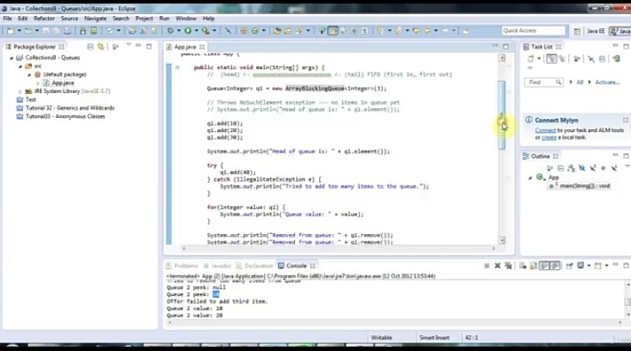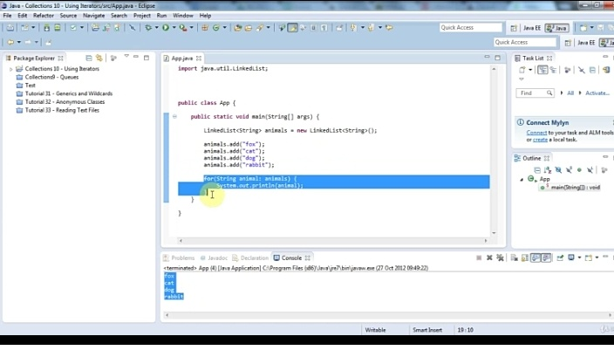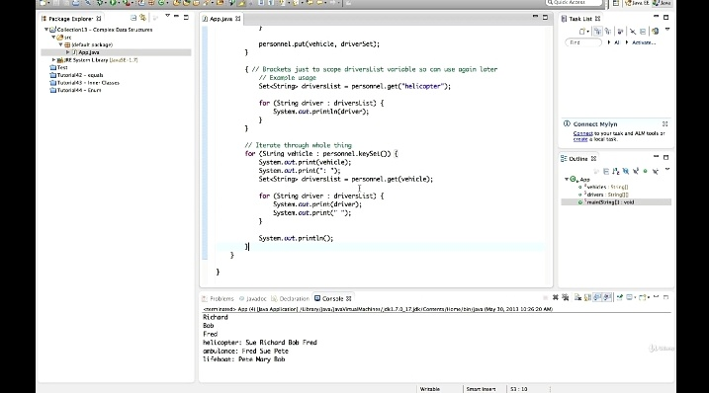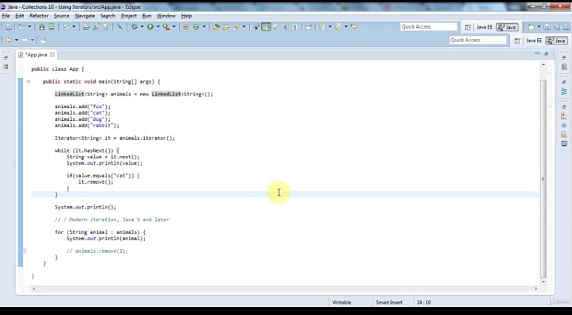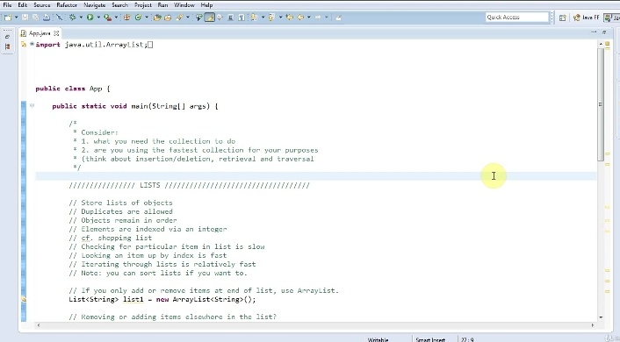

|  |
| --- |
| Report : |

|  |
| --- |
|  |

|  |
| --- |
|  |